**Frequency Content**

A bipolar 50 Hz square wave with 50 percent duty cycle and amplitude of ±5 V is filtered by a low pass filter with response as shown below. Expand the square wave signal into its harmonics, apply the filter gain to each harmonic and plot the resulting composite waveform.

symmetric square wave, frequency f0, amplitude ±A0 = for 

**1 Hz**

**10 Hz**

**100 Hz**

**1000 Hz**

**- 40 dB**

**+ 20 dB**

**0 dB**

**- 20 dB**

|  |  |  |  |  |  |
| --- | --- | --- | --- | --- | --- |
| Harmonic | Frequency (Hz) | Amplitude  (V) | Gain  (dB) | Gain | Filtered  Amplitude (V) |
| DC | 0 |  |  |  |  |
| 1 | 50 |  |  |  |  |
|  |  |  |  |  |  |
|  |  |  |  |  |  |
|  |  |  |  |  |  |
|  |  |  |  |  |  |
|  |  |  |  |  |  |
|  |  |  |  |  |  |



% p04.m - harmonics of a square wave

% HJSIII - 07.10.17

clear

clf

% bipolar square wave +/-5 V at 50 Hz, 50% duty cycle

A0 = 5;

f0 = 50;

tau = 1 / f0;

% sampling rate for display

fs = 10000;

dt = 1 / fs;

% time

is = (1:241)';

t = (is-21) * dt;

% harmonics

s1 = (4*A0/pi/1) * sin( 1 * 2*pi*f0*t );

s3 = s1 + (4*A0/pi/3) * sin( 3 * 2*pi*f0*t );

s5 = s3 + (4*A0/pi/5) * sin( 5 * 2*pi*f0*t );

s7 = s5 + (4*A0/pi/7) * sin( 7 * 2*pi*f0*t );

s9 = s7 + (4*A0/pi/9) * sin( 9 * 2*pi*f0*t );

s11 = s9 + (4*A0/pi/11) * sin( 11 * 2*pi*f0*t );

s13 = s11 + (4*A0/pi/13) * sin( 13 * 2*pi*f0*t );

s15 = s13 + (4*A0/pi/15) * sin( 15 * 2*pi*f0*t );

% square wave

sqw = A0 * sign( s1 );

% plot

clf

subplot(4,2,1)

plot( t, sqw, t, s1 )

title( '1 harmonic' )

axis( [ t(1) t(end) -1.5*A0 1.5*A0 ] )

axis off

subplot(4,2,3)

plot( t, sqw, t, s3 )

title( '1+3 harmonics' )

axis( [ t(1) t(end) -1.5*A0 1.5*A0 ] )

axis off

subplot(4,2,5)

plot( t, sqw, t, s5 )

title( '1+3+5 harmonics' )

axis( [ t(1) t(end) -1.5*A0 1.5*A0 ] )

axis off

subplot(4,2,7)

plot( t, sqw, t, s7 )

title( '1+3+5+7 harmonics' )

axis( [ t(1) t(end) -1.5*A0 1.5*A0 ] )

axis off

subplot(4,2,2)

plot( t, sqw, t, s9 )

title( '1+3+5+7+9 harmonics' )

axis( [ t(1) t(end) -1.5*A0 1.5*A0 ] )

axis off

subplot(4,2,4)

plot( t, sqw, t, s11 )

title( '1+3+5+7+9+11 harmonics' )

axis( [ t(1) t(end) -1.5*A0 1.5*A0 ] )

axis off

subplot(4,2,6)

plot( t, sqw, t, s13 )

title( '1+3+5+7+9+11+13 harmonics' )

axis( [ t(1) t(end) -1.5*A0 1.5*A0 ] )

axis off

subplot(4,2,8)

plot( t, sqw, t, s15 )

title( '1+3+5+7+9+11+13+15 harmonics' )

axis( [ t(1) t(end) -1.5*A0 1.5*A0 ] )

axis off

A bipolar 50 Hz square wave with 50 percent duty cycle and amplitude of ±5 V is filtered by a low pass filter with response as shown below. Expand the square wave signal into its harmonics, apply the filter gain to each harmonic and plot the resulting composite waveform.

symmetric square wave, frequency f0, amplitude ±A0 = for 

**1 Hz**

**10 Hz**

**100 Hz**

**1000 Hz**

**- 40 dB**

**+ 20 dB**

**0 dB**

**- 20 dB**

|  |  |  |  |  |  |
| --- | --- | --- | --- | --- | --- |
| Harmonic | Frequency (Hz) | Amplitude  (V) | Gain  (dB) | Gain | Filtered  Amplitude (V) |
| DC | 0 | 0 | 0 | 1 | 0 |
| 1 | 50 | 6.366 | 0 | 1 | 6.36 |
| 3 | 150 | 2.122 | -7.04 | 0.444 | 0.943 |
| 5 | 250 | 1.272 | -15.92 | 0.160 | 0.203 |
| 7 | 350 | 0.909 | -21.76 | 0.082 | 0.074 |
| 9 | 450 | 0.707 | -26.13 | 0.049 | 0.035 |
| 11 | 550 | 0.579 | -29.61 | 0.033 | 0.019 |
| 13 | 650 | 0.490 | -32.52 | 0.024 | 0.012 |

**Filters**

**General Low-pass Filter**

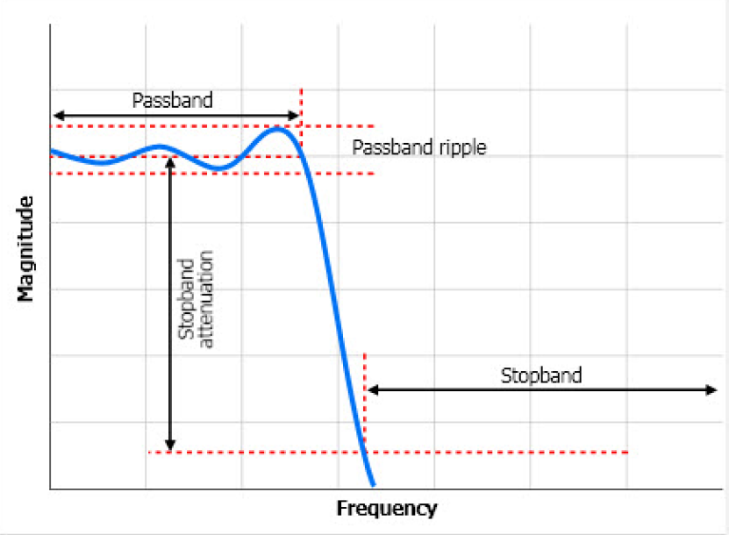

**Second-order Low-pass Butterworth**

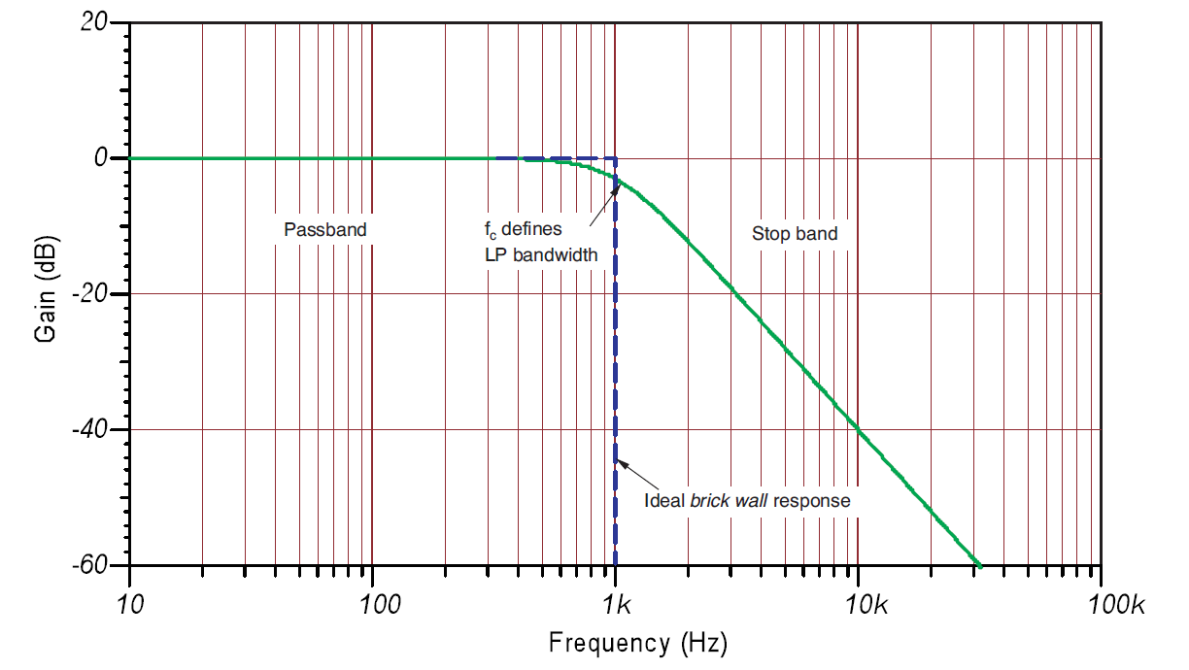

**Second-order High-pass Butterworth**

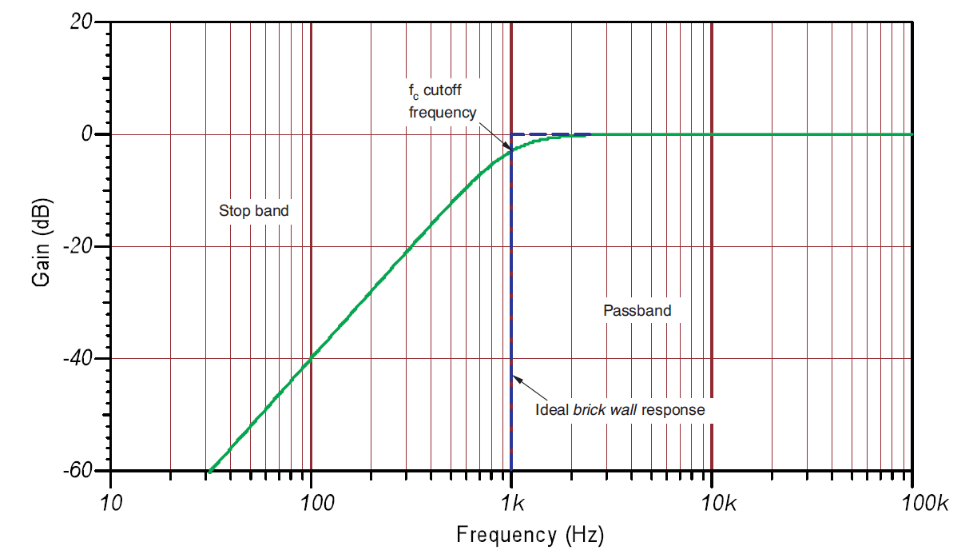

**General Band-pass Filter**

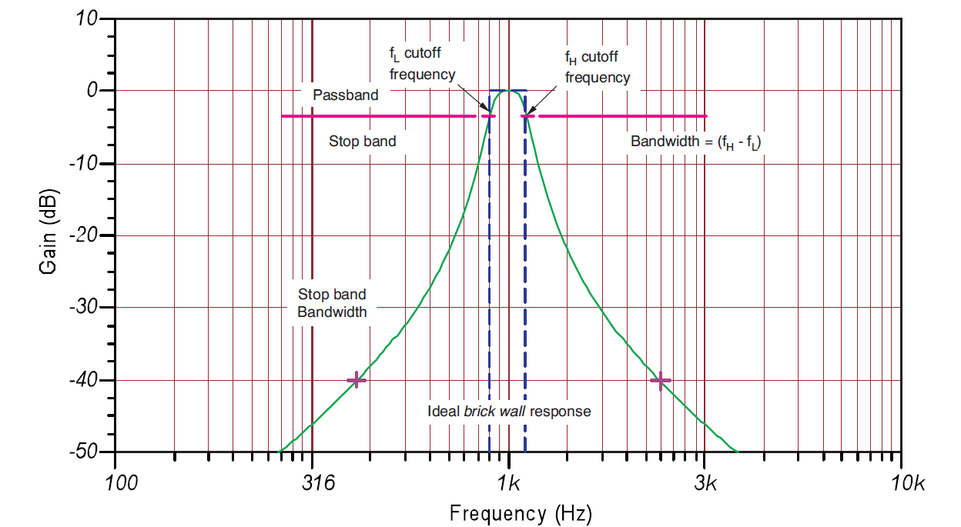

**General Band-reject (Band-stop, Notch) Filter**

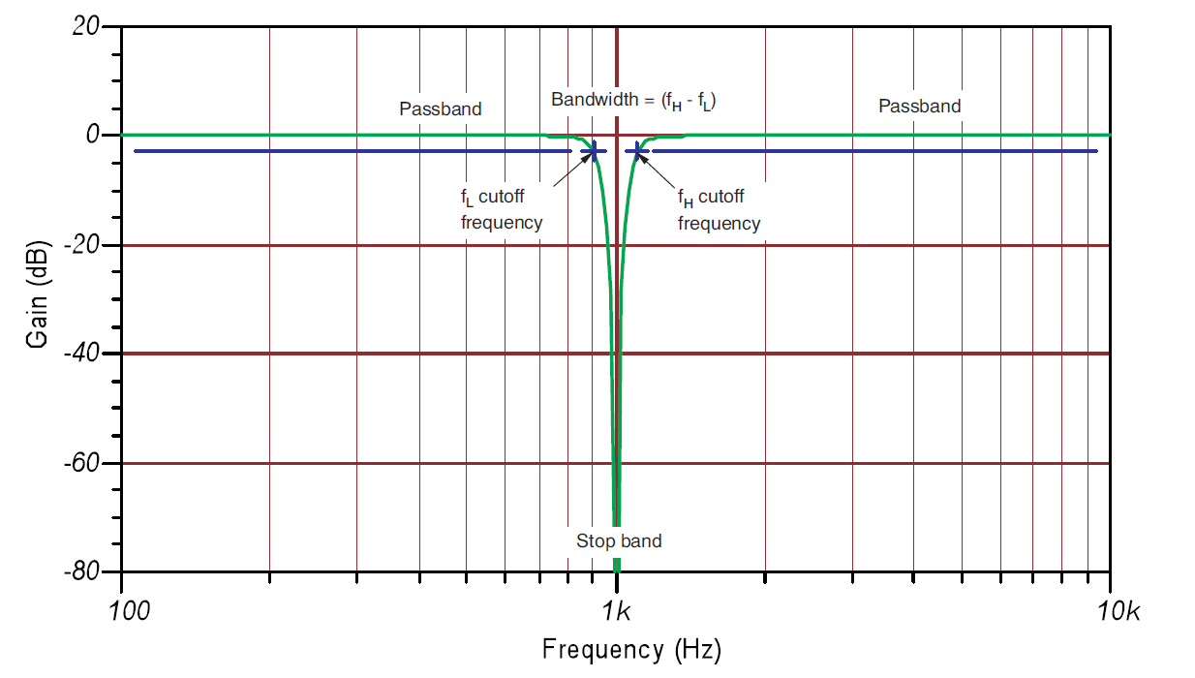

**Higher order Butterworth Filters**

simple approach G = 1 for f < fC (unity gain in pass band)

 for f > fC N = order of filter = 1, 2, 3, 4, etc.

Butterworth  N = order of filter = 1, 2, 3, 4, etc.

dB = 20 log ( G )





% gain_butterworth.m - gain for Butterworth filters

% HJSIII, 14.03.28

clear

% cutoff and orders

fc = 100;

N1 = 1;

N2 = 2;

N4 = 4;

N6 = 6;

% frequency spectrum

lf = ( 0 : 0.01 : 4 )';

f = 10 .^ lf;

% gain only - no phase

G1 = sqrt( 1 ./ ( 1 + ( (f/fc).^(2*N1) ) ) );

dB1 = 20 * log10( G1 );

G2 = sqrt( 1 ./ ( 1 + ((f/fc).^(2*N2) ) ) );

dB2 = 20 * log10( G2 );

G4 = sqrt( 1 ./ ( 1 + ((f/fc).^(2*N4) ) ) );

dB4 = 20 * log10( G4 );

G6 = sqrt( 1 ./ ( 1 + ((f/fc).^(2*N6) ) ) );

dB6 = 20 * log10( G6 );

% plot

figure( 1 )

clf

plot( lf,dB1,'r', lf,dB2,'g', lf,dB4,'b', lf,dB6,'k' )

xlabel( 'log (frequency) [Hz]' )

ylabel( 'Gain [dB]' )

axis( [ 0 4 -180 20 ] )

title( 'low pass, fc = 100 Hz, unity gain in pass band' )

legend( 'First order N=1', 'Second order N=2', 'Fourth order N=4', 'Sixth order N=6' )

% bottom of gain_butterworth

**Fourth-order Low-pass Chebyshev Filter**

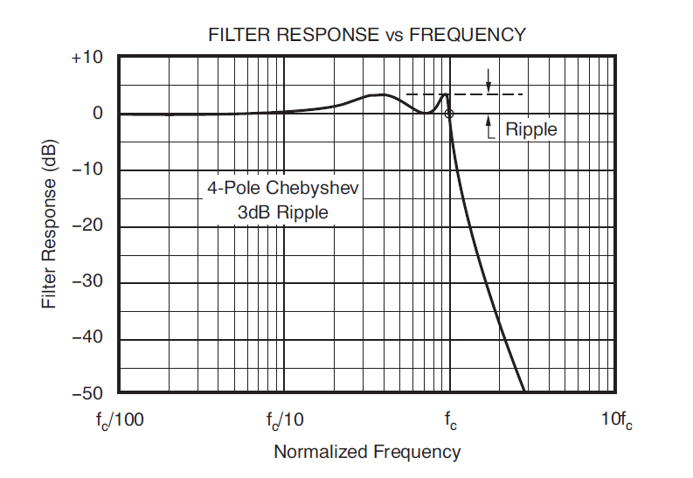

**Fourth-order Low-pass Butterworth, Chebyshev and Bessel Filters**

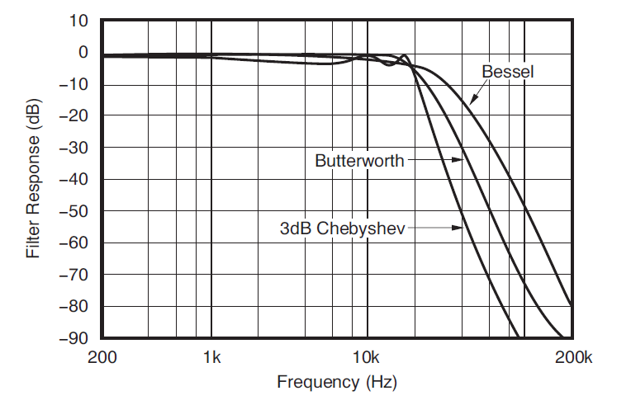

**Step Response of Low-pass Butterworth, Chebyshev and Bessel Filters**

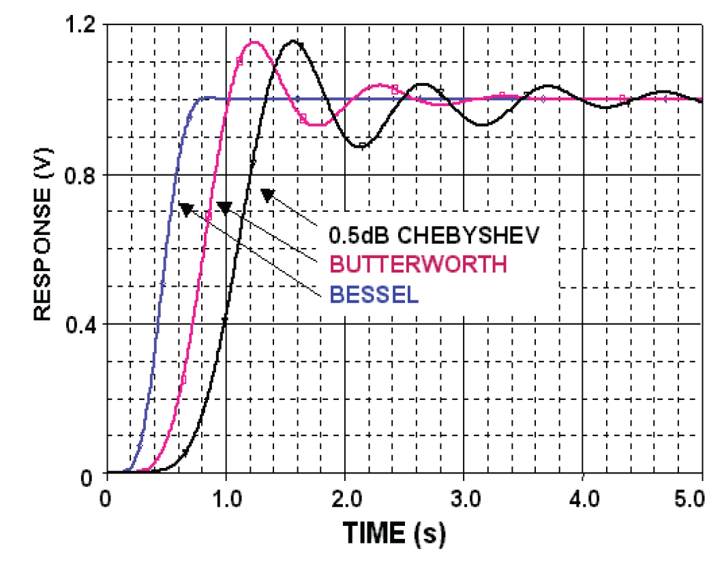

**Cascading filters**

Be very careful to prevent impedance loading!

Second-order

Low-pass

Butterworth

fc = 100 Hz

Second-order

Low-pass

Butterworth

fc = 100 Hz

Second-order

Low-pass

Butterworth

fc = 100 Hz

Second-order

High-pass

Butterworth

fc = 10 Hz

Second-order

Low-pass

Butterworth

fc = 10 Hz

Second-order

High-pass

Butterworth

fc = 100 Hz

VCVS Second-Order Filters with Passband Gain K

**VIN**

**C1**

**R2**

**VB**

**VA**

**VOUT**

**R4**

**R5**

**+**

**-**

**R1**

**VC**

**C2**

**LOW-PASS**

**VIN**

**C1**

**VB**

**VA**

**VOUT**

**R4**

**R5**

**+**

**-**

**R1**

**VC**

**R2**

**C2**

**HIGH-PASS**





|  |  |  |  |  |  |  |
| --- | --- | --- | --- | --- | --- | --- |
| Poles | Butterworth | | Bessel | | 2dB Chebyshev | |
| fn | K | fn | K | fn | K |
| 2 | 1 | 1.586 | 1.272 | 1.268 | 0.907 | 2.114 |
| 4 | 1.152  2.235 | 1.432  1.606 | 1.084  1.759 | 0.471  0.964 | 1.924  2.782 |
| 6 | 1.068  1.586  2.483 | 1.607  1.692  1.908 | 1.040  1.364  2.023 | 0.316  0.730  0.983 | 1.891  2.648  2.904 |
| 8 | 1.038  1.337  1.889  2.610 | 1.781  1.835  1.956  2.192 | 1.024  1.213  1.593  2.184 | 0.238  0.572  0.842  0.990 | 1.879  2.605  2.821  2.946 |

**VCVS Second-order Low-pass Filter Analysis**

**i1**

**i3**

**i2**

**i4**

**VIN**

**C1**

**R2**

**VB**

**VA**

**VOUT**

**R4**

**R5**

**+**

**-**

**R1**

**VC**

**C2**



















VCVS Second-order Band-pass Filter

**i1**

**i3**

**i2**

**i4**

**VIN**

**C1**

**VB**

**VA**

**VOUT**

**R4**

**R5**

**+**

**-**

**R1**

**VC**

**C2**

**R3**

**R2**





















check if the same as low-pass gain using R3 = ∞ and swap R2 ↔C1







% vcvs_2_4.m - complex numbers to compute gain and phase for

% second-order and fourth-order VCVS LP filter

% HJSIII - 07.10.17

clear

clf

% cutoff frequency [Hz] fc = 1 / (2*pi*R*C)

% capacitor [Farads]

fc = 15;

C = 0.1E-6;

C1 = C;

C2 = C;

% single-stage second-order passband gain

% K fn

% Butterworth 1.586 1

% Bessel 1.268 1.272

% 2dB Chebyshev 2.114 0.907

K = 1.586;

fn = 1;

R = 1 / (2*pi*fc*C*fn);

R1 = R;

R2 = R;

% two-stage fourth-order passband gains and normalizing factors

% KA fnA KB fnB

% Butterworth 1.152 1 2.235 1

% Bessel 1.084 1.432 1.759 1.606

% 2dB Chebyshev 1.924 0.471 2.782 0.964

KA = 1.152;

fnA = 1;

KB = 2.235;

fnB = 1;

RA = 1 / (2*pi*fc*C*fnA);

R1A = R;

R2A = R;

RB = 1 / (2*pi*fc*C*fnB);

R1B = R;

R2B = R;

% use 0.01 Hz <= f <= 1 MHz

lf = -2:0.01:6;

f = 10 .^ lf;

% capacitor impedance

ZC1 = -j ./ ( 2 * pi * f * C1 );

ZC2 = -j ./ ( 2 * pi * f * C2 );

% gain

G = K.*ZC1.*ZC2 ./ ( ( R1+ZC1).*( R2+ZC2) + R1*(ZC1- K*ZC2) );

GA = KA.*ZC1.*ZC2 ./ ( (R1A+ZC1).*(R2A+ZC2) + R1A*(ZC1-KA*ZC2) );

GB = KB.*ZC1.*ZC2 ./ ( (R1B+ZC1).*(R2B+ZC2) + R1B*(ZC1-KB*ZC2) );

G4 = GA .* GB;

% save log of gain and phase in degrees

dB = 20 * log10( abs( G ) );

dB4 = 20 * log10( abs( G4 ) );

phi = angle( G ) * 180 / pi;

phi4 = unwrap( angle( G4 ) ) * 180 / pi;

% plot

subplot(2,1,1)

plot( lf,dB,'-', lf,dB4,'--' )

axis( [ -2 6 -160 20 ] )

title('VCVS 100 Hz LP filters')

xlabel('log f')

ylabel('Gain (dB)')

legend( 'Second-order', 'Fourth-order' )

subplot(2,1,2)

plot( lf,phi,'-' , lf,phi4,'--' )

axis( [ -2 6 -360 90 ] )

xlabel('log f')

ylabel('Phase (deg)')

legend( 'Second-order', 'Fourth-order' )

**VCVS Filter Types**



% vcvs_types.m - VCVS LP filters - Fig 5.16, p. 274 in H&H

% HJSIII - 07.10.17

clear

clf

% cutoff frequency [Hz] fc = 1 / (2*pi*R*C)

fc = 10; % Hz

C = 0.1E-6; % F

C1 = C;

C2 = C;

% single-stage second-order passband gain

% K fn

% Butterworth 1.586 1

% Bessel 1.268 1.272

% 2dB Chebyshev 2.114 0.907

K_but = 1.586;

K_bes = 1.268;

K_che = 2.114;

fn_but = 1;

fn_bes = 1.272;

fn_che = 0.907;

R_but = 1 / (2*pi*fc*C*fn_but);

R_bes = 1 / (2*pi*fc*C*fn_bes);

R_che = 1 / (2*pi*fc*C*fn_che);

% use 0.1 Hz <= f <= 1000

lf = -1:0.01:3;

f = 10 .^ lf;

% capacitor impedance

ZC1 = -j ./ ( 2 * pi * f * C1 );

ZC2 = -j ./ ( 2 * pi * f * C2 );

% gain

K = K_but;

R1 = R_but;

R2 = R_but;

G_but = K.*ZC1.*ZC2 ./ ( ( R1+ZC1).*( R2+ZC2) + R1*(ZC1- K*ZC2) );

K = K_bes;

R1 = R_bes;

R2 = R_bes;

G_bes = K.*ZC1.*ZC2 ./ ( ( R1+ZC1).*( R2+ZC2) + R1*(ZC1- K*ZC2) );

K = K_che;

R1 = R_che;

R2 = R_che;

G_che = K.*ZC1.*ZC2 ./ ( ( R1+ZC1).*( R2+ZC2) + R1*(ZC1- K*ZC2) );

% gain in dB and phase in degrees

dB_but = 20 * log10( abs( G_but ) );

dB_bes = 20 * log10( abs( G_bes ) );

dB_che = 20 * log10( abs( G_che ) );

phi_but = angle( G_but ) * 180 / pi;

phi_bes = angle( G_bes ) * 180 / pi;

phi_che = angle( G_che ) * 180 / pi;

% plots

subplot(2,1,1)

plot( lf,dB_but, lf,dB_bes,'--', lf,dB_che,':' )

axis( [ -1 3 -40 10 ] )

title( 'VCVS 10 Hz LP filter types' )

xlabel( 'log f' )

ylabel( 'Gain (dB)' )

legend( 'Butterworth', 'Bessel', '2dB Chebyshev' )

subplot(2,1,2)

plot( lf,phi_but, lf,phi_bes,'--', lf,phi_che,':' )

axis( [ -1 3 -190 10 ] )

xlabel( 'log f' )

ylabel( 'Phase (deg)' )

hold on

**VCVS Component Variation**



% vcvs_tolerance.m - effects of component tolerances for VCVS

% LP filter - Fig 5.16, p. 274 in H&H

% HJSIII - 07.10.17

clear

clf

% component tolerance - 10%

pct = 0.1;

% cutoff frequency (Hz) fc = 1 / (2*pi*R*C)

% capacitor (Farads)

fc = 10;

C1C2_des = 0.1E-6;

% single-stage second-order passband gain

% K fn

% Butterworth 1.586 1

% Bessel 1.268 1.272

% 2dB Chebyshev 2.114 0.907

K_des = 1.586;

R_des = 10000;

RKm1_des = (K_des - 1) * R_des;

fn = 1;

R1R2_des = 1 / (2*pi*fc*C1C2_des*fn);

% use 0.01 Hz <= f <= 1 MHz

% -2 <= log(f) <= 6

lf = -2:0.01:6;

f = 10 .^ lf;

% initialize max/min

npts = 51;

dB_max = -1000 * ones( size(f) );

dB_min = 1000 * ones( size(f) );

phi_max = -1000 * ones( size(f) );

phi_min = 1000 * ones( size(f) );

% repeat 1000 times

nrep = 1000;

for irep = 1:nrep,

irep

if irep == nrep,

pct = 0;

end

% add random tolerance to components

R = R_des * ( 1 + pct*(2*rand-1) );

RKm1 = RKm1_des * ( 1 + pct*(2*rand-1) );

K = 1 + (RKm1 / R);

R1 = R1R2_des * ( 1 + pct*(2*rand-1) );

R2 = R1R2_des * ( 1 + pct*(2*rand-1) );

C1 = C1C2_des * ( 1 + pct*(2*rand-1) );

C2 = C1C2_des * ( 1 + pct*(2*rand-1) );

% capacitor impedance

ZC1 = -j ./ ( 2 * pi * f * C1 );

ZC2 = -j ./ ( 2 * pi * f * C2 );

% gain

G = K.*ZC1.*ZC2 ./ ( ( R1+ZC1).*( R2+ZC2) + R1*(ZC1- K*ZC2) );

% gain in dB and phase in degrees

dB = 20 * log10( abs( G ) );

phi = angle( G ) * 180 / pi;

% find max/min

dB_max = max( dB_max, dB );

dB_min = min( dB_min, dB );

phi_max = max( phi_max, phi );

phi_min = min( phi_min, phi );

% next irep

end

% set up plots

subplot(2,1,1)

Kplot = 20*log10(K)*ones( size(f) );

plot( lf,dB, lf,dB_max, lf,dB_min, lf,Kplot,'--' )

axis( [ -1 3 -40 10 ] )

title('VCVS 10 Hz LP filter - 10% component variation')

xlabel('log f')

ylabel('Gain (dB)')

subplot(2,1,2)

plot( lf,phi, lf,phi_max, lf,phi_min )

axis( [ -1 3 -190 10 ] )

xlabel('log f')

ylabel('Phase (deg)')

hold on

**Analog Filter Wizards**

<http://www.analog.com/designtools/en/filterwizard/#/type>

<http://webench.ti.com/webench5/power/webench5.cgi?app=filterarchitect&filterType=Lowpass>