1) Download https://www.mne.psu.edu/sommer/me481/h02.docx

2) Obtain a digital image of a planar linkage mechanism, and paste it into this MS-Word document. You may take a digital photo, scan a hardcopy photograph or drawing, or obtain an on-line image.

3) Provide a name and brief description of the purpose for your mechanism.

Polycentric hinge - This is a hidden hinge used for cabinet doors. The center of rotation

is not a fixed revolute.

______________________________________________________________________________

4) Use the MS-Word drawing toolbar or other drawing tools to draw the kinematic skeletal diagram for your mechanism directly on top of your image. Additionally, copy the skeletal diagram and past it onto a blank area of this this MS-Word file. Clearly label the links and joints. Number the links using 1 for the ground link, and letter the joints A, B, C, etc.

5) Identify the number of links (nL), 1 DOF joints (nJ₁), 2 DOF joints (nJ₂) and mobility (M).
10 (9R, 1P)
1
0
nL __________ nJ₁ __________ nJ₂ __________ M __________

6) Diagram the topology of your mechanism.

7) Submit PDF copy via Canvas.
8

EXTRA CREDIT
Provide a drawing of the Peaucellier mechanism. Diagram its topology and analyze its mobility.

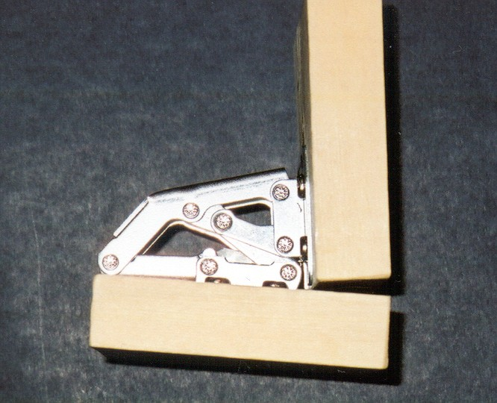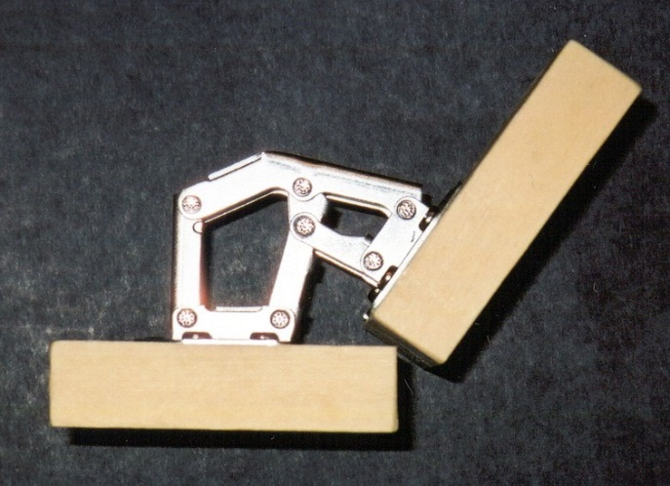
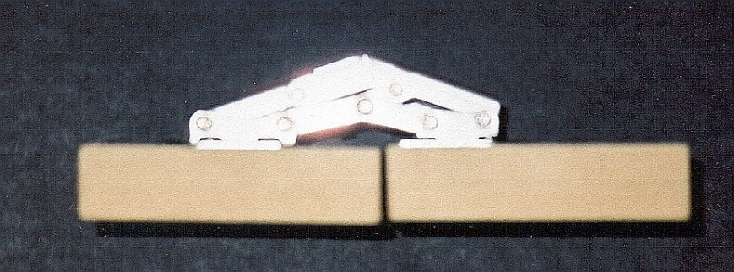

A

B

C
D

E

H

F

G
2
6
3
4
5
8
7
1
1

H

A

B

C
D

E

F

G
2
6
3
4
5
8
7
1
1
Note: Two revolutes between 1-7 and 1-6 exist at point H
A
B
C
D
E
F
H₁-₆
1
2
3
H₁₋₇
4
5
6
7
8
G
R
R
R
R
R
R
R
R
R
P

