Definitions

Kinematics – the study of constrained motion without regard to forces that cause that motion

Dynamics – the study of how forces cause motion

Causality – the relationship between cause and effect

Degrees-of-freedom (DOF) of motion – specific ways in which a rigid body or mechanical system may move

Kinematic joint – a connection between two rigid bodies that restricts specific DOF of motion in a reproducible manner

Dyad (kinematic pair) – a pair of rigid bodies connected by a kinematic joint

Kinematic chain (loop) – a sequence of dyads

Link – a rigid body in a kinematic chain

Binary link – a link with two joint connections

Ternary link - a link with three joint connections

Open kinematic chain (loop) – one that does not close back onto itself

Closed kinematic chain (loop) – one that does close back onto itself

Mechanism - a kinematic chain designed to transfer motion but not a significant amount of power

Machine - a kinematic chain designed to transfer power

Skeletal diagram – a succinct schematic drawing of a kinematic chain

Topology – connectivity analysis of a chain without regard to geometry

Mobility – DOF for a mechanism

Instant center - unique point at which two objects in general planar motion have the same velocity

Forward kinematics
a) given motion across internal joints
b) find motion of output links

Inverse kinematics
a) given motion of output links
b) find motion across internal joints

Forward dynamics
a) given external forcing functions acting on a system
b) find the resultant motion and internal forces

Inverse dynamics
a) given specified or measured motion of a system
b) find internal forces and external forcing functions required to cause that motion

Skeletal Diagrams

Use letters for points
Use numbers for links - number ground link as 1

Skeletal links represent geometry of joint connections but not actual shape

Binary link Ternary link

Planar J1 joint - allows 1 DOF, restricts 2 DOF

Revolute (R)

Prismatic (P)

V = r ω
Pure rolling with no slip

Planar J2 joint - allows 2 DOF, restricts 1 DOF

Pin-in-slot

Rolling with slip (similar to pin in slot)
V ≠ r ω
Single loop, closed chains
A
B
D
2
3
4

C
A
B
2
3
C
4

Four bar In-line slider crank
C
A
2
4
3
B
A
B
2
3
C
4

Offset slider crank Inverted slider crank

Single loop, open chain Two loop, closed chain
A
B
D
2
3
4

C
5
E
6
A
B
D
2
3
4

C

Human arm and hand Sewing machine
Robotic manipulator
Track hoe

Points may exist on several links simultaneously
B2
B3
B4
C
A
2
4
3
B

Mobility

5
3
4
C
C₅
5
3
C₃
4
C₄

2D mobility - Kutzbach (general), Grubler (only J1 joints)

nL = number of links, nJ1 = number of J1 joints, nJ2 = number of J2 joints

M = 3(nL-1) - 2 nJ1 - nJ2

nL=3, nJ1=3, M=0 nL=4, nJ1=4, M=1 nL=5, nJ1=5, M=2

Special geometry may allow additional DOF

nL=5, nJ1=6, M=0 nL=5, nJ1=6, M=0

Topology

Use blobs for links – intersections are joints - do not try to represent shape
R
R
R
P
B
C3,
C4
A
C1,
C4
2
4
3
1
R
R
B2,
B3
A
2

P
R
B3,
B4
C
4
3
1
R
R
R
R
B
C
A
D
2
4
3
1

Four-bar Slider crank Inverted slider crank

R
R
R
R
B
C3,C4
A
D
2
4
3
1
R
R
6
P
5
C4,C5
A
B
D
2
3
4

C
5
E
6

nL=6, nJ1=7, M=1

Connectivity

Use circle with one tick mark for each link – connections are joints
1
1
2
3
4
R
R
R
P
1
2
3
4
R
R
R
R

R
R
4
2
R
P

3
Four-bar Slider crank Inverted slider crank
A
B
D
2
3
4

C
5
E
6
1
2
3
4
R
P
R
R
5
6
R
R
R

nL=6, nJ1=7, M=1
Tracked Excavator

For the tracked excavator shown below, identify the number of links (nL), 1 DOF joints (nJ1), 2 DOF joints (nJ2) and mobility (M).
12 15 (12R,3P) 0 3
nL __________ nJ1 __________ nJ2 __________ M __________

Diagram the topology of this mechanism.

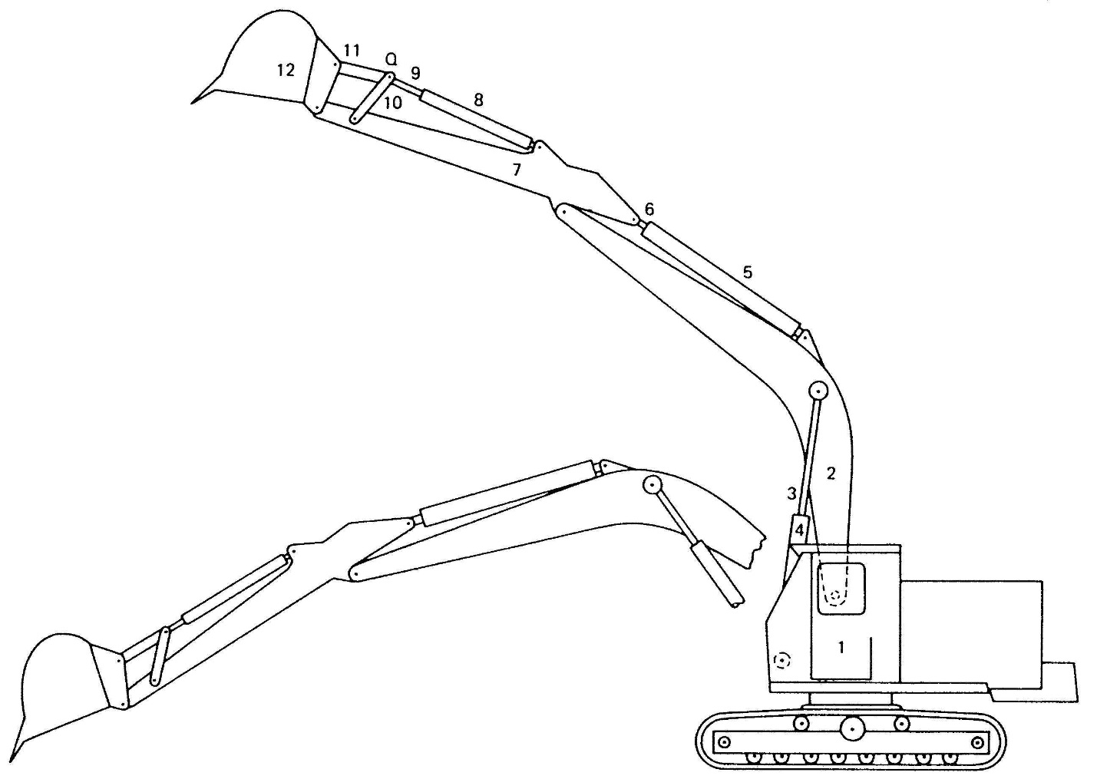
R
R
P
R
P
R
R
R
R
R
R
p
R
R
R
4
1
2
5
3
6
11
12
7
10
8
9

Wanzer Needle Bar

A Wanzer needle bar mechanism is shown below. Disk 2 has two orthogonal offset slots B and C that guide slider blocks 4 and 5. Fixed slot D guides slider block 6. The slider blocks are connected to rigid triangular link 3 at revolutes E, F and G. Link 3 translates and rotates. Disk 2 has pure rotation about fixed revolute A. Sliders 4 and 5 are long enough that they do not jam as they cross the intersection of slots B and C, and they are short enough that they do not collide.

Identify the number of links (nL), 1 DOF joints (nJ1), 2 DOF joints (nJ2) and mobility (M).
6 7 (4R,3P) 0 1
nL __________ nJ1 __________ nJ2 __________ M __________

Diagram the topology and connectivity of this mechanism.

R
R
P
P
R
5
F2,F5
3
4
F3,F5
E2,E4
E3,E4
2
G3,G6
6
P
R
1
G1,G6
A
E
F
A hidden under link 3
2
3
4
5
slot B
slot C
G
6
slot D

1
2
3
4
R
P
P
R
5
6
R
R
P

Grashof Criterion
Grashof's criterion provides a simple test to ascertain if an input link for a four bar mechanism can rotate freely through one complete revolution.
The sum of the shortest and longest links cannot be greater than the sum of the remaining links if there is to be continuous relative rotation between two links. If the above condition is not met then only rocking motion would be possible for any link
Four inversions of a four bar linkage are shown below.Grashof's law states that one of the links (generally the shortest link) will be able to rotate continuously if the following condition is met...
b (shortest link ) + c(longest link) < a + d
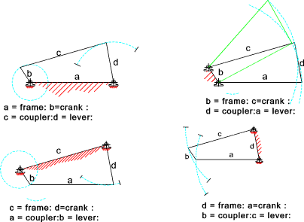
Driver Dyad for Fixed Excursion of a Pivoted Link
with a Grashof Crank-Rocker

D
4
C₂
C₁
θ₁
θ₂
y
x

Place a local coordinate frame at the pivot for the link. Select point C along the link and compute local locations C1 and C2 for each given limit position θ1 and θ2. Angular excursion (θ2-θ1) must be less than 180°. Compute displacement {d} of point C and unit direction .
D
4
C₂
C₁
y
x
{d}

Use the link as the output rocker of a Grashof crank rocker four bar mechanism. Crank center A will fall along the line joining C1 and C2. Crank length R will be one-half displacement d. Any length L for the coupler BC may be selected as long as it satisfies the Grashof criterion. Typically L = CD + R work wells. Crank center A may be placed on either side of the link.
D
4
C₂
y
x
B
A
R
L
D
4
C₁
y
x
B
A
R
L

D
4
C₂
y
x
B
A
R
L
D
4
C₁
y
x
B
A
R
L

