**Finite Center of Rotation**

**Instantaneous Center of Rotation**

**Instantaneous Centers**

Instant center - unique point at which two objects in general planar motion have the same velocity

Absolute center – instant center between an object and ground

Relative center – instant center between two moving objects

Velocity of a point – tangent to the path of the point, perpendicular to the line that joins the point and the relative instant center of rotation

Kennedy-Aronhold theorem – relative instant centers between three bodies are collinear

J1 joints define instant centers

7

1

5

3

4

6

2,3

2

1,4

1

1,7 at ∞

5,6 at ∞

no slip

V = r 

8

1

1,8

1,2 and 2,3 are collinear with 1,3

1,4 and 3,4 are collinear with 1,3

1,2 and 1,4 are collinear with 2,4

A

B

D

2

3

4

C

1,3

2,4

2,3 and 3,4 are collinear with 2,4

1

2

3

4

from J1 joints

by Kennedy-Aronhold

**Velocity Transfer**

2

3

Q ≡ 2,4

P ≡ 1,3

A

B

D

4

C

2

P ≡ 1,3

A

B2

VB2

B3

VB3

2

3

D

4

C3

C4

VC4

VC3

4

VB2 = 2 (AB)

VB2 = VB3

VB3 = 3 (BP)

VC3 = 3 (CP)

VC3 = VC4

VC4 = 4 (CD)

2

Q ≡ 2,4

A

B

D

4

C

2

4

VQ2 = VQ4

VQ2 = 2 (AQ)

VQ2 = VQ4

VQ4 = 4 (DQ)

r1 = AD r2 = AB r3 = BC r4 = CD

P ≡ 1,3

D

4

C

3

B

2

q2

A

q3

g

q3

q4-q2

p-g

Q ≡ 2,4

q4

q2-q3



triangle PBC









Note: will not provide correct ± signs for CW and CCW

triangle QDC



R = AB L = BC s = AC

3

2

B

# C

4



❑

2,3

3,4

P ≡ 1,3

p/2-

Q ≡ 2,4

1,2

A

1

1

1,4 at ∞

1,4 at ∞

q+f

p/2-f



VB2 = 2 (AB)

VB2 = VB3

VB3 = 3 (BP)

VC3 = 3 (CP)

VC3 = VC4

VQ2 = 2 (AQ)

VQ2 = VQ4

VQ4 = VC4

triangle PBC









Note: will not provide correct ± signs for CW and CCW

triangle QAC





**Sewing Machine**

Determine the angular velocity of links 2, 3, 4 and 5 as well as the velocity of needle 6 for the sewing machine linkage as shown below when sewing at 4 stitches per second constant speed.

3,4 at C

1,4 at D

1

2

4

3

6

5

C

D

**Q** ≡ 4,6

62.7°

4

4,5 at E

E

1,2 and 1,4 intersect 2,4 ≡ P

2,3 and 3,4

1,6 and 1,4 intersect 4,6 ≡ Q

4,5 and 5,6

1,2 and 1,6 intersect 2,6 ≡ R

2,4 and 4,6

3

32.7°

**P** ≡ 2,4

5

2,3 at B

constant

2

AB = 1.60 cm

BC = 3.57 cm

DC = 2.24 cm

CE = 1.60 cm

DE = 2.74 cm

EF = 3.81 cm

AG = 1.42 cm

DG = 3.81 cm

DCE = 90 deg

CDE = 35.7 deg

B

45°

15.4°

2

AG = 1.15 inch on page = 1.42 cm actual

AR = 2.10 inch on page = 2.59 cm actual

AP = 1.64 inch on page = 2.00 cm actual

DP = 1.76 inch on page = 2.17 cm actual

DQ = 2.36 inch on page = 2.88 cm actual

G

**R** ≡ 2,6

A

1,2 at A

F

1,6 at ∞

6

5,6 at F

R

A

2

VR2

2 = 8  rad/s CCW

VR2 = 2 (AR) = 65.09 cps

VR2 = VR6

VR6 = VF6

P

D

2

VP2 = VP2

4

D

O2

4

Q

VQ4

VP2 = 2 (AP) = 50.27 cps

VP2 = VP4

VP4 = 4 (DP) 4 = 23.16 rad/s CW

VQ4 = 4 (DQ) = 66.71 cps

VQ4 = VQ6

VQ6 = VF6

(2.4 % different from complex numbers)

**Rigid Body**

Determine the velocity of point C on rigid body link 3. The rigid body and the velocity vectors are drawn to scale. Link 3 is NOT pinned to the ground. Show your work.

C

IC1,3 = P

Xc = 27 mm

Yc = 121 mm

3

VB3 = 5.7 cm/sec

dir for VC3

20º

B

XB = 90 mm

YB = 80 mm

3

XA = 43 mm

YA = 56 mm

A

25º

VA3 = 9.2 cm/sec

define P at IC1,3 VA3 ┴ AP VB3 ┴ BP VC3 ┴ CP

measurements AP = 73.7 mm BP = 45.8 mm CP = 47.5 mm 182º

VA3 = 3 (AP) 3 = 1.253 rad/sec CCW

VB3 = 3 (BP) 3 = 1.244 rad/sec CCW

use 3 = 1.249 rad/sec CCW average

VC3 = 3 (CP) = 59.3 mmps 272º

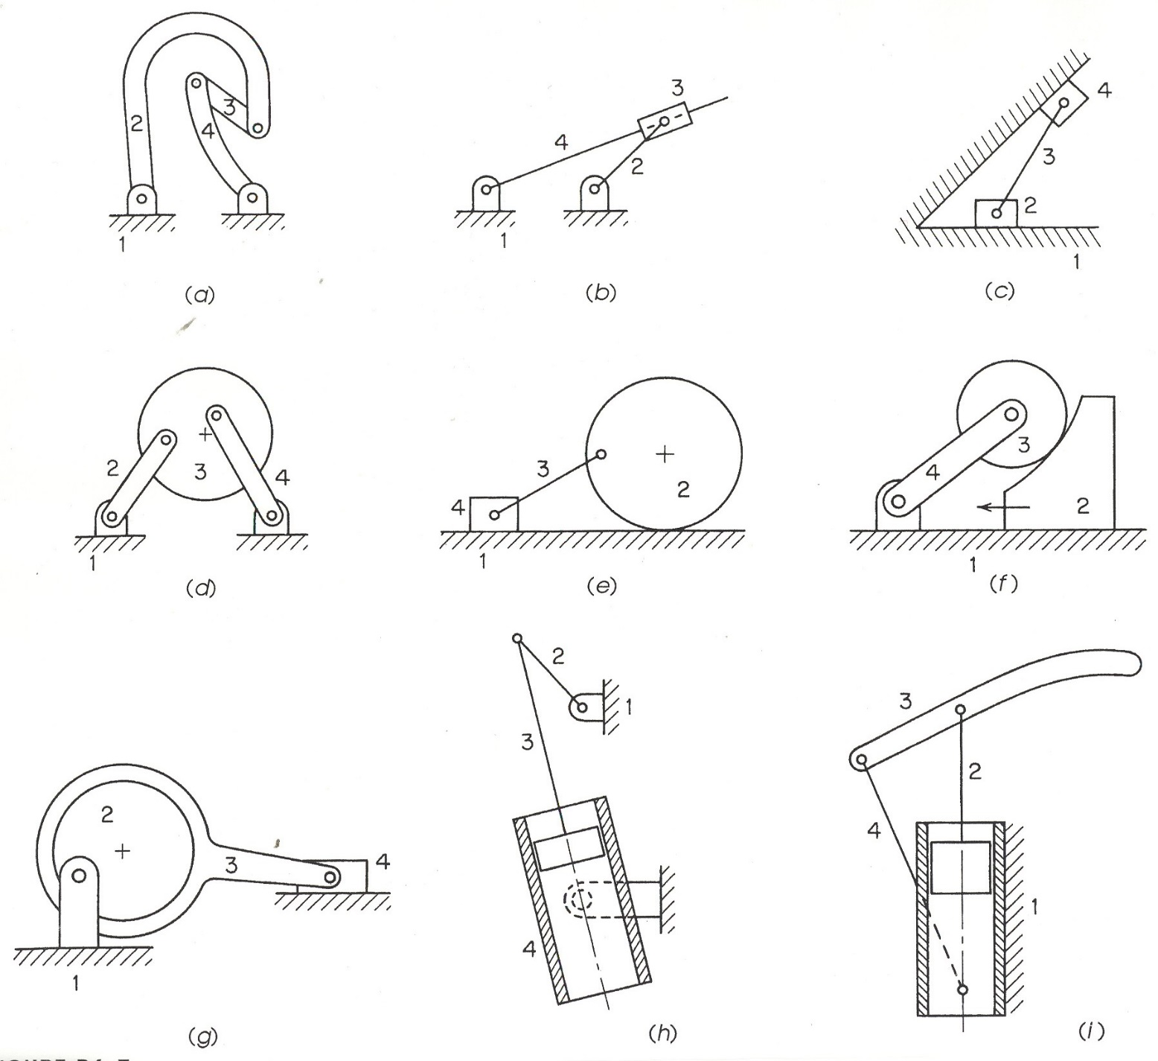

Norton

**Design of Machinery**

3rd edition

Figure P6-7

Problem 6-14

4

3

1

2

1,2

2,3

3,4

1,3

2,4

1,4

1,4

1,2

at ∞

2,4

see below

3,4

at ∞

1,2

2,3

3,4

1,3

2,4

1,4

1,2

2,3

1,3

2,4

1,4

2,3

3,4

1,3

1,2

2,3

3,4

1,3

2,4

1,4

2,3

3,4

1,3

2,4

2,3

3,4

1,3

1,4

1,2

2,3

3,4

1,3

2,4

2,3

3,4

1,3

1,2

2,3

1,3

2,4

1,4

3,4

at ∞

1,2

at ∞

1,4

at ∞

2,4

at ∞

1,2

1,4

at ∞

1,2

at ∞

1,4

at ∞

1,2

at ∞

1,4

at ∞

1,4

at ∞

3,4

at ∞

3,4

at ∞

1,2

at ∞

2,4

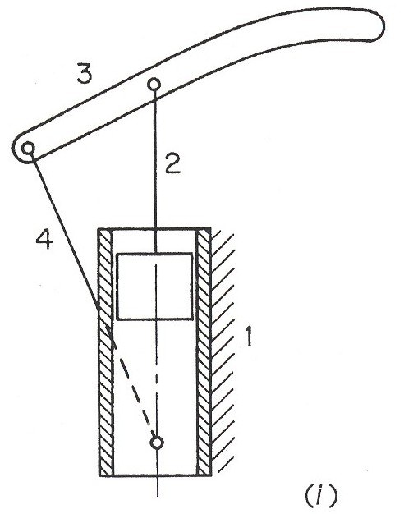

2,3

3,4

1,3

2,4

1,4

1,2

at ∞

4

3

1

2

1,2

at ∞

1,4

**Centrodes of Four Bar**

**2**

**3**

**4**

**Instantaneous Screw Axes**

**ISA1,4**

**ISA1,3**

**ISA1,2**

**Knee ACL and PCL**

