**Instantaneous Screw Axis (ISA)**















ISA



**Finite Screw Axis (Finite Helical Axis - FHA)**

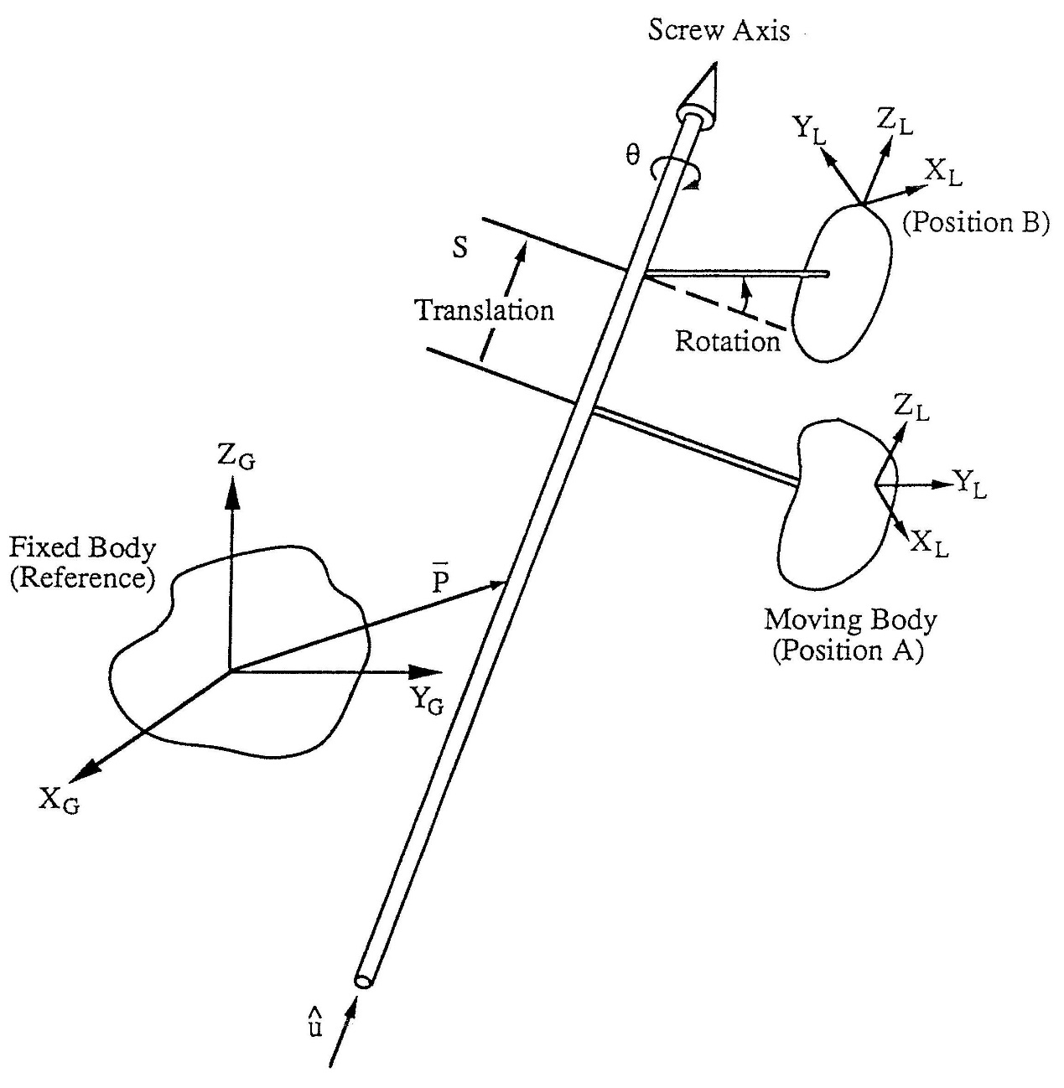

**Three-Dimensional Kennedy-Aronholdt Theroem**

ISAs between three bodies share a common perpendicular

**Axode**

