**Vehicle Inertial Measurements**

SAE J182 - Motor Vehicle Fiducial Marks and Three-Dimensional Reference System

SAE J1100 - Motor Vehicle Dimensions

**roll**

**Y**

**A**

**pitch**

**X**

**Z**

**yaw**

**F**

**L**

**R**

+X forward

+Y right

+Z down

+roll, right moves down

+pitch, front moves up

+yaw, front moves right

F = front

A = aft

L = left

R = right

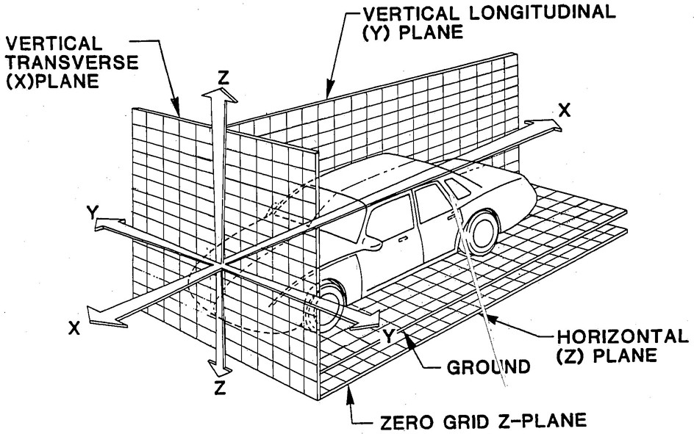

**Scales Method**

#### ISO 10392 - Road vehicles - Determination of centre of gravity

#### ISO 789-6 - Agricultural tractors - Test procedures - Part 6: Centre of gravity

#### ISO 612 - Dimensions of motor vehicles and towed vehicles - Terms and definitions

### ISO 3833 - Road vehicles - Types - Terms and definitions

#### ISO 8855 - Road vehicles - Vehicle dynamics and road-holding ability - Vocabulary

Measure the force under each tire with the vehicle level using wheel scales or a platform scale. The transmission should be in neutral with brakes off

W = FRF + FLF + FRA + FLA

FF = FRF + FLF FA = FRA + FLA FR = FRF + FRA FL = FLF + FLA

Measure l = wheelbase

zCG



xCG

**FA**

**FF**

measured forward from rear axle

*l*

Measure b = tread



zCG

measured to right from centerline

yCG

**FR**

**FL**

b

rSTATIC

dTIRE

hTIRE

Measure r STATIC = h TIRE – d TIRE / 2

Suspend aft of vehicle or place rear tires onto blocks at angle  greater than 15° with transmission in neutral and brakes off

Measure the force FF’ under the front tires. Repeat for several different angles.

**FF’**

****



measured up from ground

**FF’**

****

**W**

xCG

a

**FA’**

**M about rear axle CCW+**





 

HMMWV-M1025 m = 5960 lbm = 185.2 slug

Jxx = 1750 slug.ft2, Jyy = Jzz = 3500 slug.ft2 kxx = 3.07 ft, kyy = kzz = 4.35 ft

**Tilt Table Method**

## ISO 16333 - Heavy commercial vehicles and buses - Steady-state rollover threshold - Tilt-table test method

SAE J2180 - Tilt Table Procedure for Measuring the Static Rollover Threshold for Heavy Trucks

<http://www.natc-ht.com/PDF/tilt.pdf>

zCG

(b + wTIRE) / 2



for small yCG 



STATIC



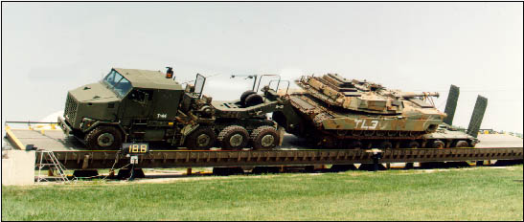

**Inertial Properties of American Vehicles**

x forward - y right - z down Jxx roll – Jyy pitch – Jzz yaw

|  |  |  |  |  |  |  |  |  |
| --- | --- | --- | --- | --- | --- | --- | --- | --- |
|  |  |  |  | Front |  |  |  |  |
| Vehicle Class | Sprung | Wheel | Track | Axle | CG | Jxx | Jyy | Jzz |
|  | Mass | Base | Width | to CG | Height |  |  |  |
|  | [kg] | [m] | [m] | [m] | [m] | [kg.m2] | [kg.m2] | [kg.m2] |
| Passenger Small | 969.0 | 2.524 | 1.446 | 1.021 | 0.519 | 392.6 | 1632.2 | 1798.8 |
| Passenger Large | 1403.0 | 2.679 | 1.468 | 1.277 | 0.585 | 632.3 | 2749.7 | 2893.3 |
| Pickup Small | 1409.4 | 2.948 | 1.424 | 1.396 | 0.620 | 571.3 | 3142.8 | 3326.3 |
| Pickup Large | 1885.8 | 3.425 | 1.619 | 1.581 | 0.684 | 940.5 | 5344.0 | 5642.3 |
| SUV Small | 1718.5 | 2.683 | 1.496 | 1.350 | 0.688 | 803.3 | 3367.0 | 3522.2 |
| SUV Large | 2251.1 | 3.032 | 1.579 | 1.628 | 0.767 | 1157.3 | 5960.8 | 6111.0 |
| Van | 1847.5 | 2.947 | 1.589 | 1.480 | 0.698 | 992.3 | 4410.7 | 4617.8 |

Jyy ≈ Jzz ≈ 5 Jxx 4.15 ≤ Jyy/ Jxx ≤ 5.68 4.38 ≤ Jzz/ Jxx ≤ 6.00

Heydinger GJ, Bixel RA, Garrott WR, Pyne M, Howe JG, Guenther DA

(1999) Measured Vehicle Inertial Parameters - NHTSA's Data Through November 1998

SAE 1999-01-1336

