**Two-mass Equivalent Link**

B

C

G3

m3 JG3

B

C

G3

m3B

m3C

total mass 

centroid location 

check approximate mass moment 

(for slender rod )

**Shaking Force for Slider Crank**

1

1

2

3

4

A=G2

B



❑

**P**

**T12**

G3

C

m3B

m3C+m4

mBAL

assume crank is statically balanced G2 = A constant crank speed 

split link 3 into m3B and m3C assume  is small

Case I - static force analysis for only d’Alembert inertial force P with no friction





Case II - static force analysis for only inertial force 



Case III - place additional counterbalance mBAL on the crank at radius R and 180º from pin B

Superposition = Case I + Case II + Case III











**Model 1 – no additional balancing mass**

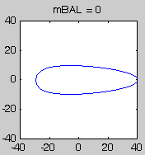

mBAL = 0

**Model 2 – unidirectional in-line shaking force**

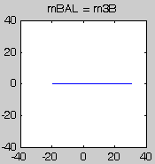





**Model 3 – minimize the maximum magnitude of shaking force (approximate)**

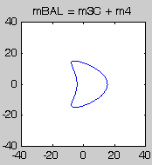



**Model 4 – minimize in-line shaking force (approximate)**

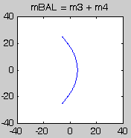







% shake.m - single cylinder shaking force Notes_08_04

% HJSIII, 13.03.14

clear

% constants

d2r = pi / 180;

% geometry [inches]

R = 0.985;

L = 4.33;

% crank speed [rad/sec]

w = 104.719;

% masses [lbm]

m3B = 0.351;

m3C = 0.111;

m4 = 0.781;

% crank angle

th_deg = (0:360)';

th = th_deg * d2r;

% piston acceleration [inch/s/s]

sdd = -R*w*w*(cos(th) +R*cos(2*th)/L);

% plot four models

figure( 1 )

clf

res = [];

%%%%%%%%%%%%%%%%%%%%%%%%%%%%%%%%%%%%%%%%%%%%%%%%%%%%%%%%

% Model 1 - mBAL = 0

subplot( 2,2,1 )

mBAL = 0;

% shaking force [lbm.in/s/s] * [lbf*s*s / 32.174 lbm.ft] * [ ft / 12 in ]

Fx = ( (m3B-mBAL)*R*w*w*cos(th) - (m3C+m4)*sdd ) / 386; % [lbf]

Fy = ( (m3B-mBAL)*R*w*w*sin(th) ) / 386;

Fs = sqrt( Fx.*Fx + Fy.*Fy );

Fs_max = max( Fs );

res = [ res ; mBAL Fs_max ];

% plot shaking force curve

plot( Fx, Fy )

axis square

axis( [ -40 40 -40 40 ] )

title( 'mBAL = 0' )

%%%%%%%%%%%%%%%%%%%%%%%%%%%%%%%%%%%%%%%%%%%%%%%%%%%%%%%%

% Model 2 - mBAL = m3B

subplot( 2,2,2 )

mBAL = m3B;

% shaking force [lbm.in/s/s] * [lbf*s*s / 32.174 lbm.ft] * [ ft / 12 in ]

Fx = ( (m3B-mBAL)*R*w*w*cos(th) - (m3C+m4)*sdd ) / 386; % [lbf]

Fy = ( (m3B-mBAL)*R*w*w*sin(th) ) / 386;

Fs = sqrt( Fx.*Fx + Fy.*Fy );

Fs_max = max( Fs );

res = [ res ; mBAL Fs_max ];

% plot shaking force curve

plot( Fx, Fy )

axis square

axis( [ -40 40 -40 40 ] )

title( 'mBAL = m3B' )

%%%%%%%%%%%%%%%%%%%%%%%%%%%%%%%%%%%%%%%%%%%%%%%%%%%%%%%%

% Model 3 - mBAL = m3C + m4

subplot( 2,2,3 )

mBAL = m3C + m4;

% shaking force [lbm.in/s/s] * [lbf*s*s / 32.174 lbm.ft] * [ ft / 12 in ]

Fx = ( (m3B-mBAL)*R*w*w*cos(th) - (m3C+m4)*sdd ) / 386; % [lbf]

Fy = ( (m3B-mBAL)*R*w*w*sin(th) ) / 386;

Fs = sqrt( Fx.*Fx + Fy.*Fy );

Fs_max = max( Fs );

res = [ res ; mBAL Fs_max ];

% plot shaking force curve

plot( Fx, Fy )

axis square

axis( [ -40 40 -40 40 ] )

title( 'mBAL = m3C + m4' )

%%%%%%%%%%%%%%%%%%%%%%%%%%%%%%%%%%%%%%%%%%%%%%%%%%%%%%%%

% Model 4 - mBAL = m3 + m4

subplot( 2,2,4 )

mBAL = m3B + m3C + m4;

% shaking force [lbm.in/s/s] * [lbf*s*s / 32.174 lbm.ft] * [ ft / 12 in ]

Fx = ( (m3B-mBAL)*R*w*w*cos(th) - (m3C+m4)*sdd ) / 386; % [lbf]

Fy = ( (m3B-mBAL)*R*w*w*sin(th) ) / 386;

Fs = sqrt( Fx.*Fx + Fy.*Fy );

Fs_max = max( Fs );

res = [ res ; mBAL Fs_max ];

% plot shaking force curve

plot( Fx, Fy )

axis square

axis( [ -40 40 -40 40 ] )

title( 'mBAL = m3 + m4' )

%%%%%%%%%%%%%%%%%%%%%%%%%%%%%%%%%%%%%%%%%%%%%%%%%%%%%%%%

% plot maximum shaking force versus balancing mass

keep = [];

for mBAL = 0 : 0.01 : (m3B+m3C+m4),

% shaking force [lbm.in/s/s] * [lbf*s*s / 32.174 lbm.ft] * [ ft / 12 in ]

Fx = ( (m3B-mBAL)*R*w*w*cos(th) - (m3C+m4)*sdd ) / 386; % [lbf]

Fy = ( (m3B-mBAL)*R*w*w*sin(th) ) / 386;

Fs = sqrt( Fx.*Fx + Fy.*Fy );

Fs_max = max( Fs );

keep = [ keep ; mBAL Fs_max ];

end

% plot results

figure( 2 )

clf

plot( keep(:,1),keep(:,2),'b', res(:,1),res(:,2),'ro' )

axis( [ 0 1.4 0 45 ] )

xlabel( 'Balancing mass [lbm]' )

ylabel( 'Maximum shaking force [lbf]' )

% bottom of shake

**Model 5 – minimize the maximum magnitude of shaking force (exact) does not work ?????**



















% model5.m - min/max shaking force for slider crank

% does not work ???????????????

% HJSIII, 13.03.14

clear

% geometry [inches]

R = 0.985;

L = 4.33;

% masses [lbm]

m3B = 0.351;

m3C = 0.111;

m4 = 0.781;

% cosine solution

rho = R / L;

c1 = (-1 + sqrt( 1 + 6*rho*rho ) ) /6 /rho;

c2 = (-1 - sqrt( 1 + 6*rho*rho ) ) /6 /rho;

% values

v1 = 2*rho*c1*c1*c1 + c1*c1 - rho*c1;

v2 = 2*rho*c2*c2*c2 + c2*c2 - rho*c2;

% balancing masses

mBAL1 = m3B + (m3C+m4)*v1

mBAL2 = m3B + (m3C+m4)*v2

**Shaking Force for In-line Two Cylinder Air Compressor**

A = G2

B

C

D

E

y in

z

x

a

x

B

  

D   + 180°

C

y

D

E

A = G2

z out

same crank, connecting rods

and pistons

only ABC 

both 



both 

shaking moments 

**In-line Four Cylinder Engine**

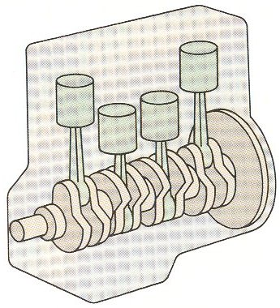

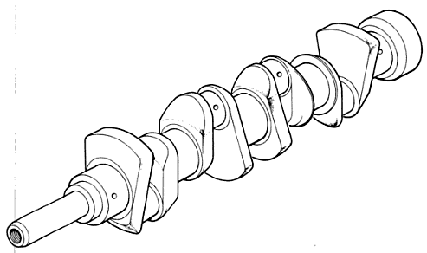

**Shaking Force for In-line Four Cylinder Engine**

x

1,4

C

y

2,3

E

A = G2

z out

2

x

1

4

3

y in

z

same crank, connecting rods

and pistons



same as two two-cylinder compressors mirrored end to end



shaking moments 

**In-line Six Cylinder Engine**

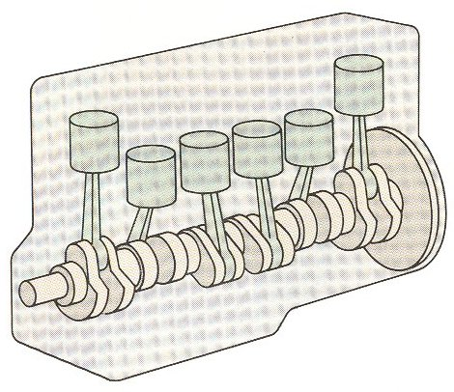

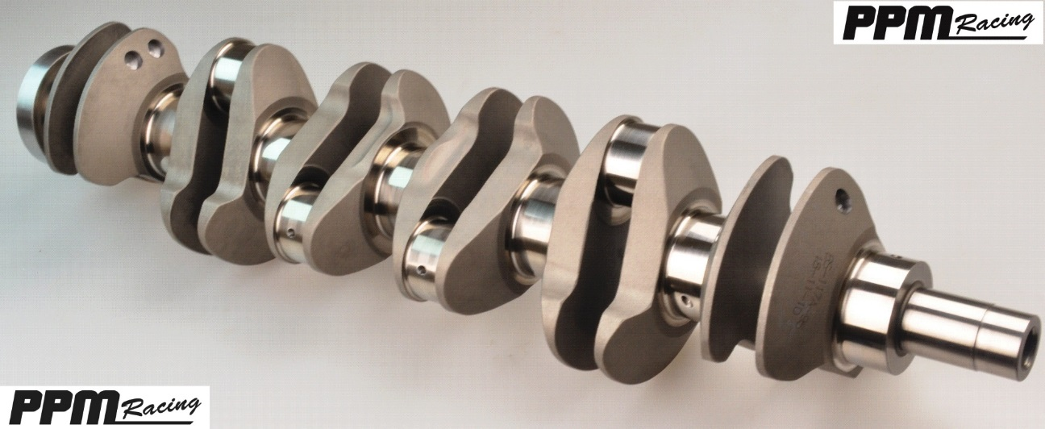

**Shaking Force for In-line Six Cylinder Engine**

x

1,6

y

A = G2

z out

2,5

3,4

x

y in

same crank, connecting rods

and pistons

z

6

5

4

3

2

1







**V8 separate cranks**

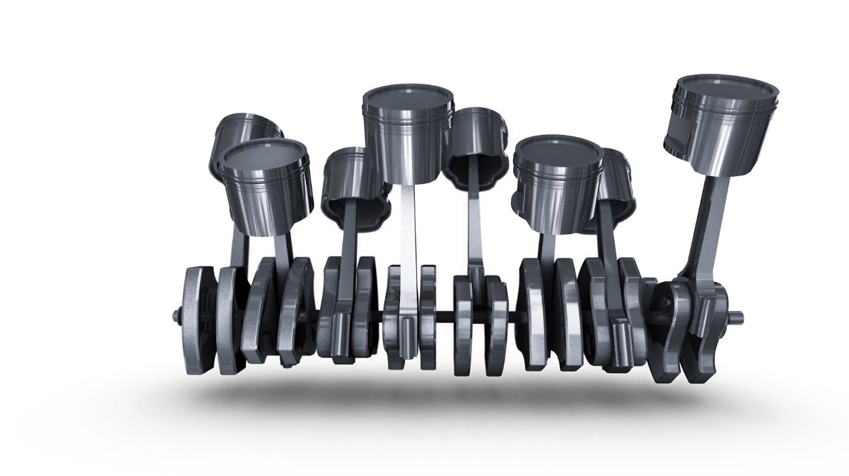

**V8 dual cranks**

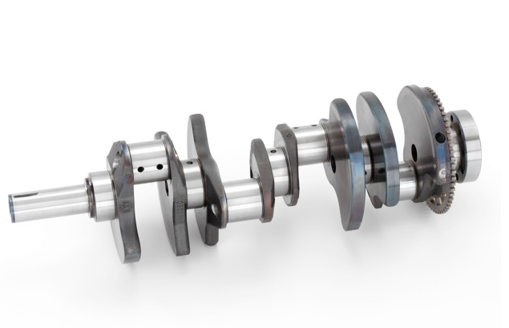

**V8 split cranks**

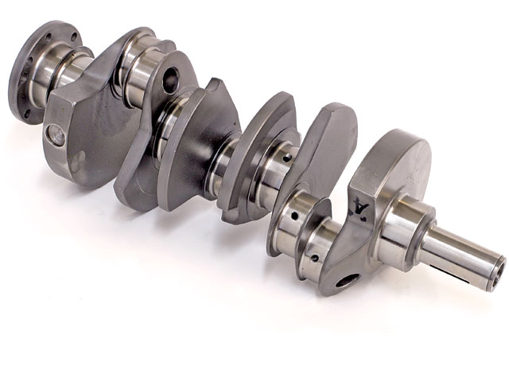

**V8 with pistons**

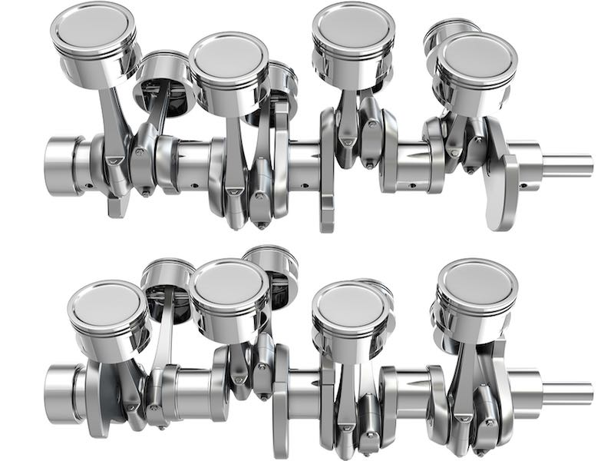

**Shaking Force for Four Bar**

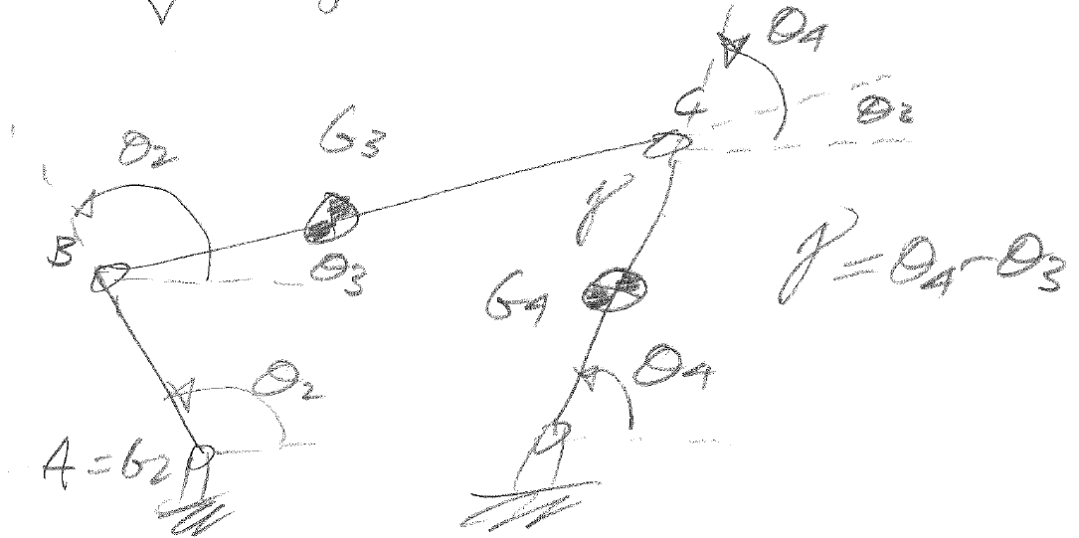

assume crank is statically balanced G2 = A

split link 3 into m3B and m3C assume  is small link 3 becomes two-force member

static force analysis with d’Alembert inertial forces

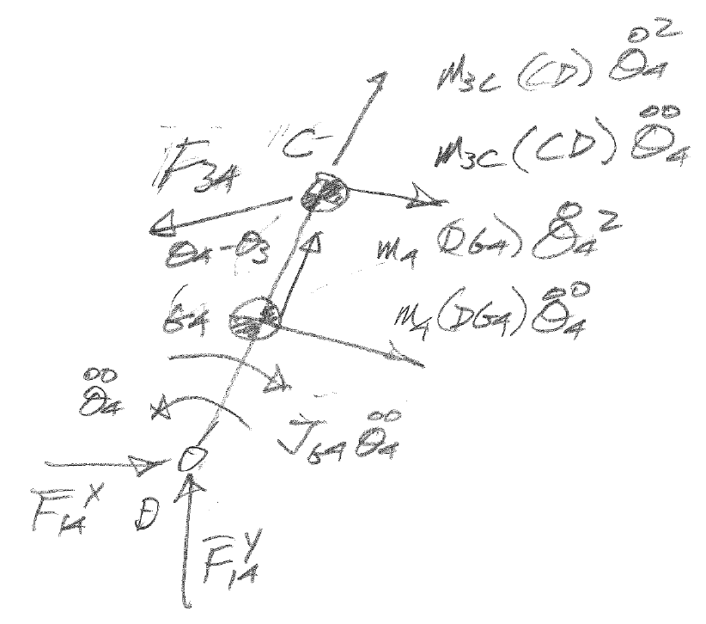

**M on 4 about D CCW +** 



# 

# 

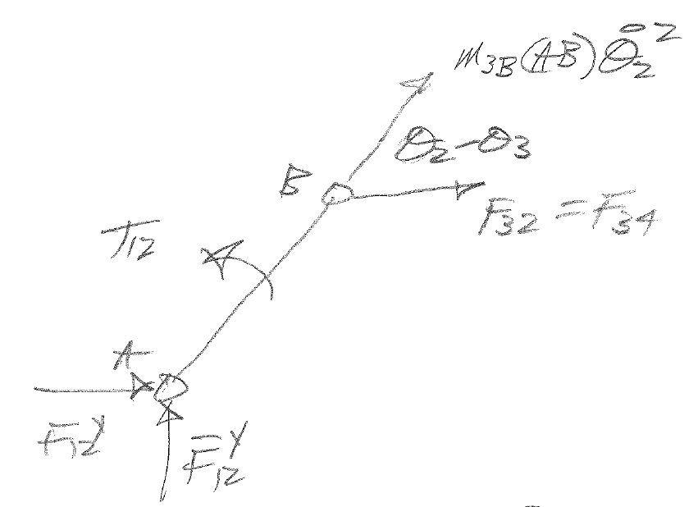



**M on 2 about A CCW +** 



 from Notes_03_02

 from Notes_03_02







