Three-Dimensional Constraints

**General**















**Scleronomic constraints**

independent of time such as mechanical joints







use same  for both  and  solutions

must use  for  and different  for  solutions

must use  for  and different  for  solutions

**Spherical**













  version

  version



  version









**Double spherical**











  version

  version

  version









**Dot-1**











  version

  version

  version









**Dot-2**











  version

  version

  version









**Euler parameters**









  version

**Fixed revolute rotation driver (angle  about fixed axis [u v w ]T)**





recommend dot products to get  four-quadrant

or  or  or 







  version

  version





**3D relative distance driver (see double spherical)**









  version

**Dot-2 distance driver (see dot-2)**









  version

**General revolute rotation driver**

  version

**Screw distance-angle (see dot-2 and revolute rotation driver)**





Local Joint Definition Frames

do not need secondary joint frames for spherical (S) and double spherical (S-S)

**need secondary joint frames** if axes of constraints for universal U, revolute R, cylindrical C, prismatic P, or helical (screw) H **are not parallel** to local body-fixed direction

xi'

yi'

zi'

i

xi'

yi'

zi'

i

zPi''

yPi''

xPi''

Pi

Qi

Ri











Three-Dimensional Joint Constraints

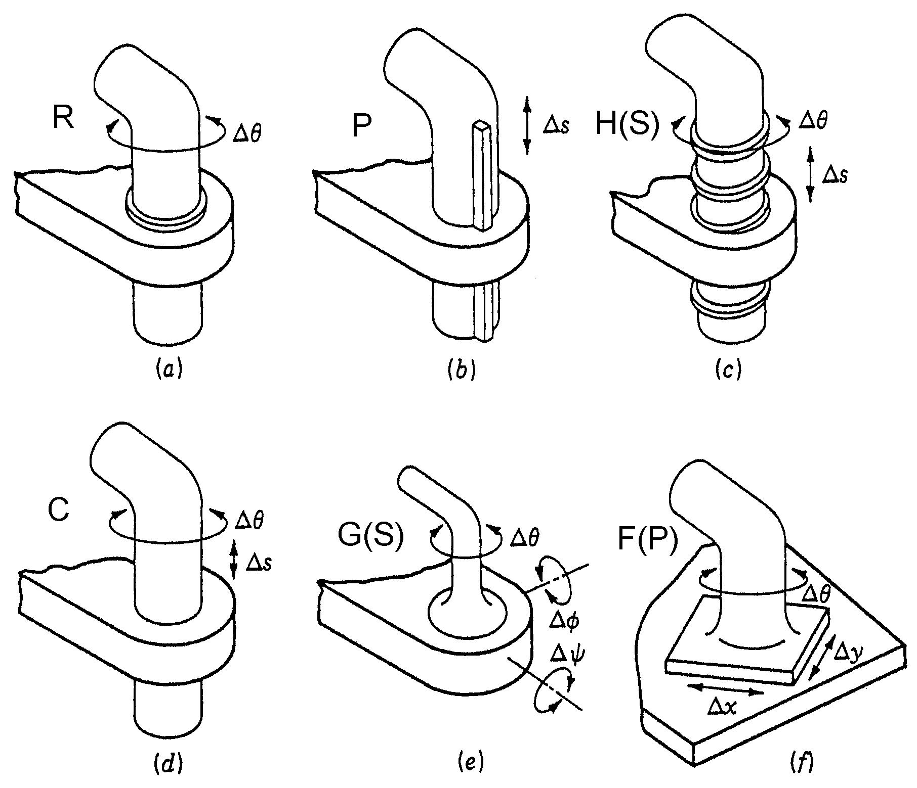

Restricts Allows

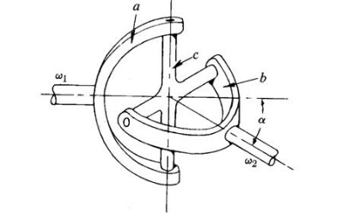Revolute R 5 1

Prismatic P 5 1

Helical (Screw) H(S) 5 1

Cylindrical C 4 2

Universal (Hooke) U(H) 4 2

Globe (Spherical) G(S) 3 3

Flat (Planar) F(P) 3 3

3D mobility

M = 6 nML - 5 nJ1 - 4 nJ2 - 3 nJ3

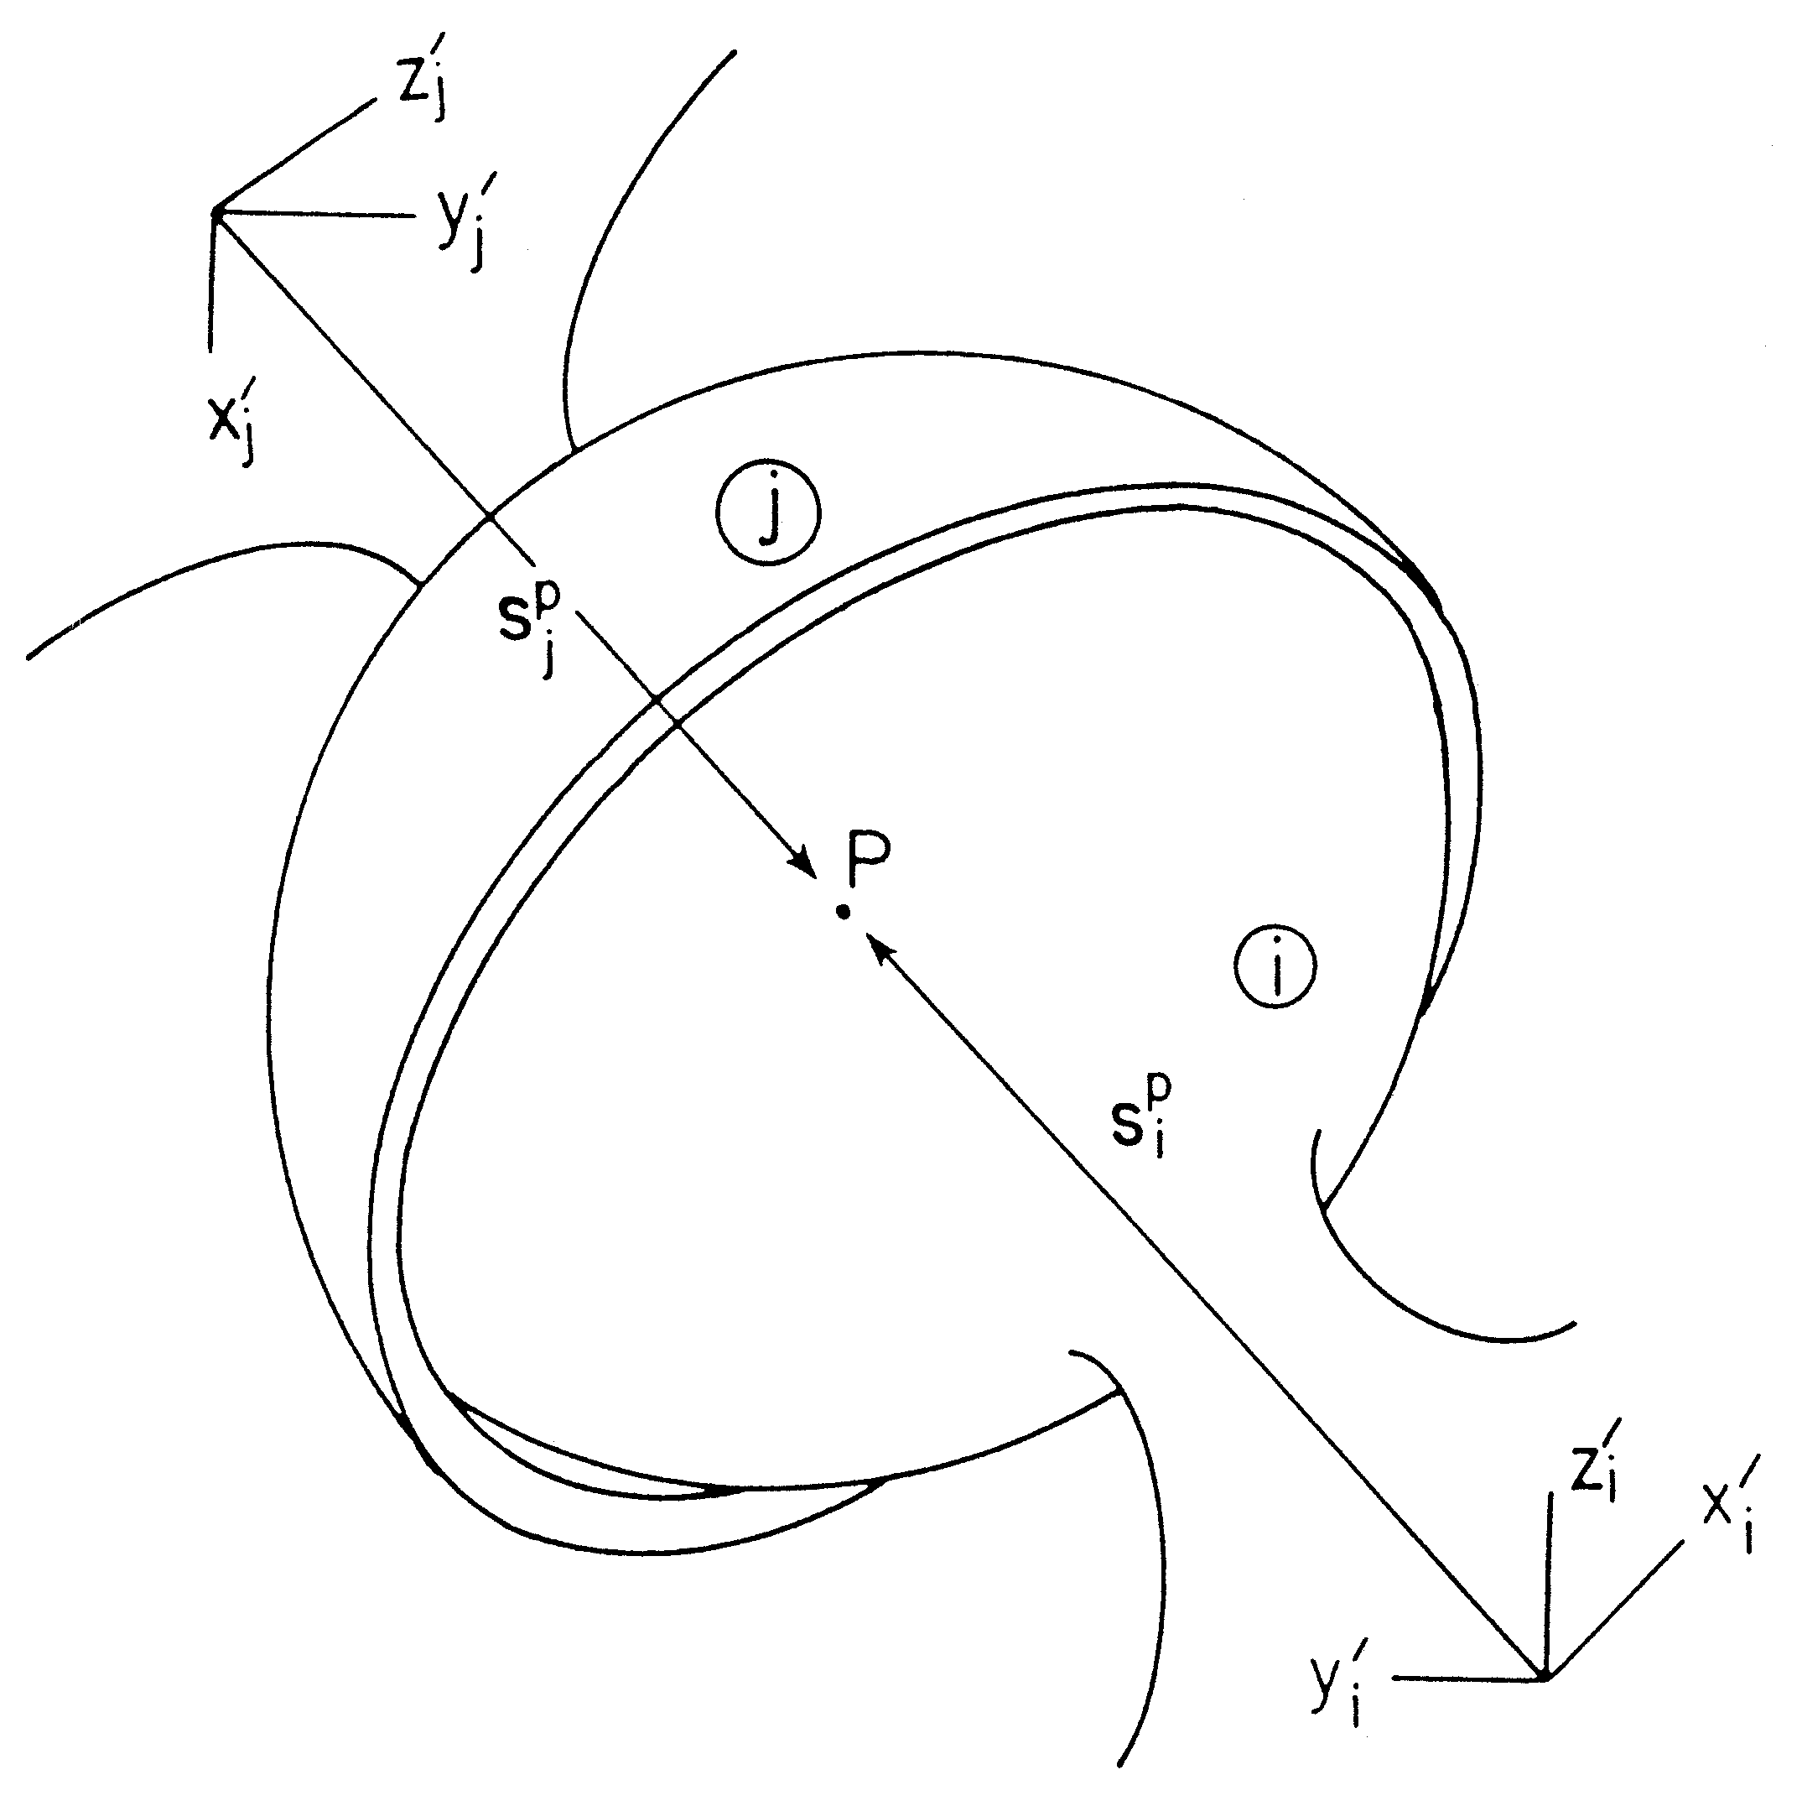

Spherical S (Globe G)

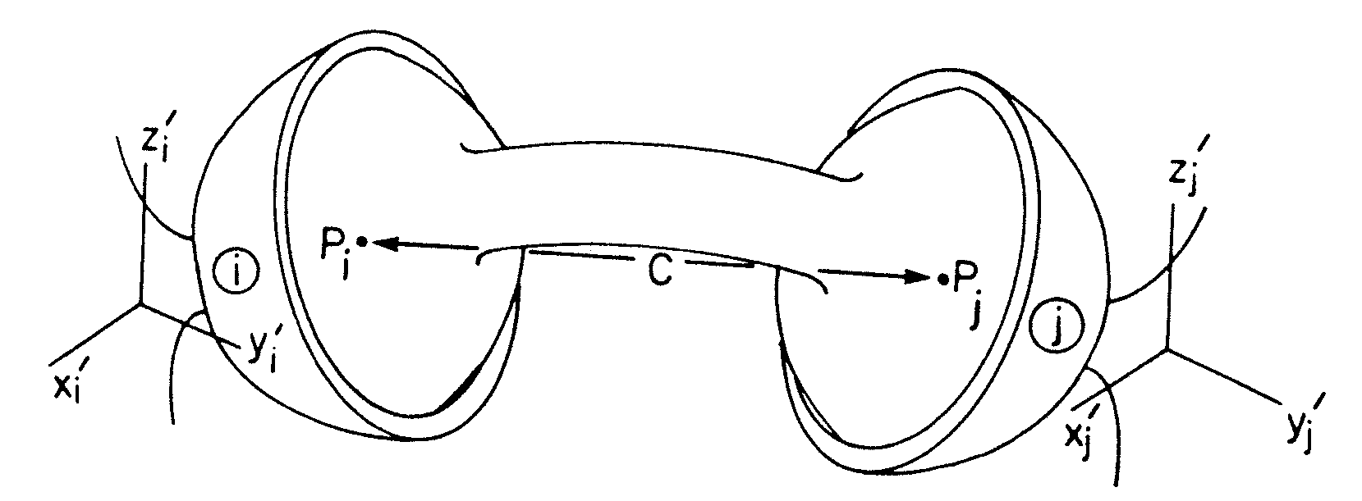

Double Spherical SS

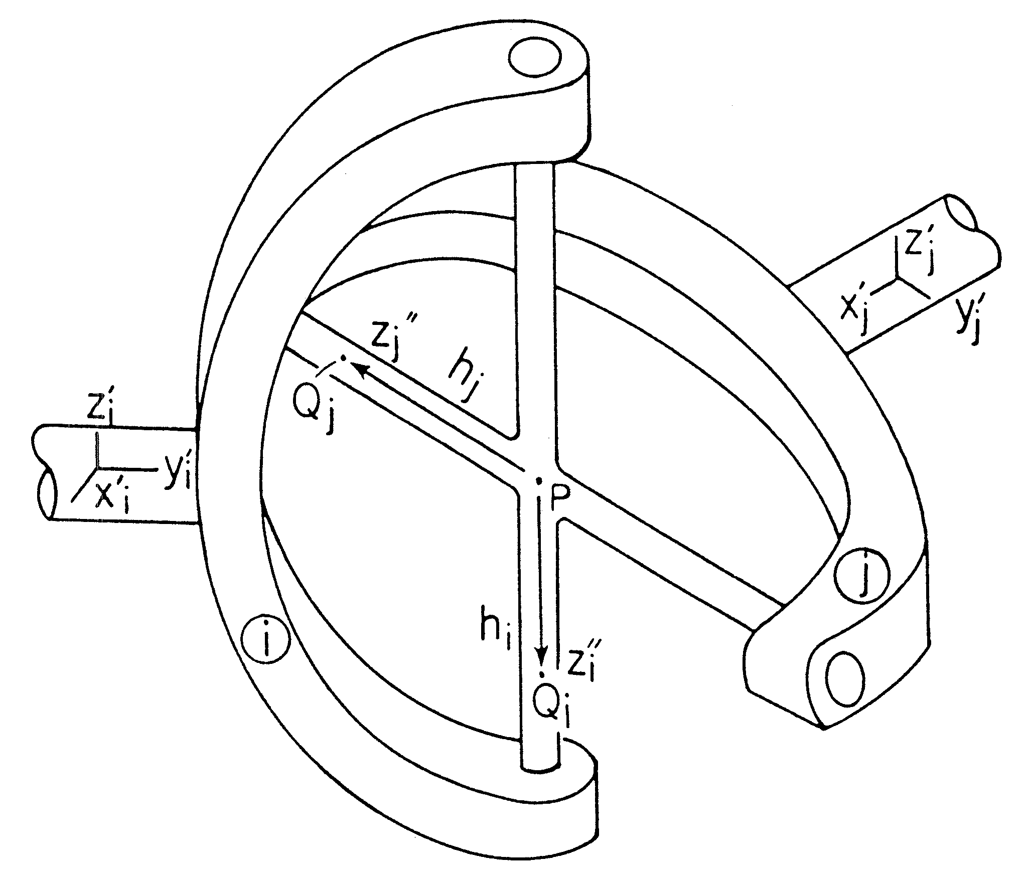

Universal U (Hooke H)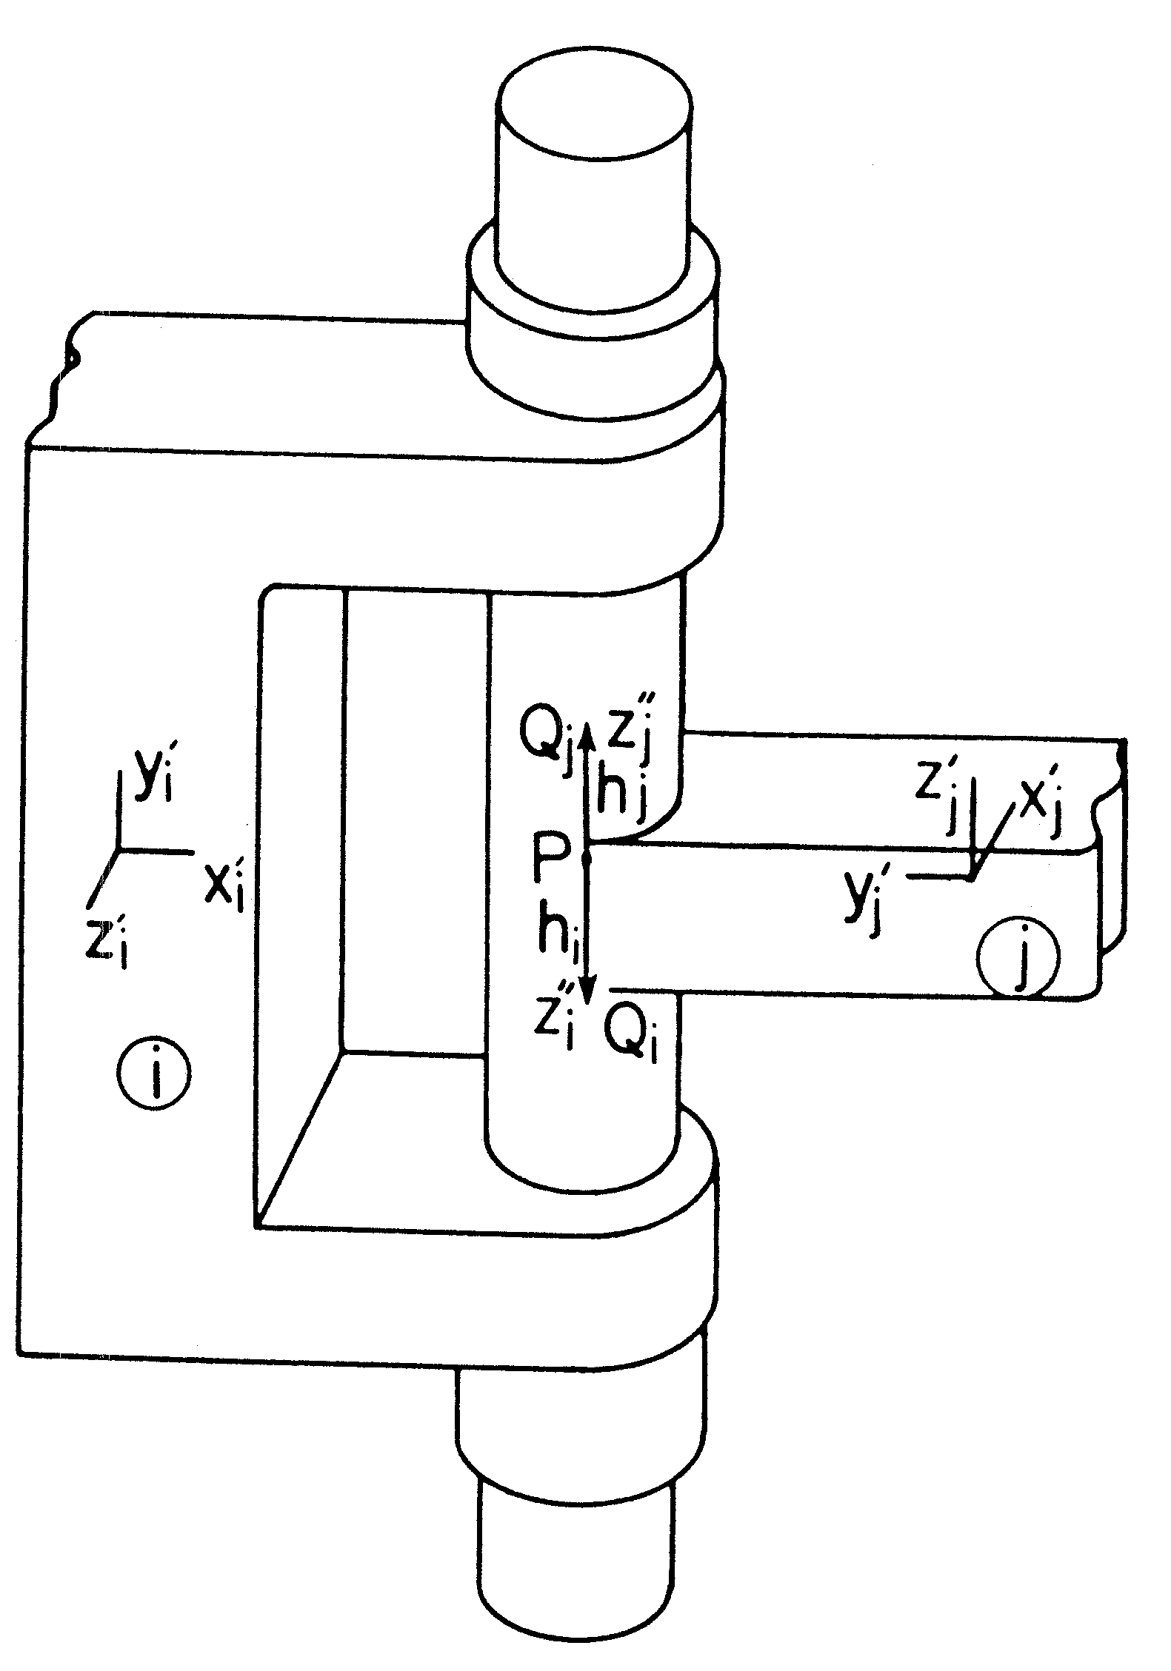

Revolute R

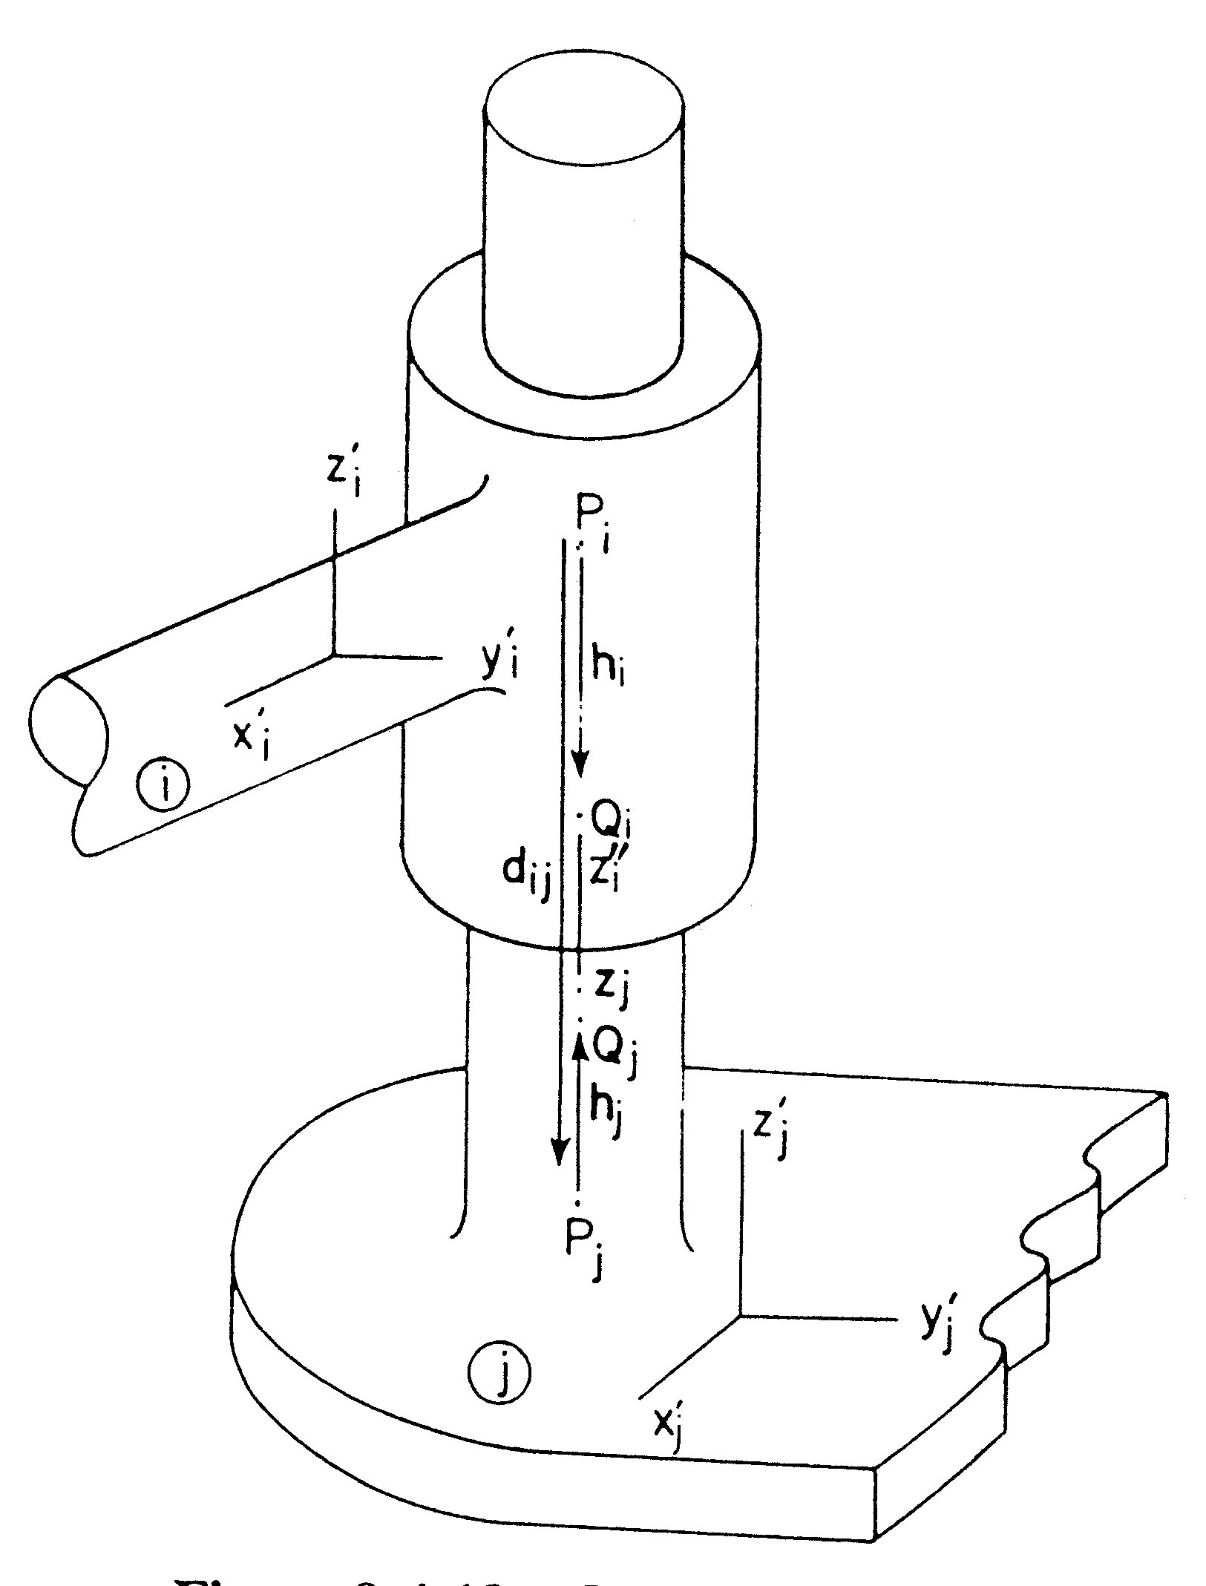

Cylindrical C

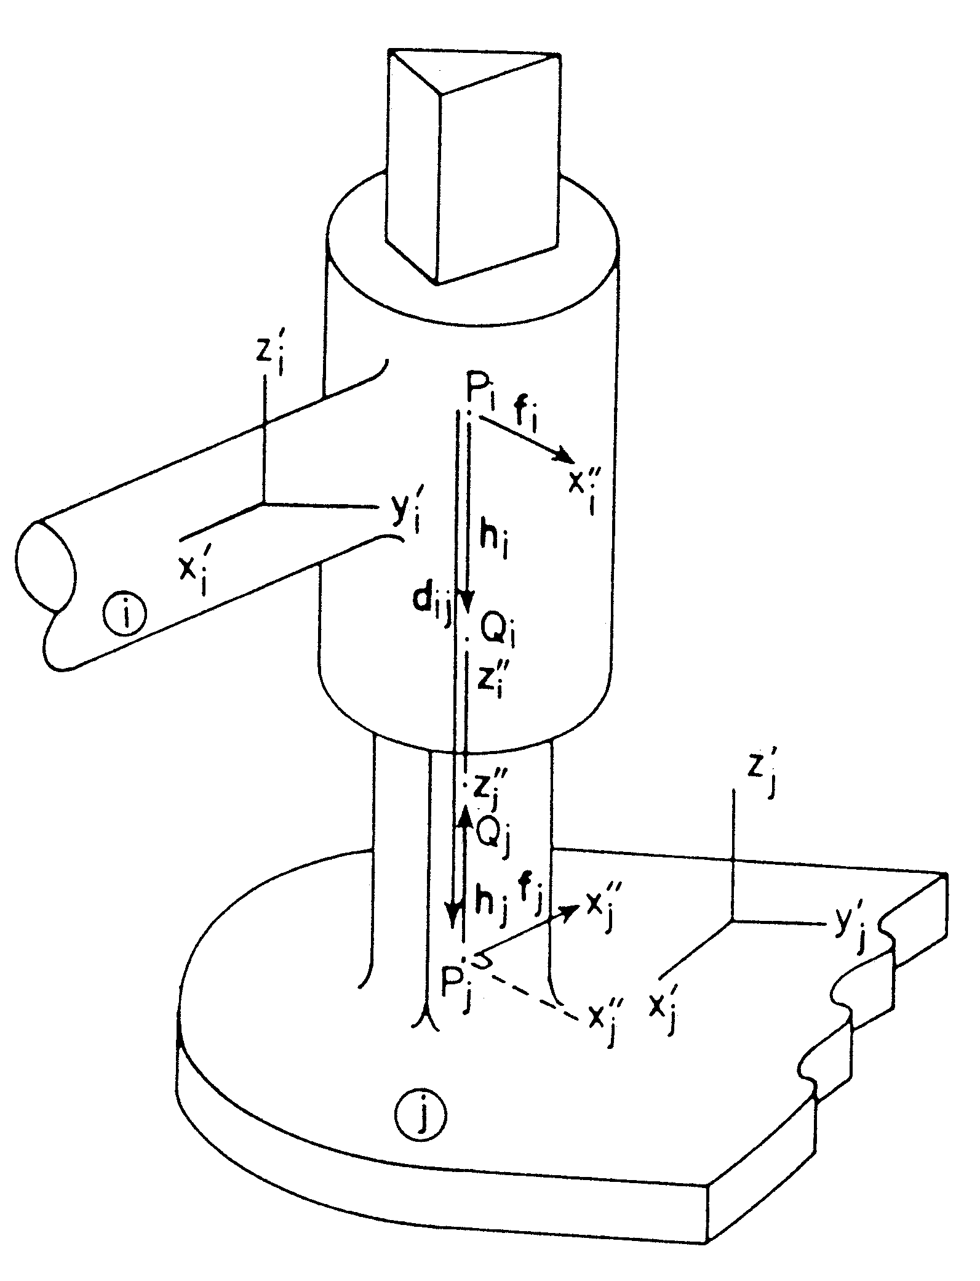

Prismatic P (Translational T)

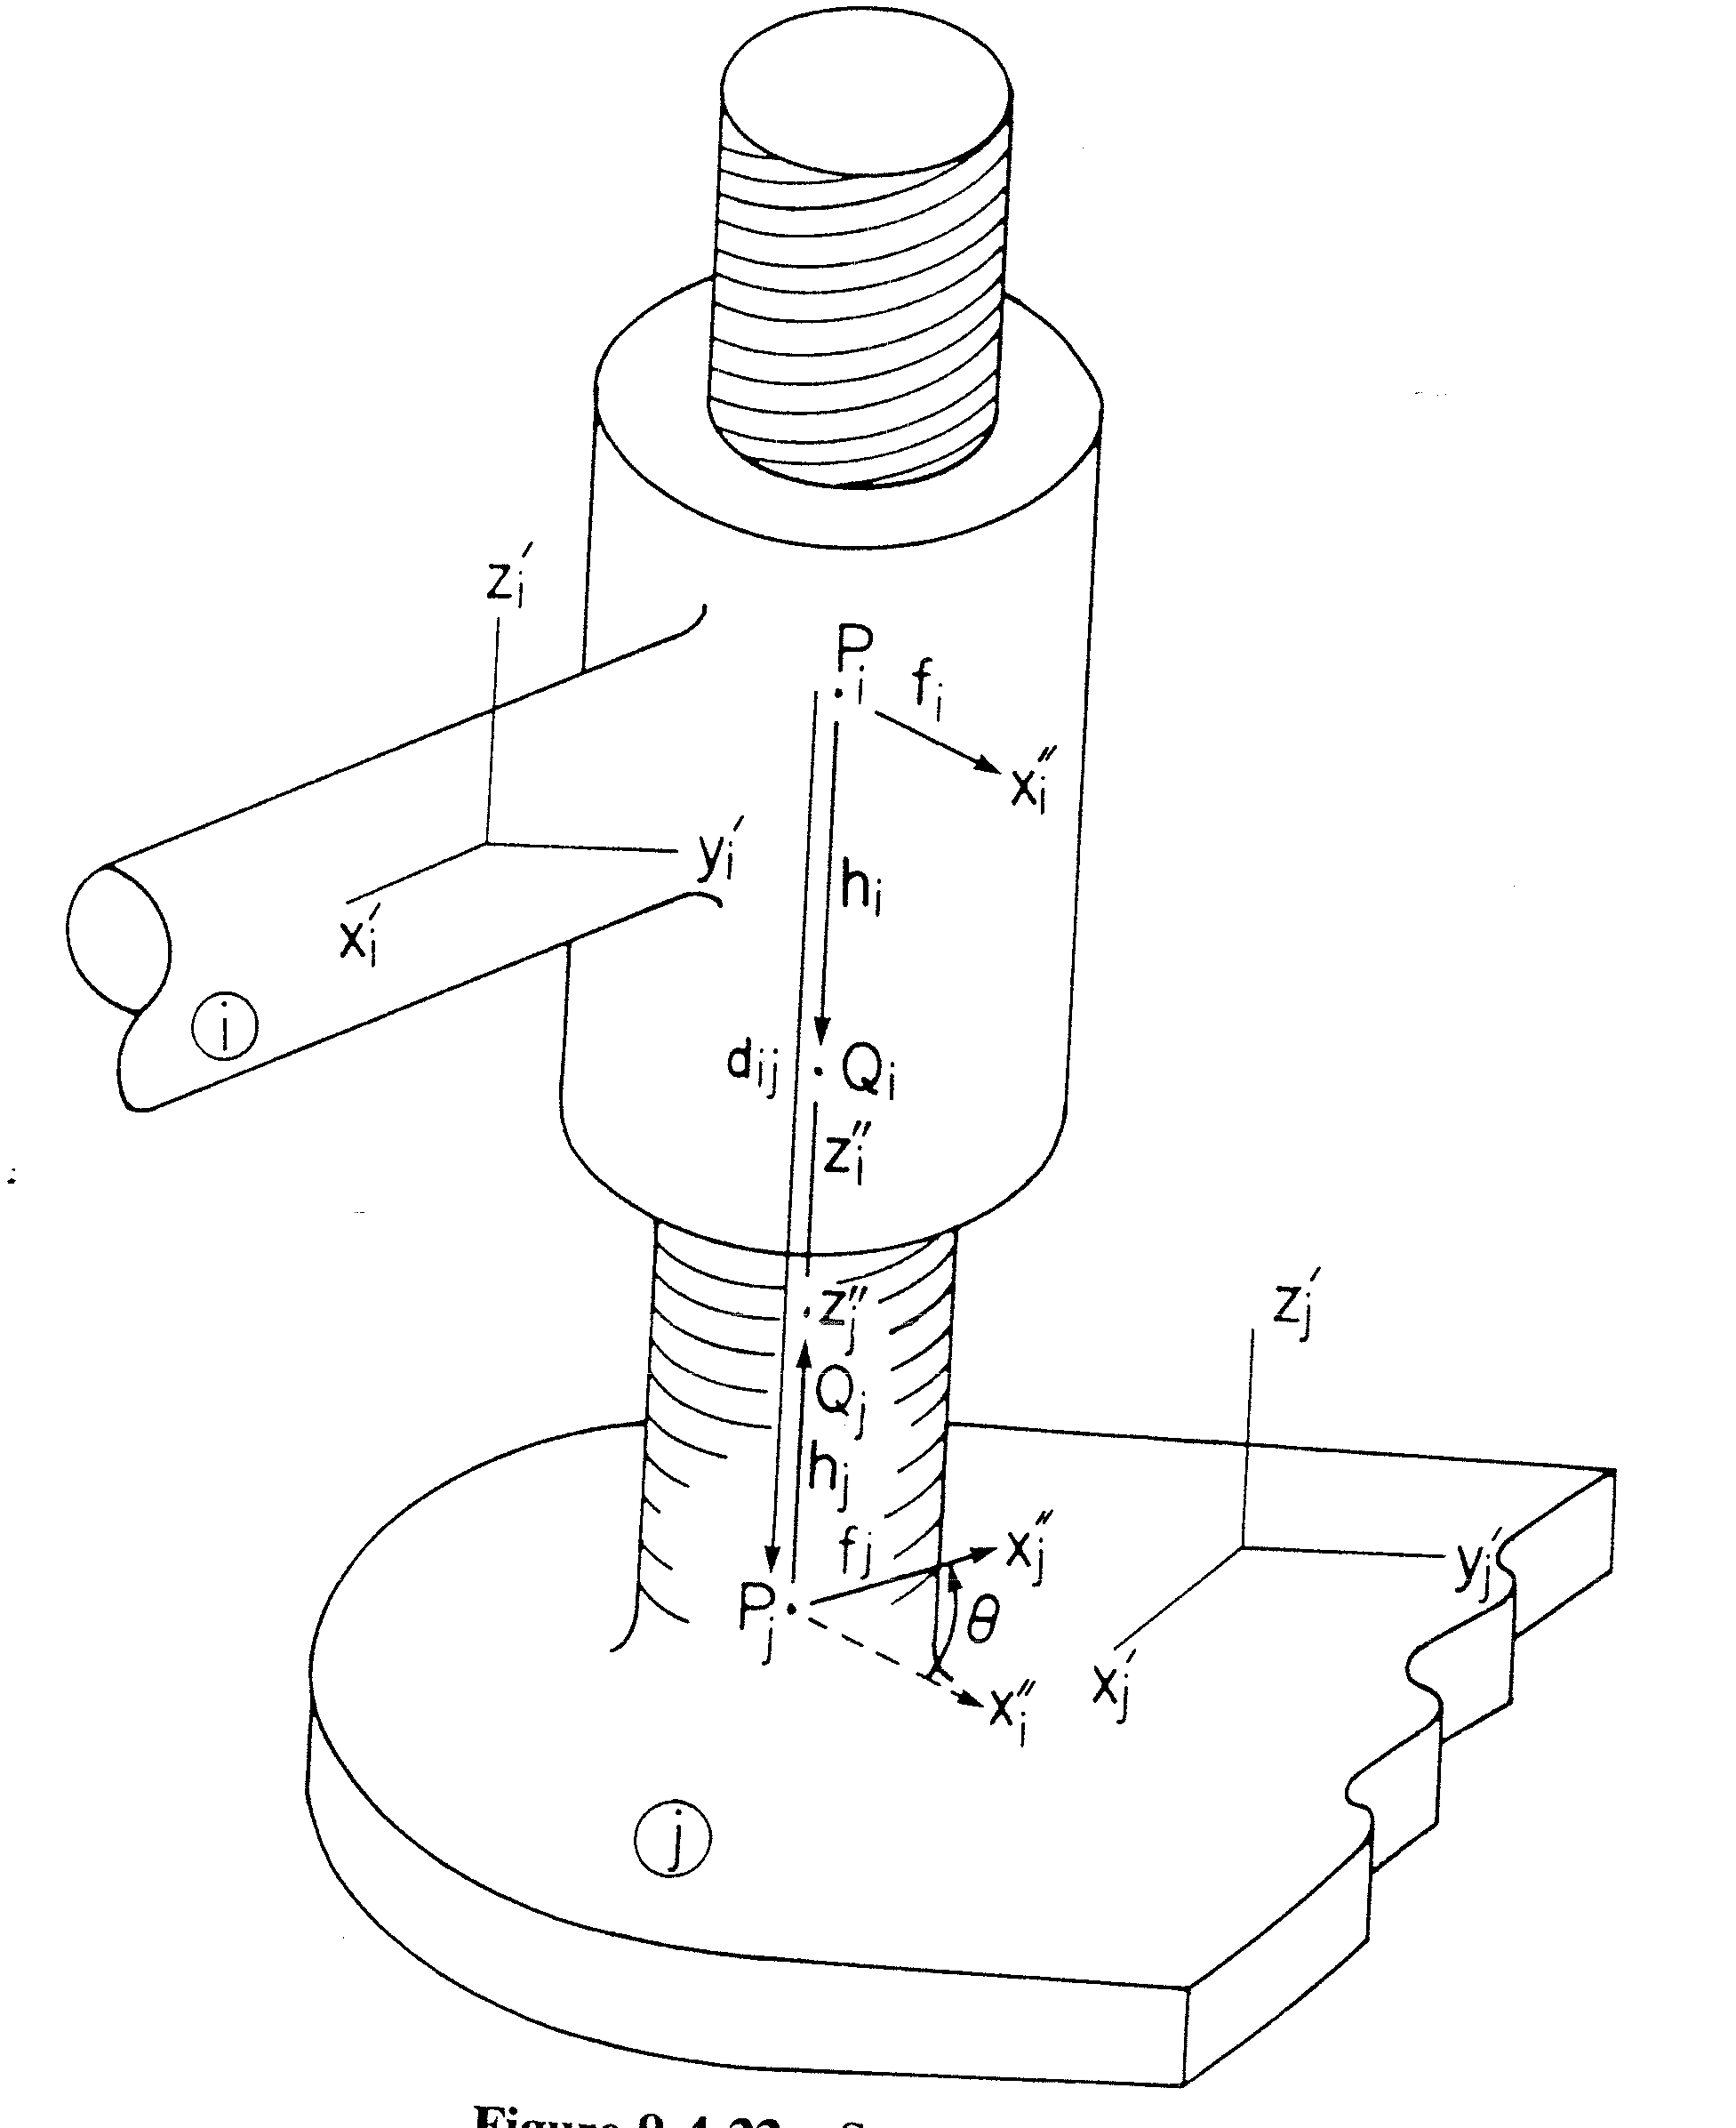

Screw S (Helical H)

