Name: ______________________________________________

Date of lab: ______________________ Section number: M E 345._______
Lab 9

Precalculations – Individual Portion

Dynamic Systems Lab: Dynamic Systems Response

Precalculations Score (for instructor or TA use only): | _____ / 20

- (6) Derive the equation of the time constant τ as a function of resistance R and capacitance C
for a first-order low-pass RC filter circuit. Also sketch the circuit.

- (6) For a low-pass filter with R = 100 kohm and C = 2.0 microfarad, calculate the time constant in seconds. Calculate the “error fraction” at t = τ. If the input is 3.00 V, calculate the output at t = τ.

- (6) Suppose the peak displacement amplitude is measured over some finite time for an oscillating spring-mass-damper system. The first peak amplitude y₁ is 1.58 cm. The twentieth peak amplitude y₂₀ is 0.61 cm. Calculate the log decrement and the damping ratio for this case, showing all your work.

- (2) For a second-order system with a damping ratio between 0 and 1, which is higher, the natural frequency, or the damped natural frequency? At which frequency will the physical system oscillate?

Cover Page for
Lab 9

Lab Report – Group Portion

Dynamic Systems Lab: Dynamic Systems Response

Name 1: ___________________________________________________ Section M E 345._______

Name 2: ___________________________________________________ Section M E 345._______

Name 3: ___________________________________________________ Section M E 345._______

[Name 4: ___________________________________________________ Section M E 345._______ ]

Date when the lab was performed: ______________________

Group Lab Report Score (For instructor or TA use only):

Lab experiment and results, plots, tables, etc. | _____ / 50
Discussion | _____ / 30
TOTAL | ______ / 80

Lab Participation Grade and Deductions – The instructor or TA reserves the right to deduct points for any of the following, either for all group members or for individual students:

- Arriving late to lab or leaving before your lab group is finished.
- Not participating in the work of your lab group (freeloading).
- Causing distractions, arguing, or not paying attention during lab.
- Not following the rules about formatting plots and tables.
- Grammatical errors in your lab report.
- Sloppy or illegible writing or plots (lack of neatness) in your lab report.
- Other (at the discretion of the instructor or TA).

Name | Reason for deduction | Points deducted | Total grade (out of 80)

Comments (for instructor or TA use only):

Dynamic Systems Lab: Dynamic Systems Response

Author: John M. Cimbala; also edited by Michael Robinson and Savas Yavuzkurt, Penn State University
Latest revision: 14 November 2013

Introduction and Background (Note: To save paper, you do not need to print this section for your lab report.)
In this lab, electrical circuits will be used to illustrate first-order and second-order dynamic system response, and an oscillating spring-mass system will be used to illustrate second-order dynamic system response.

Input Impedance:
Consider current I passing through resistor R₁ from voltage V_{i} to V_{o} as sketched to the right. If the voltmeter or DMM measuring voltage V_{o} has an infinite input impedance, V_{o} exactly equals V_{i}, and the current I passing through the resistor is zero.

Any real voltage measurement device, however, has a non-infinite input impedance. The actual circuit behaves more like the circuit to the right, where the input impedance of the DMM is shown as resistor R₂. This circuit now acts as a voltage divider, with . The current is no longer zero, and V_{o} is smaller than V_{i}. In this lab, you will measure the output voltage for several values of R₁, and then calculate the input impedance of the DMM.
First-Order System:
A simple RC low-pass filter (as shown to the right) behaves as a first-order system. The differential equation for output voltage was shown in the related learning module to be . From this equation, we can calculate the time constant τ. In this lab, a step function input will be applied by suddenly changing input voltage V_{in} from 0 V to 5 V. The dynamic behavior of the output voltage V_{out} with time will then be recorded, and compared to the theoretical behavior of a first-order system.

Some experimental results are provided here as an example. The data are plotted to the right. In this case, data were sampled every 0.05 seconds, and the sudden step change in the input occurs at approximately 0.2 seconds. It would be difficult to obtain an accurate estimate of time constant τ from this plot. A better and more accurate way to measure the time constant of a first-order system is through use of the error fraction, defined as . Specifically, by taking the natural logarithm of both sides of this equation, the result is a linear relationship between the natural log of the error fraction and time, . Regression analysis can then be used to determine the slope of the resulting best-fit straight line, from which the slope, and therefore the time constant, can be obtained. A plot of error fraction versus time for the sample data is shown below. In the range from 0 to about 0.25 seconds, nothing has happened yet, so the error fraction is zero. In the range from about 0.25 to 0.8 seconds, the data decrease quite linearly. At higher values of time, experimental error becomes too great to obtain accurate values of the error fraction. A linear regression analysis was performed only on the data between 0.25 to 0.8 seconds, as indicated by the blue line. It is a simple matter to calculate the time constant τ from this least-squares fit. Namely, τ is equal to the negative of the inverse of the slope of the line. In this particular example, the slope is −8.00 s⁻¹, so that τ = −1/(−8.00 s⁻¹) = 0.125 seconds.
Second-Order System:
In this lab, a mass hung from a spring is given an initial displacement, and allowed to oscillate. This system has a mass, a spring constant, and some internal damping, and thus behaves as a second-order dynamic system. The amplitude of oscillation decays with time, of course, due to the damping, as sketched below. In the figure, y_{i} is the amplitude of peak i (i is an integer counting each peak), n is the number of cycles (peak-to-peak oscillation amplitude) being considered (n = 3 in the sketch), t is the time it takes for n cycles to occur, and T is the period of oscillation (T = t/n), namely, the time period of one cycle. Caution: In the analysis here, it is assumed that y oscillates about zero. If there is some offset in y, the y_{i} amplitude must be defined relative to that offset.

A common method for analyzing the damping of an oscillation is the logarithmic decrement method, for which the following relations apply: , , , and . The parameters are defined as follows: ζ is the damping ratio, δ is the log decrement, ω_{n} is the undamped natural frequency (actually an angular frequency, in radians per second), and ω_{d} is the damped natural frequency (also in radians per second). Angular frequency can easily be converted to the more common physical frequency (cycles per second or hertz) since there are 2π radians per cycle or period. Thus, f_{n} and f_{d} are the undamped natural physical frequency and damped natural physical frequency, respectively, in Hz. Note from the above equations that the damped natural physical frequency is simply 1/T; this is the frequency actually observed in the experiment. For good accuracy in an experiment such as this, at least 20 oscillation cycles should be measured (n > 19), if possible.

A pendulum can be thought of as a special case of the spring mass damper. In this case, gravity acts as the spring, and the mass rotates about a pivot. While the full pendulum equations are nonlinear, for small oscillations, we can approximate the system as linear. From physics, the natural frequency of a simple pendulum with all of its mass concentrated at the end is as follows: .

Lego angle sensor:
An image of the Lego angle sensor is shown in Figure 1.
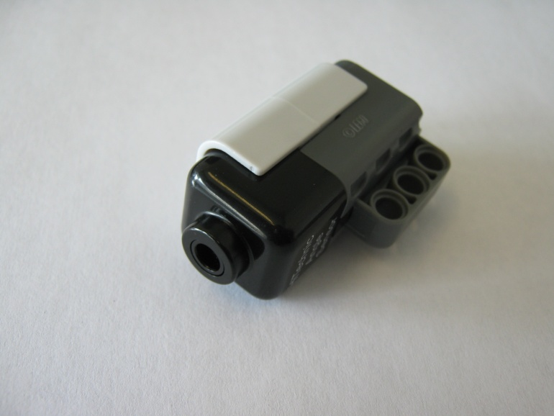
Figure 1: Lego angle sensor
This sensor measures both positive and negative angles. Note that the sensor sets zero degrees to be the position of the sensor when it is connected to the NXT, or the position when the NXT is turned on. If you want to connect this sensor to a Lego beam, the bracket (Figures 2 and 3) is a good starting point, but feel free to experiment.
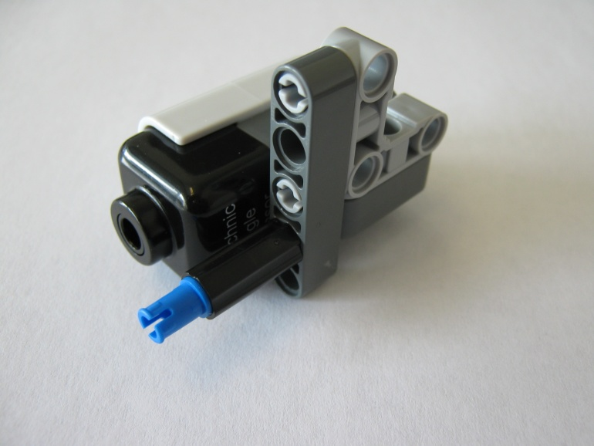
Figure 2: Angle sensor with bracket
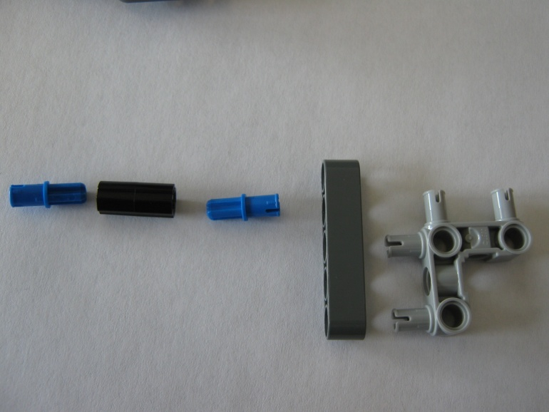
Figure 3: Disassembled angle sensor bracket
Objectives
- Obtain a better understanding of input impedance.
- Measure the time response of a simple RC low-pass filter.
- Use the error fraction method to calculate the time constant of the low-pass filter, and compare with theoretical predictions.
- Investigate the second-order dynamic system performance of a second-order low-pass filter.
- Investigate the second-order dynamic system performance of a pendulum.
- Investigate how changing the mass hanging from the pendulum affects the dynamic performance of the system.

Equipment
- powered breadboard (with +5 V DC power supply and jumper wires)
- BNC, banana, and alligator cables
- capacitor (C approximately 1 microfarad)
- decade resistance box
- inductor (L approximately 1 henry)
- digital multimeter (DMM)
- computer with digital data acquisition system and MATLAB sampling code (from a previous lab; also posted on the course website as “USB1608G_Sample.m”)
- Lego NXT Kit, along with some LabView and MATLAB files to run the Lego experiment

Procedure
Input Impedance
- Set up the powered breadboard with a ground bus and a +5 V bus.
- (1) Using the DMM, measure and record the actual voltage from the 5 V power supply – we call this voltage V_{i}.

Measured power supply voltage V_{i} = ___________ V

- (1) Dial in 500 ohms on the decade resistance box. Measure and record the resistance (we call this R₁).

Measured resistance R₁ = ___________ Ω

- Connect one terminal of the decade resistance box to the 5 V bus. Connect the other terminal of the decade resistance box to the positive (red) lead of the DMM.
- Connect the common (black) lead of the DMM to the ground bus. (See the circuit diagram in the Introduction – this is the circuit you should now have.)
- Record both resistance R₁ (as read from the decade resistance box dials) and voltage output V_{o} (as measured by the DMM) onto an Excel spreadsheet.
- Repeat for several values of resistance, namely, 1000, 10,000, 100,000, 1,000,000, and 9,000,000 ohms. Enter R₁ and V_{o} in two different columns in the spreadsheet.
- (4) From the equation for the voltage divider (see the circuit diagram in the Introduction), derive an equation for R₂ as a function of V_{i}, V_{o}, and R₁. Show your results here:

- (2) Create another column in Excel to calculate the input impedance of the DMM (we call this R₂) for each different value of resistance. Print out your spreadsheet table and attach to your lab report.

See attached, Table number ___________

First-Order System – Low-pass filter
- (1) Measure and record the capacitance of the nominally 1.0 microfarad capacitor.

Measured capacitance C = ___________ μF

- (3) Calculate the value of resistance that yields a time constant of 0.2 seconds. Show all your work here, including unit conversions.

Calculated resistance R = ___________ Ω

- (1) Adjust the decade resistance to as close as you can get to this value. Measure and record the actual resistance.

Measured resistance R = ___________ Ω

- Construct an RC low-pass filter on the breadboard, using the capacitor and the decade resistance box. Note that the capacitor is directional – the arrow points in the direction that current should flow through it.
- Connect the output of the low-pass filter to the DMM. Connect the input to the 5 V DC power supply, and watch the voltage reading on the DMM. It should rise, and after a few seconds, should level off to a value around 5 V DC.
- Start MATLAB and open the posted file called “USB1608G_Sample.m”.
- Apply 0 V DC to channel 0 of the DAQ, and run the code to get everything initialized and working. The voltage displayed on the time trace should show zero (or nearly zero) V for all samples. If errors occur, you may need to re-boot the computer.
- Connect the output of your low-pass filter to channel 0 of the DAQ.
- In the MATLAB code, adjust the sampling frequency and number of samples so that the time response of the circuit can be measured effectively. (A sampling frequency of 20 Hz with 200 points per scan works well. This gives ten seconds of sampling time, with the time between samples equal to 1/20 = 0.05 s. In other words, every row in the spreadsheet represents 0.05 seconds of elapsed time.)
- Now apply a step function as follows:
  - Turn off the power to the breadboard.
  - Pull out the banana plug connected to the 5 V DC input on the breadboard.
  - Touch this plug to the banana plug that is plugged into the breadboard ground (while that plug is still in). Wait a few seconds for the output voltage to drop to zero (the capacitor needs to fully discharge).
  - Turn the breadboard power back on.
  - Hit Run in MATLAB.
  - Wait about a second, and then quickly plug the banana plug (that you had removed) back into the 5 V DC input. If done correctly, the time trace on the computer screen will show a signal that starts at zero volts, then rises asymptotically towards 5 V, as plotted in the Introduction for a sample case.
- With the write-to-file switch still off, practice the above procedure a couple times until a nice first-order dynamic system response can be produced consistently on the time trace. Be sure to discharge the capacitor.
- Perform the step function procedure again, this time recording the data to a file. [MATLAB writes the data that are displayed on the time trace.] If the recorded signal is not satisfactory, repeat. Data should have been placed into an Excel file in your MATLAB working directory. If you open the Excel file, make sure to close it before you run your MATLAB code again.
- When a nice time trace has been recorded, open the spreadsheet file to verify that the data have been correctly written. (It is a good idea to plot the data to make sure that they were written to the file properly.)
- (3) Insert the JPEG image of your figure into your lab report.

See attached, Figure number ___________

- (4) Calculate the theoretical time constant for the particular resistor and capacitor used in the low-pass filter experiment, using measured properties of the resistor and capacitor. Show all your work here.

Theoretical time constant τ_{theoretical} = ___________ s

- (4) Calculate the experimental time constant of the low-pass filter circuit, using the error fraction technique. (It is suggested that this be done in Excel. Attach a printout of the key portion(s) of your spreadsheet to the lab report.) On the plot of ln(Γ) vs. t, mark the region where regression analysis was performed.

Experimental time constant τ_{experimental} = ___________ s

Second-Order System – Low-Pass Filter
- Add the inductor in series with the resistor to create a second-order low-pass filter, as discussed in the filter learning module. The inductor changes the dynamic system from first-order to second-order.
- Using MATLAB, repeat the sudden step change input as previously (discharge the capacitor through the banana plug, and then connect it quickly). Adjust the resistance until you can clearly see underdamped second-order dynamic system behavior. A resistance in the range 10 to 100 Ω works best. Adjust the sampling frequency and number of data points until you see a good time trace. Note: The damped natural frequency is > 100 Hz, so you need to sample at a fairly high frequency to see the response.
- (1) When you have an output that shows underdamped response, record the value of resistance that you used.

Measured resistance R = ___________ Ω

- (4) Insert the JPEG image of your figure into your lab report.

See attached, Figure number ___________

- Exit MATLAB.
- Remove the jumper wires and turn off the power supply. You are finished with the breadboard.

Second-Order System – Lego Pendulum
In this section you will need to build a pendulum out of the Legos that will allow you to learn about second-order mechanical systems. This section is intended to be open ended. You will be able to make many decisions about how you want to conduct this experiment. Try to focus on anticipating what results you will obtain and how the design decisions you made affect your results.

- (5) Build a simple pendulum out of Legos. You will need to incorporate the Lego angle sensor into your design. See the introduction for background on this sensor. Provide a sketch or photograph below of the pendulum indicating where you will measure the length used in the natural frequency calculation (see introduction) and calculate the theoretical natural frequency of your system.
Theoretical natural frequency _____________Hz
System Sketch or Photograph:

- Press the orange square on the front of the NXT to turn it on. It will take a few seconds for it to boot up
- Connect the NXT to your computer with the USB cable provided. If a message appears in the lower right corner about installing a driver for the NXT, wait a minute until another message indicates that the hardware is ready to use. You will need to connect the angle sensor to port 1 using the black Lego cables.
- Open the LabVIEW file called “Dynamic_Lab_Angle_Log.vi”, which is posted on the website.
- Record the behavior of the Lego pendulum: Start swinging the pendulum, then press the white “Run” arrow in LabVIEW, the program will automatically record the angle of the pendulum for 30 seconds. The white run arrow turns black while the program is running. When it turns white again, you can view the data. Do not stop the LabVIEW program, or data on the Lego NXT will not be properly saved.
- In the top menu of LabVIEW go to Tools-NXT Application Browser and open Data Viewer.
- Click the “Add Data” button on the left side of the window
- On the new window that pops up, under the NXT heading, Click the icon with the small red page.
- You can now look at the data you obtained. If you are satisfied with the data, click export, and save the file as “data.txt”
- You can now open this file in MATLAB with the file “Dynamic_Lab_Lego_FFT.m”, which is posted on the course website.
- Run the MATLAB file to see the FFT and the original signal you generated. Note that the data file you created must be in the same folder as the MATLAB file. A convenient way to get data points from a MATLAB plot is to use the data cursor as seen below.
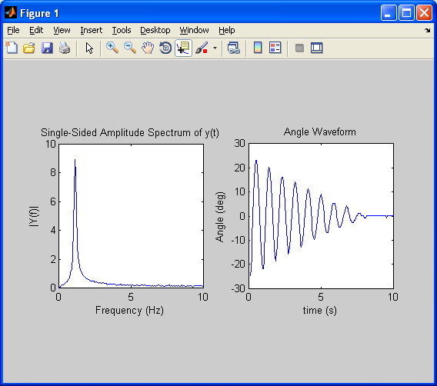
Click Here
Then click on any point in either plot to see the data at that point
- (5) Use the logarithmic decrement method from the introduction to calculate the damping ratio of your pendulum. Use the FFT to find the damped natural frequency. Record your values for the measurements below. Also, attach the plot generated by MATLAB. Note: Leave MATLAB and the NXT Data Viewer open. You will need to use them again later in this experiment.

First measured oscillation amplitude y_{i} = _____________deg
Measured amplitude after n oscillations y_{i+n} = _____________deg
Log decrement δ = _____________
Damping ratio ζ = _____________
Damped natural frequency from FFT f_{d} = _____________Hz
Experimental natural frequency f_{n} = _____________Hz
See attached, Figure number ___________

- (1) Increase the mass on the end of the pendulum, and predict what will happen to the damping ratio. Record your prediction below and write a sentence or two explaining your choice:
With additional mass, the damping ratio of the pendulum will (circle one): increase not change decrease

- (5) Now that the pendulum has more mass, repeat steps 5-11 and record your new values below. Also, attach the plot generated by MATLAB.

First measured oscillation amplitude y_{i} = _____________deg
Measured amplitude after n oscillations y_{i+n} = _____________deg
Log decrement δ = _____________
Damping ratio ζ = _____________
Damped natural frequency from FFT f_{d} = _____________Hz
Experimental natural frequency f_{n} = _____________Hz
See attached, Figure number ___________

- (5) Using the same mass from step 12 above, increase the length of the pendulum and repeat steps 5-11. Record the new values for this setup below. Also, attach the plot generated by MATLAB.

First measured oscillation amplitude y_{i} = _____________deg
Measured amplitude after n oscillations y_{i+n} = _____________deg
Log decrement δ = _____________
Damping ratio ζ = _____________
Damped natural frequency from FFT f_{d} = _____________Hz
Experimental natural frequency f_{n} = _____________Hz
See attached, Figure number ___________

Discussion Questions
Input Impedance
- (4) What is the input impedance of the DMM? Is this a good DMM?

First-Order System
- (4) Compare the experimental time constant of the low-pass filter circuit with the theoretical value. Calculate the percentage error. Any suggestions (other than “human error”) as to reasons for the discrepancy?

- (4) Explain why the final steady-state output voltage of the low-pass filter is lower than 5.0 V.

- (3) Now that the time response of the first-order low-pass filter is more clearly understood, explain briefly (in terms of time response) why high frequency signals are attenuated by a low-pass filter.

Second-Order System
- (2) Is the second-order filter system underdamped, critically damped, or overdamped? Explain.

- (2) Was the pendulum you created underdamped, critically damped, or overdamped? Explain.

- (2) What physical mechanism(s) determines the damping ratio of the pendulum you created?

- (2) In the MATLAB code provided, the line y=y-mean(y); (line 7) subtracts the average value from the angle signal. Why is this necessary?

Continued on next page →
Note that questions 5, 6, and 7 are open-ended. There isn’t just one correct answer.
- (2) From the introduction to this lab, we assumed that a pendulum can be modeled as a concentrated mass at the end of the pendulum arm. Based on your experimental results, how reasonable was this assumption? Explain.

- (2) Another assumption we made was that the pendulum could be described by linear equations. The torque on the pendulum from gravity was assumed to be equal to mglθ (where θ is the angle of the pendulum measured in radians) when from basic physics the actual torque is equal to mglsin(θ). How reasonable is this assumption? Hint: Compare θ in radians and sin(θ) for different values of θ to see how close they are.

- (3) Write a brief paragraph describing the experiment you created. What difficulties did you encounter while designing this experiment? Is there anything you would do differently if you were to repeat this experiment?

