Name: ______________________________________________

Date of lab: ______________________ Section number: M E 345._______
Lab 8

Precalculations – Individual Portion

Strain Gage Lab: Measurement of Strain

Precalculations Score (for instructor or TA use only): | _____ / 20

- (3) What are the color bands on a 120 Ω resistor?

- (4) Look up and report the value of Young’s modulus for aluminum compared to typical plastics, like ABS plastic. Which material has the larger Young’s modulus? Be sure to give the reference(s) and the units.

- (13) Explain, in your own words, why instead of a single strain gage in a quarter-bridge Wheatstone bridge circuit, one might use a half-bridge circuit with a second dummy (unloaded) strain gage for temperature compensation. Draw some sketches to show which resistors in the bridge are used for the two strain gages, and explain why this arrangement helps to compensate for temperature changes.

Cover Page for
Lab 8

Lab Report – Group Portion

Strain Gage Lab: Measurement of Strain

Name 1: ___________________________________________________ Section M E 345._______

Name 2: ___________________________________________________ Section M E 345._______

Name 3: ___________________________________________________ Section M E 345._______

[Name 4: ___________________________________________________ Section M E 345._______ ]

Date when the lab was performed: ______________________

Group Lab Report Score (For instructor or TA use only):

Lab experiment and results, plots, tables, etc. | _____ / 50
Discussion | _____ / 30
TOTAL | ______ / 80

Lab Participation Grade and Deductions – The instructor or TA reserves the right to deduct points for any of the following, either for all group members or for individual students:

- Arriving late to lab or leaving before your lab group is finished.
- Not participating in the work of your lab group (freeloading).
- Causing distractions, arguing, or not paying attention during lab.
- Not following the rules about formatting plots and tables.
- Grammatical errors in your lab report.
- Sloppy or illegible writing or plots (lack of neatness) in your lab report.
- Other (at the discretion of the instructor or TA).

Name | Reason for deduction | Points deducted | Total grade (out of 80)

Comments (for instructor or TA use only):

Strain Gage Lab: Measurement of Strain

Author: John M. Cimbala; also edited by Mikhail Gordin, Pralav Shetty, Savas Yavuzkurt, and Faysal Ashour, Penn State University
Latest revision: 03 November 2014

Introduction and Background (Note: To save paper, you do not need to print this section for your lab report.)
Axial stress is defined as force per unit area. Axial strain is the fractional change in length (change in length divided by length) of a material. Although it is difficult to directly measure stress, it is fairly straightforward to measure strain. Fortunately, stress is linearly proportional to strain for non-deforming loads on beams; thus, stress can be measured indirectly by measuring strain.

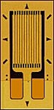
Strain is traditionally measured with resistive-type strain gages. Strain gages work on a simple principle − when a wire is stretched, its resistance increases. The effect is more pronounced if the wire is long; the longer the wire, the greater the increase in resistance. An effectively longer wire can be achieved by looping the wire back and forth in the direction of the desired strain measurement. A modern commercially available strain gage consists of a thin metal foil, etched into a looped pattern (grid), and attached to a thin, flexible substrate, as shown to the right. Wires are soldered to the copper leads at the bottom. The direction of axial strain for the orientation of the strain gage shown here would be vertical (up or down), so that the grid is stretched or compressed in the direction of the long segments of metal foil on the grid. When stretched, the resistance of the strain gage wire increases; when compressed, the resistance decreases. (The resistance also changes a little if the strain gage is stretched or compressed in the direction normal to the long segments of metal foil, but this effect is negligible.)

When a beam of cross sectional area A and length L is loaded with a force as shown in the sketch, the axial stress is and the axial strain is . Also, in the elastic region of a material where stress is linearly proportional to strain, Hooke’s law applies, which states that , where E = Young’s modulus, also called the modulus of elasticity. E gives us a measure of the material’s stiffness. Strain gages also work well (even better) when a beam, such as a cantilever beam is bent. Think, for example about a diving board at a swimming pool. If a strain gage were mounted on the top surface of the diving board, it would stretch as the person stood at the tip of the board; this is positive strain. Similarly, a strain gage on the bottom of the board would compress; this is negative strain. For either case, when the person dives, the diving board flaps up and down, and we would expect the strain to alternate between positive and negative, damping out like a second-order dynamic system.

Due to the very small change in resistance of the strain gage, conventional resistance measurement techniques, such as an ohm meter, are not usually used. Instead, changes in strain gage resistance are measured through the use of a comparative measurement system such as a Wheatstone bridge, as sketched to the right. In this circuit diagram, V_{s} is the supply voltage (a DC power supply, typically around 5 V), V_{o} is the voltage output, and R₁, R₂, R₃, and R₄ are resistors that make up the bridge circuit. When the bridge is balanced, the output voltage across the bridge is zero. Ideally, this occurs when R₁ = R₂ = R₃ = R₄. However, in practice the four resisters do not have exactly the same resistance. Thus, a variable resistance (potentiometer) is often supplied in place of one of the resistors (in this case R₂) to fine-tune the resistance on that leg of the bridge, in order to balance the bridge.

Three Wheatstone bridges are described in the related learning module on the course website, namely quarter bridge, half bridge, and full bridge circuits. A quarter bridge circuit is the simplest one, in which a single strain gage replaces one of the four bridge resistors (in the sketch here, R₃). For a half bridge, two strain gages replace two of the resistors (e.g., R₃ and R₂), while a full bridge circuit contains strain gages in place of all four resistors. As discussed in the related learning module, we need to be careful of the sign of the strain when wiring the bridge circuit.

The sensitivity of the bridge circuit is defined as the ratio of the change in output voltage to the change in resistance of a strain gage under strain. A half bridge theoretically yields twice as much bridge sensitivity as a quarter bridge if both are measuring the same strain, while a full bridge yields four times as much sensitivity as a quarter bridge.

Suppose a quarter bridge circuit is balanced (V_{o} = 0) when no load is applied to the beam. When the beam is loaded (when a strain is applied to the strain gage), its resistance changes, which unbalances the bridge. In principle, we could re-balance the bridge with the variable resistor, record the change in resistance, and calculate the new resistance of the strain gage. In practice however, during strain measurements, it is simpler and more desirable to operate the Wheatstone resistance bridge in unbalanced mode. In unbalanced mode, the change in output voltage turns out to be proportional to the change in strain gage resistance, which is convenient for measurement. However, the imbalance should always be small to avoid excessive resistive heating of the strain gage. Resistive heating is undesirable because changes in resistance lead to a bias in the resulting strain measurement. The strain gage manufacturer usually specifies the maximum tolerable voltage drop across the strain gage.

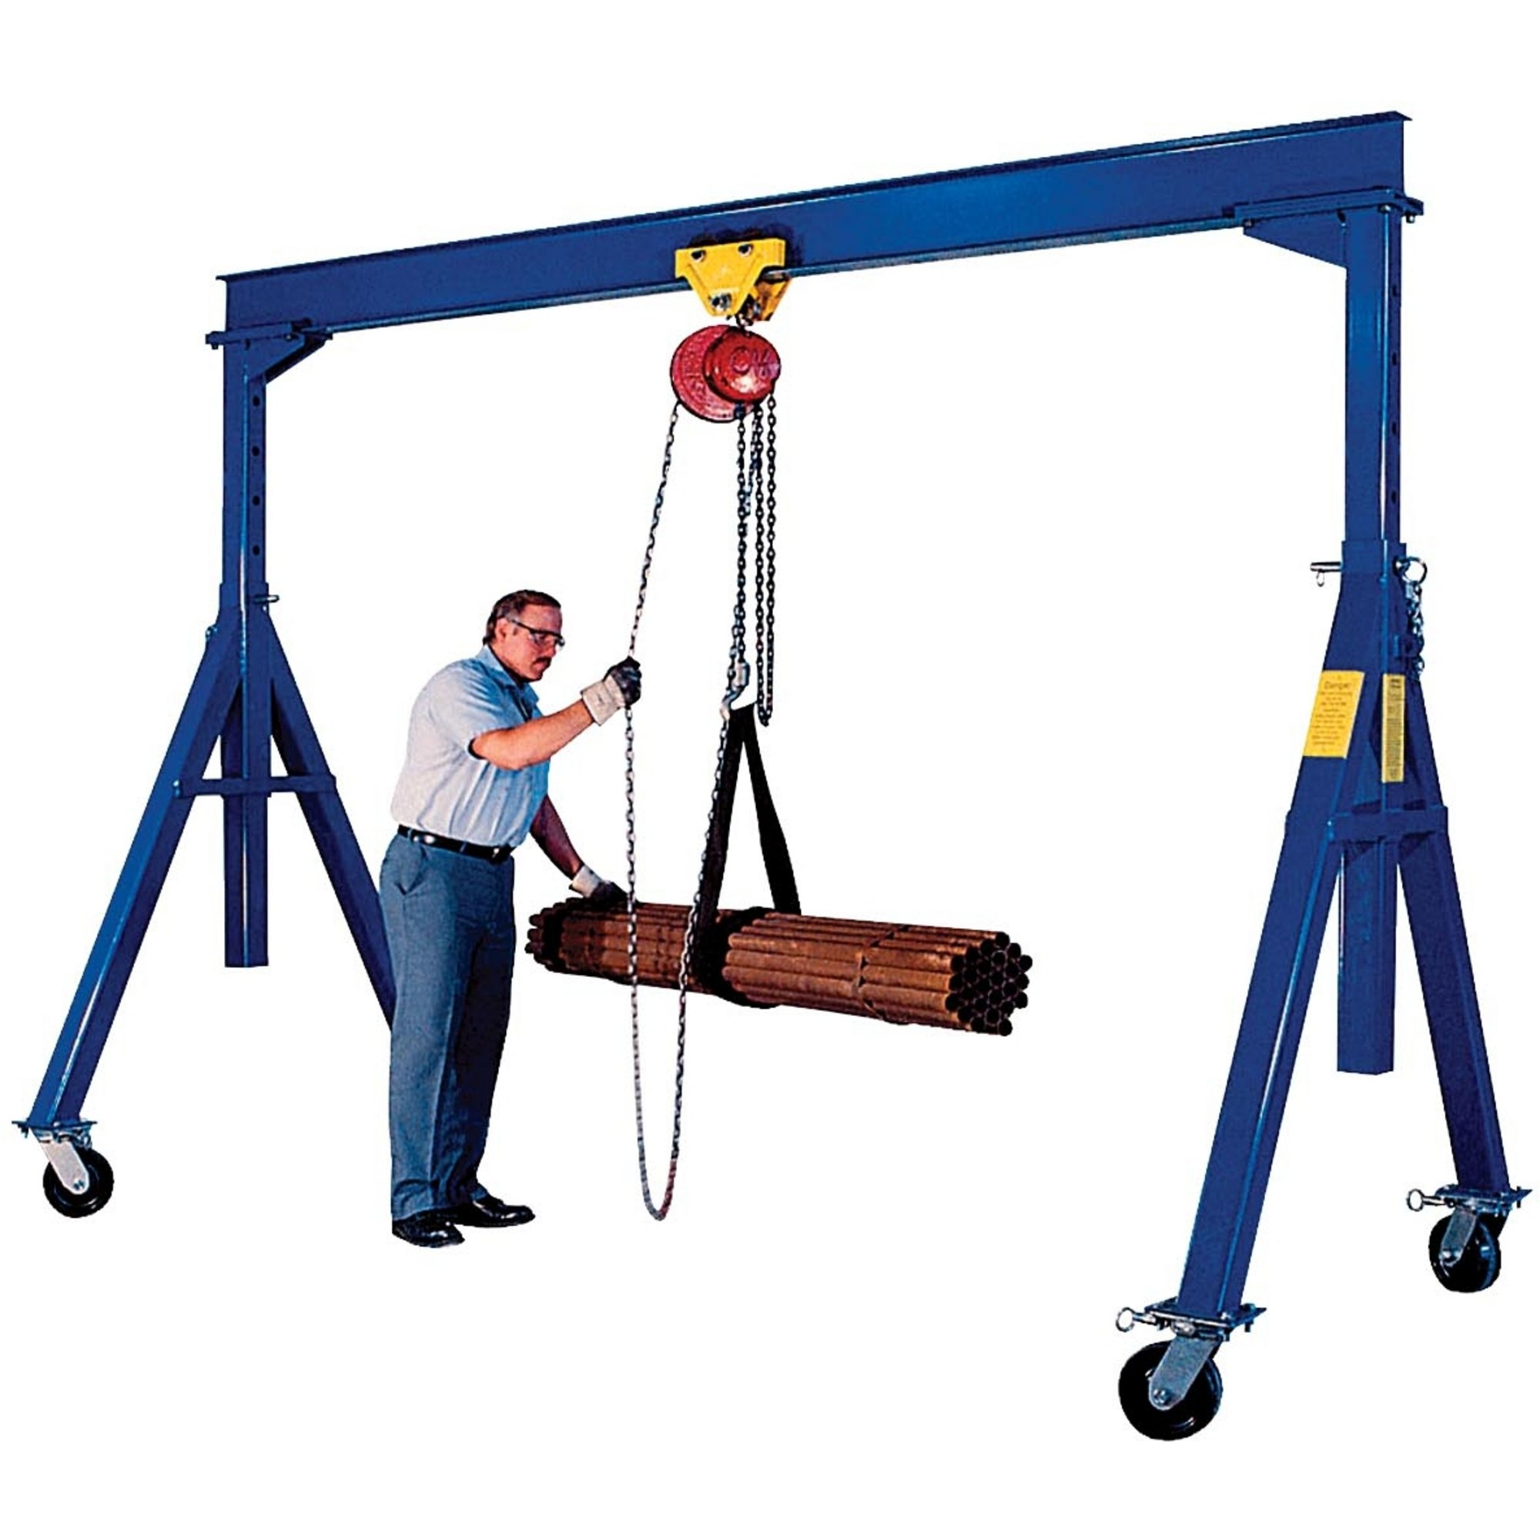
As discussed in the related learning module, the strain is calculated from analysis of the Wheatstone bridge circuit, and the result is where n is the number of active gages (n = 1 for a quarter bridge, n = 2 for a half bridge, and n = 4 for a full bridge), and S is the nondimensional strain gage factor, which depends on the type of metal used in the strain gage (those purchased for this lab have a strain gage factor of approximately 2.09). We note that the relative voltage is used in place of the actual voltage for the general case in which the bridge is originally unbalanced. In the derivation of the above equation, it is assumed that positive strain gages (R₁ and R₃) are chosen for positive strain (tension), and negative strain gages (R₂ and R₄) are chosen for negative strain (compression). If instead we wire the circuit such that the positive gages are in compression and the negative gages are in tension, a negative sign would appear in the above equation.

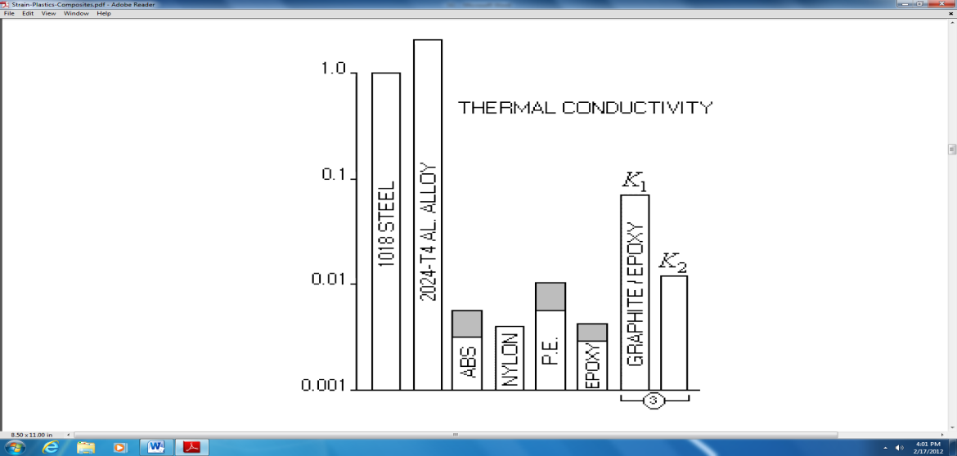

In this lab, we measure the strain on the horizontal beam of a Gantry crane. These devices are used in construction, shipping, and to lift heavy objects. A small one is shown in the upper picture to the right, from http://www.northerntool.com/shop/tools/category_material-handling+hoists-lifts-cranes+gantry-cranes, and a larger one is shown in the lower picture, from https://sites.google.com/site/manufacturersofhoists/uses-of-gantry-cranes-in-industry. Though most gantry cranes are constructed of steel, we will build a small gantry crane with plastic Lego beams. The main disadvantage of using plastic members instead of steel is that plastics have much lower Young’s moduli (often two or more orders of magnitude lower). Thus, Hooke’s law is not valid as the axial strain becomes large. However, based on previous experimental runs, the stress-strain curves of the Lego members don’t show significant non-linearity for loads up to about 1 kg, and this will be the limit of our testing to prevent any damage to the Lego members.

Another limitation of using plastic members to prototype a gantry crane is the low thermal conductivity of plastics as compared to steel as seen in the figure to the right, from http://www.measurementsgroup.com/guide/ta/pc/pca.htm. This causes an accumulation of heat at the surface where the strain gage is attached to the plastic. As discussed in the online lecture notes, heat build-up causes a change in the resistance of the strain gage and is thus undesirable if one needs to make accurate strain measurements based on the output voltage of the Wheatstone bridge. This issue can be overcome by allowing a steady current to pass through the gage for a long time until the gage reaches a steady elevated temperature.

Another important fact to keep in mind while dealing with plastic members is that the strain gages characteristically undergo a zero shift with each strain cycle, and the zero may float back and forth as the strain changes. This can be overcome by re-zeroing the output voltage of the Wheatstone bridge via the REL button on the digital multimeter (DMM) every time before loading the Lego member to measure the local strain. You may need to re-zero the output voltage multiple times to avoid major fluctuations in the output voltage.
Objectives
- Learn how strain gages work.
- Learn how to build and test a Wheatstone bridge.
- Build a quarter bridge Wheatstone bridge to measure strain with a strain gage.
- Use a strain gage to measure stress on the outside of an aluminum soda can.
- Build a Lego gantry crane and calibrate strain vs. load on the cross beam, using one strain gage.
- Repeat the calibration using two strain gages, one on the top and one on the bottom of the beam.
Equipment
- Measurements Group (Vishay) strain gages (strain gage factor S = 2.09)
- Lego beams and connectors, including a 15-hole Lego beam with two mounted strain gages, one on the top and one on the bottom of the beam
- digital multimeter
- hooks and/or loops for hanging masses; mass set with hooks for loading the gantry crane
- powered breadboard and jumper wires
- miscellaneous: clips, BNC, alligator, and banana jack cables as needed
- several 120 Ω resistors
- unopened soda can at room temperature; masking tape, and super glue (Krazy Glue)
- sandpaper and disposable latex gloves

Procedure

Set-up of the Wheatstone Bridge
- (2) Measure the resistance of each of four nominally 120 Ω resistors.
Measured resistance, R₁ = ___________ Ω Measured resistance, R₂ = ___________ Ω
Measured resistance, R₃ = ___________ Ω Measured resistance, R₄ = ___________ Ω

- Note: For safety reasons, turn off the power to the breadboard while building or modifying circuits.
- Create a ground bus on the breadboard. (A long bus is recommended to serve as the ground bus.)
- Create a bus for the +5 V DC voltage supply. (Again, a long bus is recommended.)
- (1) Using the DMM, measure the voltage on the +5 V DC bus to make sure that it is working properly – the voltage should be close to 5 V when you turn it on. (If this power output does not work, either get a different breadboard or use a separate 5 V DC power supply instead.)

Measured voltage from the +5 V DC power supply, V_{s} = ___________ V

- On the breadboard, create a Wheatstone bridge circuit, using the four fixed 120 Ω resistors. Don’t forget to wire the top junction to the +5 V DC bus and the bottom junction of the bridge to the ground bus.
- (4) Turn on the +5 V DC power supply, and measure the bridge output voltage in units of millivolts.

Measured bridge output voltage, V_{o} = ___________ mV

Is the bridge output voltage exactly zero? ( Yes No ). Explain why (or why not).

Some Fun with a Can of Soda
- Now turn your attention to the unmounted strain gage (it should have two lead wires soldered onto it).
- Measure and record the resistance of the unmounted strain gage. This is most easily done as follows:
  - Set the multimeter to the 200 Ω resistance scale.
  - Plug two banana-to-alligator clip cables into the multimeter.
  - Connect each alligator clip to a lead wire coming from the strain gage.
  - (1) Measure the resistance of the strain gage.

Measured resistance of the unmounted strain gage, R_{strain gage} = ___________ Ω

- Connect this strain gage in place of resistor R₃ to create a quarter bridge circuit. Note: The other three resistors are fixed resistors (120 Ω), so that the bridge is a simple quarter bridge.
- (1) Connect the bridge output voltage to the DMM, and record the bridge output voltage in mV.

Measured bridge output voltage, V_{o} = ___________ mV

- Note: Since the bridge can’t be balanced exactly, the relative voltage can be measured by pushing the REL button (sometimes Δ button) on the multimeter. After pushing the REL button, the DMM simply measures subsequent voltages relative to the present voltage − it “zeroes” the present reading. (Note: On most multimeters, the letters “REL” appear on the display when the relative button is turned on.) Warning: This is a nice feature of DMMs, but is also a dangerous feature if you forget that it has been turned on! Pushing the REL button a second time turns the relative voltage feature off. Play with the REL button.
- One lab group member needs to put on a pair of disposable latex gloves (to protect the strain gage from contamination due to oily skin, dirt, etc.). That person is the one to do the following exercise:
  - Firmly grasp the soldered end of the strain gage between the thumb and forefinger of one hand. Do not grasp the wires - grasp the plastic portion of the strain gage itself.
  - With the other hand, gently tug on the other end of the strain gage so as to expose it to some tension. Don’t pull too hard or the strain gage will rip.
  - (2) Compare the voltage readings for the two cases: (strain gage with no load – no tension, and strain gage in tension). Since the voltage may be initially somewhat unstable, wait until it stabilizes before recording the readings, and then record the voltages. Use the REL feature right before measurement.

Measured bridge output voltage – no tension, V_{o} = ___________ mV

Measured bridge output voltage – in tension, V_{o} = ___________ mV

Has the bridge output voltage gone up as expected? ( Yes No ). If not, you probably have something wired incorrectly.
- The person with the gloves on should also do the following:
  - Carefully spread some super glue on the bottom side of the strain gage, Note: Put glue only on the underside of the gage; do not put glue on the active or “business side” where the leads are soldered to the lead wires.
  - Press the strain gage onto the middle of a full soda can, as sketched here. Make sure the portion of the strain gage with the soldered lead wires is not glued down to the can, as shown in the sketch above. Sand that area of the soda can with some sandpaper, and wipe away the dust as necessary for good adhesion. A piece of masking tape is recommended to hold down the wires while the glue is drying.
  - Allow a minute or two for the glue to dry.
  - If the bridge output has drifted, push the REL button on the DMM off, and then push it on again a few seconds later to re-zero the reading.
  - (1) With the soda can standing upright, measure the voltage, pop off the top of the soda can, and record the voltage reading again.

Measured bridge output voltage before top popped off, V_{o} = ___________ mV

Measured bridge output voltage after top popped off, V_{o} = ___________ mV

  - Carefully peel off the strain gage from the can. Do this by grabbing the soldered end of the strain gage, which is sticking up, and pulling gently so as to slowly peel up the rest of the gage. Try not to damage the strain gage so that it can be re-used by a later lab group. If you rip it, give it to the instructor or TA – he or she will recycle the wires onto a new strain gage for later use.
  - (2) When the strain gage is off of the can (and if it is still alive), record the bridge voltage again.

Measured bridge output voltage after strain gage removed from can, V_{o} = ___________ mV

Has the bridge output voltage returned to approximately its original (zeroed) value? ( Yes No ).

  - Put the strain gage back into the box so that it is ready for the next group.
- If someone in the group likes warm soda, he or she can drink the soda. Otherwise, carry it to the sink and spill it out. Rinse it out and toss the empty can into the recycling can in the hallway on your way out.

Warming up the Strain Gages on the Lego Beam

- (4) Examine the two strain gages that are glued to the Lego beam. This beam will be used as the top load-bearing cross beam of a Lego gantry crane. When a load is applied, the beam will bend, and the two strain gages will have strains of the (circle one): ( same opposite ) sign. Explain. (Sketches help.)

- (2) If not already connected, carefully couple the wire connectors so that resistance can be measured across the strain gages. Measure the resistance of each strain gage independently to ensure that the strain gages are not damaged. (If the resistance is not close to 120 Ω, consult the instructor or teaching assistant − either you are measuring incorrectly, or there is a broken connection somewhere that will need to be re-soldered.)

Measured resistance, top strain gage, R_{top} = ___________ Ω

Measured resistance, bottom strain gage, R_{bottom} = ___________ Ω

- (3) In your Wheatstone bridge circuit, replace resistor R₃ with one of the strain gages attached to the Lego beam, and replace resistor R₂ with the other strain gage so as to construct a half-bridge Wheatstone bridge circuit. Explain here why this setup is a half-bridge circuit.

- (3) Temperature compensation corrects for changes in ambient temperature, to which the strain gages are sensitive. Both strain gages will be exposed to the same ambient temperature. The second strain gage will thus serve as a temperature compensating strain gage, as well as an additional strain gage to improve the sensitivity of the circuit. Explain below why the second strain gage provides temperature compensation.

- (2) Turn on the power supply and measure the bridge output voltage. Note: Use the appropriate range setting on the DMM so as to get the best possible resolution.

Measured bridge output voltage, V_{o} = ___________ mV

Is the bridge output voltage exactly zero? ( Yes No )

- Leaving the power supply on, set the Lego beam and Wheatstone bridge circuit aside. The plastic Lego beam needs to warm up since there is heat transfer from the strain gages, and this takes some time. With the beam unloaded and the Wheatstone bridge on, let the setup sit there to warm up for at least 15 minutes while you construct your Lego gantry crane.

Construction of a Lego Beam Gantry Crane

- Construct a (cool looking) gantry crane out of Lego beams, using a 15-hole Lego beam without the mounted strain gages as the top cross beam. A truss-type structure is recommended for the sides for strength. Use the two outermost holes on the top Lego beam so that the load bearing portion of the beam is as long as possible. Make sure your crane is tall enough to hang a 1 kg mass (the maximum required load of the gantry crane).
- Test the strength of your gantry crane by attaching the hook and applying a load of 1 kg.
- (1) Ask your TA or instructor to initial here to certify that your crane can indeed support a 1 kg load.

TA or Instructor initials and date: _________________________________ .
- (5) Attach a photo of your gantry crane to your lab report.
See attached, Figure number ___________ .

Calibration of Strain on the Lego Beam Cross Bar of a Gantry Crane using a Half Bridge Circuit

- After your gantry crane has been certified, replace the top load-bearing cross beam of your gantry crane with the Lego beam that has the mounted strain gages. At this point, do not apply any load. Make sure that you attach the Lego beam in the proper orientation so that positive strain yields positive voltage.
- “Zero” the bridge with no load on the beam by pushing the REL (or Δ ) button on the DMM in order to zero the voltage output of the bridge, as discussed previously.
- (3) Test that the Wheatstone bridge circuit is operating properly by loading the beam with a 1 kg mass. The load should cause a positive output voltage change. [If the output voltage is negative when the load is applied, check the wiring − typically the wrong resistor has been replaced by the strain gage, or the leads from the multimeter are backwards.] When the weight is removed, the meter reading should return to approximately the same value as before the load was added. Record your voltage readings.

[Unloaded] Bridge output voltage before loading, V_{o} = ___________ mV

[Loaded] Bridge output voltage while loaded, V_{o} = ___________ mV

[Unloaded] Bridge output voltage after unloading, V_{o} = ___________ mV

- Take data (output voltage in mV as a function of applied load in grams) for various mass values ranging from 0 (no load) to 1 kg. Enter the data into Excel.
- Calculate the strain (in units of microstrain) experienced by the beam surface for each data point, and plot strain (in microstrain) as a function of load (in grams). Plot the data points as symbols (no line), and on the same plot, plot a least-squares linear fit as a line (no symbols) for your data.
- (5) Attach both the table and the plot to your lab report.
See attached, Table number ___________ .

See attached, Figure number ___________ .

Calibration of Strain on the Lego Beam Cross Bar of a Gantry Crane using a Quarter Bridge Circuit

- Replace one of the strain gages in your bridge with a fixed 120 Ω resistor. Now you have a quarter bridge.
- “Zero” the bridge with no load on the beam by pushing the REL (or Δ ) button on the DMM in order to zero the voltage output of the bridge, as discussed previously.
- (3) Test that the quarter-bridge Wheatstone bridge circuit is operating properly by loading the beam with a 1 kg mass as previously. As before, push the REL button to zero the multimeter before testing the bridge. The load should cause a positive output voltage change. [If the output voltage is negative when the load is applied, check the wiring − typically the wrong resistor has been replaced by the strain gage, or the leads from the multimeter are backwards.] Then remove the 1 kg mass, recording the voltage outputs below.

[Unloaded] Bridge output voltage before loading, V_{o} = ___________ mV

[Loaded] Bridge output voltage while loaded, V_{o} = ___________ mV

[Unloaded] Bridge output voltage after unloading, V_{o} = ___________ mV

- Take data as before (output voltage in mV as a function of applied load in grams) for various mass values ranging from 0 (no load) to 1 kg. Enter the data into Excel.
- Calculate the strain (in units of microstrain) experienced by the beam surface for each data point, and plot strain (in microstrain) as a function of load (in grams). Plot the data points as symbols (no line), and on the same plot, plot a least-squares linear fit as a line (no symbols) for your data.
- (5) Attach both the table and the plot to your lab report.
See attached, Table number ___________ .

See attached, Figure number ___________ .

Clean up

- When finished, turn off all instruments, disassemble your gantry crane, disconnect all circuit wiring, and return the work station to the same conditions as when the lab began.

Discussion Questions
- (5) Explain briefly why a Wheatstone bridge is used when measuring strain with strain gages. Why can’t we just measure the resistance of the strain gage directly with an ohm-meter?

- (5) Explain (qualitatively only) what happened when the soda can was opened, and why it happened.

- (15) Compare your two data sets for the gantry crane (quarter bridge and half bridge). Which has more sensitivity? Which one has temperature compensation? Which one gave better results? Explain.

- (5) In this lab, we used a single Lego beam as the top beam of the gantry crane, and it bends when a load is applied at its midpoint. Discuss (include a sketch) how you might build a better (stronger) gantry crane if you were not restricted to just one Lego beam as the top beam.

