3D Joints
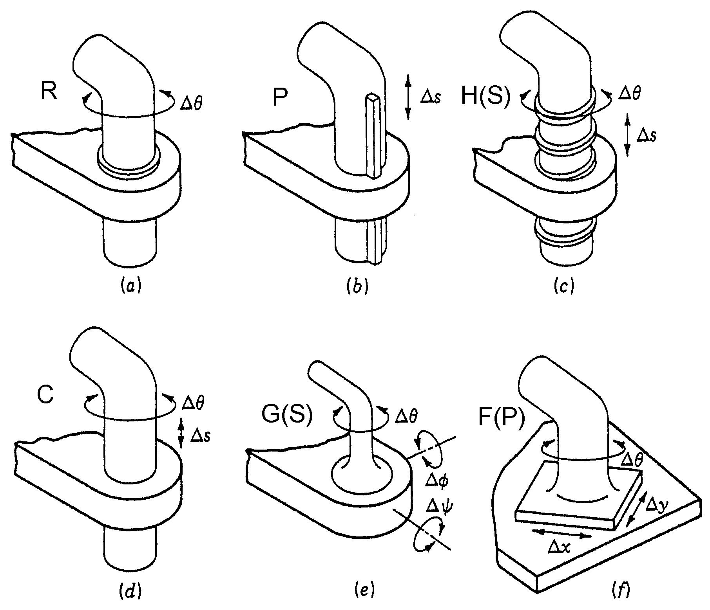
Restricts Allows
Revolute R 5 1
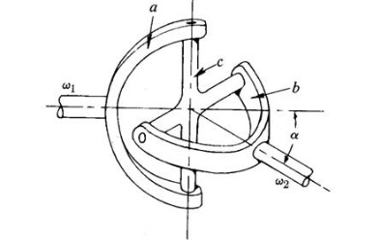
Prismatic P 5 1
Helical (Screw) H(S) 5 1
Cylindrical C 4 2
Universal (Hooke) U(H) 4 2
Globe (Spherical) G(S) 3 3
Flat (Planar) F(P) 3 3

3D mobility

M = 6(nL-1) - 5 nJ1 - 4 nJ2 - 3 nJ3
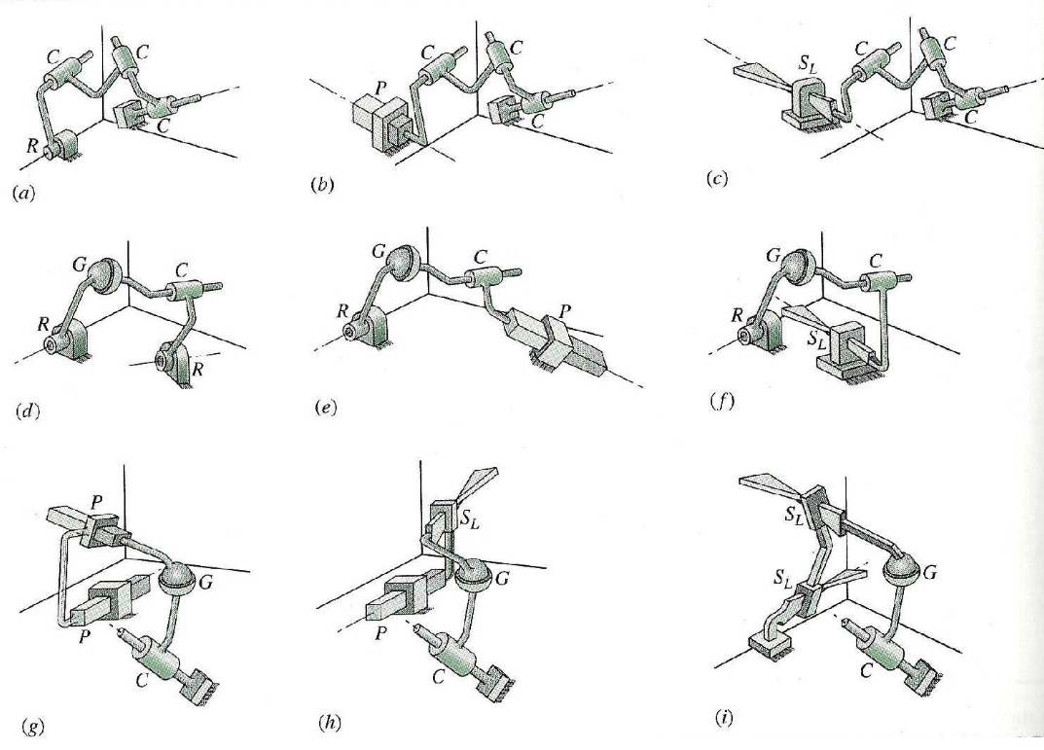

MacPherson Strut

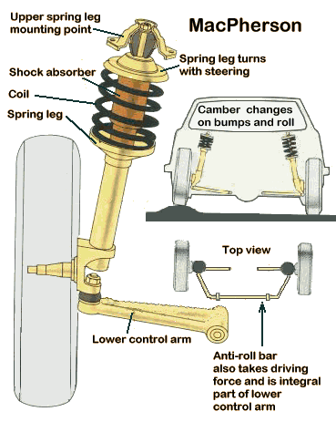

MacPherson Strut
6 2 (R,P) 1 (C) 4 (4G) 4
nL __________ nJ1 __________ nJ2 __________ nJ3 __________ M __________

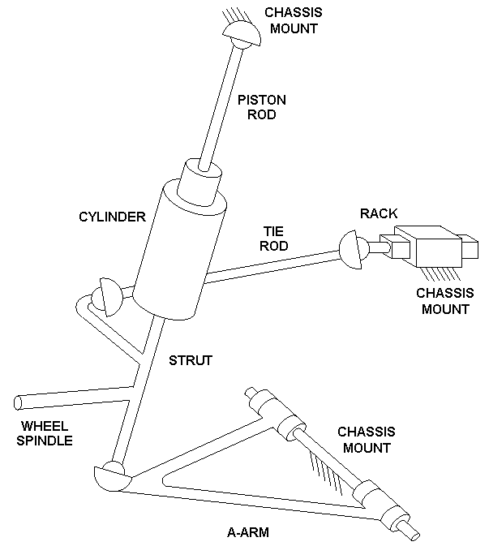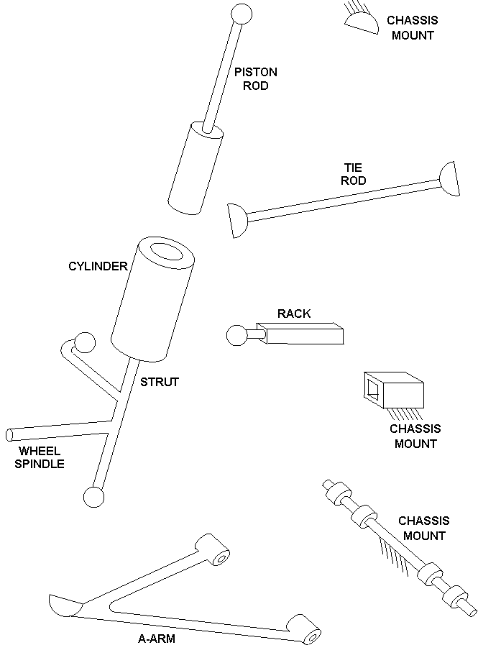

R
G
G
C
G
P
G
PISTON ROD
CHASSIS
A-ARM
STRUT
RACK
TIE
ROD

Stewart-Gough Platform (hydraulic)
14 0 18 (12U, 6C) 0 6
nL __________ nJ1 __________ nJ2 __________ nJ3 __________ M __________

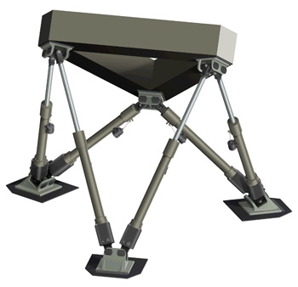
U
U
U
U
U
U
TOP PLATE
PISTON
GROUND
CYLINDER
U
U
U
U
U
U
C
C
C
C
C
C

Stewart-Gough Platform (electric)
20 12 (6R, 6H) 12 (U) 0 6
nL __________ nJ1 __________ nJ2 __________ nJ3 __________ M __________

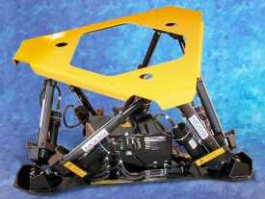
R
R
R
U
U
TOP PLATE
NUT
GROUND
MOTOR
U
U
U
R
R
R
H
H
H
H
H
H
U
SCREW
U
U
U
U
U
U

Planar and Spherical Four Bar
4 4 0 0 -2 ???
nL __________ nJ1 __________ nJ2 __________ nJ3 __________ M __________

