Working Model Tutorial for Slider Crank

1) Start Working Model 2D

2) Set display and units
Select View then Workspace
Check the X,Y Axes and Coordinates boxes and then select Close
You may also select Grid Lines and Rulers if you wish
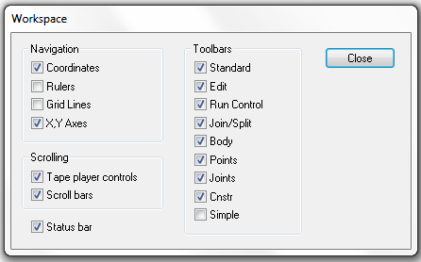
Select View then Numbers and Units then More Choices
Select Distance in Millimeters
Select Rotation in Radians and then select OK
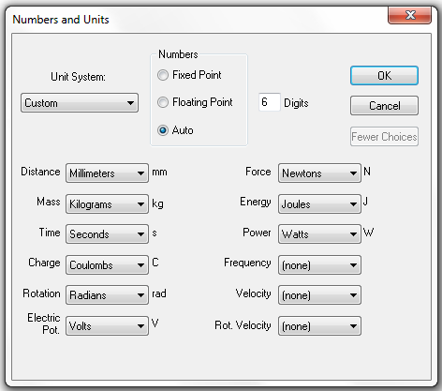

Select View then View Size
Set Window width to 100 then select OK
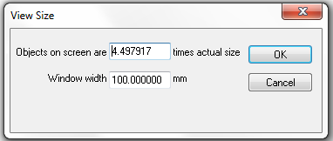

3) Save this example
Select File then Save As and choose a suitable folder and filename and then select Save

REMEMBER TO SAVE YOUR WORK OFTEN!

4) Draw a link and add points to it
Select the Rectangle drawing tool from the tool bar on the left and draw a rectangle
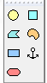
You may use the H and W indicator boxes at the bottom tool bar to resize
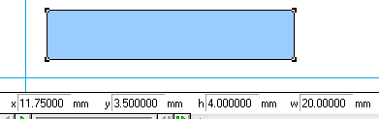

Select the round Point Element drawing tool from the tool bar on the left
Position the cursor over an edge of the link and WAIT for a small X to snap onto that edge
Left-click to attach the point to the link
Place a second round point on the link
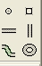

5) Label the link and points
Left-click on the link to highlight it and select Window then Appearance
Remove checks on Track center of mass and Track outline box

Check Show, Show name and Show center of mass boxes
Left-click on the box containing “Rectangle” and enter the name “Crank”
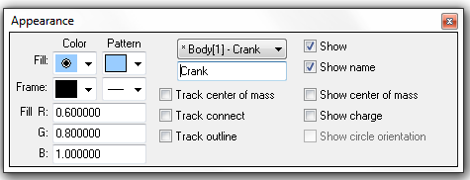

Left-click on one point on the link and select Window then Appearance
Remove the check on the Track center of mass box
Check the Show name box
Left-click on the box containing “Point” and type the name “A”
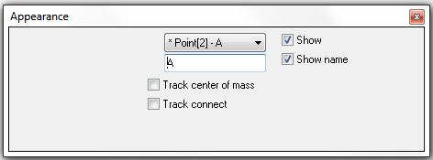

Repeat to name the other point B
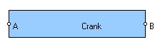

6) Create a revolute joint connected to ground
Select the round Point element drawing tool from the tool bar on the left
Position the cursor and left-click to attach a ground pin
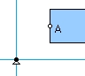

Left-click on the ground pin to highlight it if necessary
Hold down the Shift Key and left-click on point A on the Crank to highlight it also
Select the Join button from the tool bar on the left to create a revolute joint
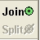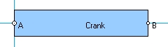

You should be able to left-click and drag the link to move it around
Animate your pendulum by selecting Run and then later Stop from the toolbar at the top
Select World then Erase Track (Ctrl+E) to clean the screen if needed
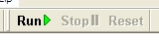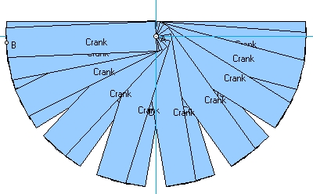

7) Create a revolute joint connected to another link
Repeat steps 4) and 5) to create “ConRod” with round points B and C attached to it

Left-click on point B on Crank to highlight it
Hold down the Shift Key and left-click on point B on the ConRod to highlight it also
Select the Join button from the tool bar on the left to create a revolute joint

You should be able to left-click and drag the links to move them around

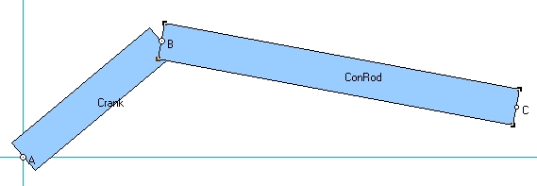

8) Create a pin-in-slot joint connected to ground
Select the horizontal Slot element drawing tool from the tool bar on the left
Position the cursor and left-click to attach a slot to ground
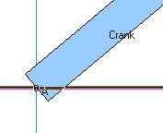

Left-click on the slot to highlight it if necessary
Hold down the Shift Key and left-click on point C on the ConRod to highlight it also
Select the Join button from the tool bar on the left to create a pin-in-slot joint
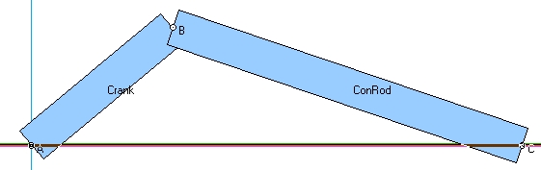

You should be able to left-click and drag the links to move them around
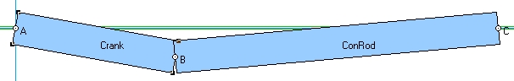

9) Create a prismatic joint
Repeat step 4) to create a small block “Piston”
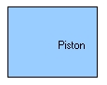

Select the Square Point element drawing tool from the tool bar on the left
Position the cursor over an edge of the Piston and WAIT for a small X to snap onto that edge
Left-click to attach the point to the Piston and name it D
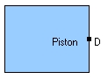

Left-click on the slot to highlight it
Hold down the Shift Key and left-click on square point D on the Piston to highlight it also
Select the Join button from the tool bar on the left to create a prismatic joint
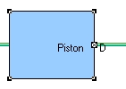

You should be able to left-click and drag the link to slide it

10) Create a slider crank
Left-click on point C on the ConRod to highlight it and press the Delete Key to remove point C
Left-click and drag the ConRod away from the slot
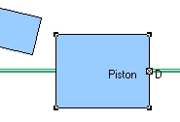

Add a new round point C to the end of the ConRod
Add a new round point C to the middle of the Piston
Highlight the points and use the Join button to create a revolute joint
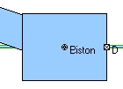

You should be able to left-click and drag the links to move them around

11) Create a slot connected to a link
Repeat steps 4) and 5) to create a large block “Cylinder”
Select the horizontal Slot element drawing tool from the tool bar on the left
Position the cursor over the Cylinder and left-click to attach a slot to the Cylinder
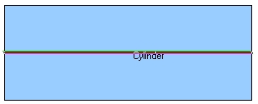

Select the Anchor tool from the tool bar on the left
Position the cursor over the Cylinder and left-click to connect the Cylinder to ground
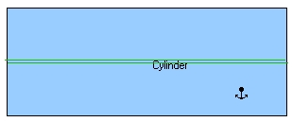

Left-click on square point D to highlight it and press the Delete Key to remove point D
Left-click and drag the Piston away from the ground slot
Left-click on the ground slot and press the Delete Key to remove it
Add a new square point D to the Piston
Left- click on the Piston and select Object then Move to Front
Left- click on the ConRod and select Object then Move to Front
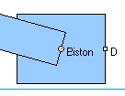

Move the slot in the cylinder where the ground slot had been
Left-click on the slot attached to the Cylinder to highlight it if necessary
Hold down the Shift Key and left-click on point D on the Piston to highlight it also
Select the Join button from the tool bar on the left to create a prismatic joint
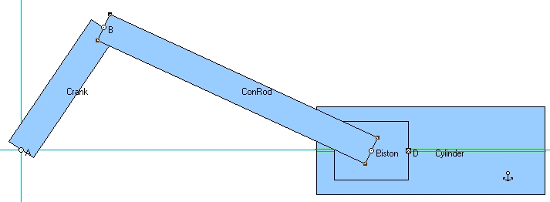

You should be able to left-click and drag the links to move them around
The Cylinder should not move

12) Collision
Depending on how you designed your Piston, the ConRod may collide with your Cylinder
You can ignore or enforce collision between objects in two ways

Global setting
Select World then Preferences and choose if you want all objects to collide or not collide
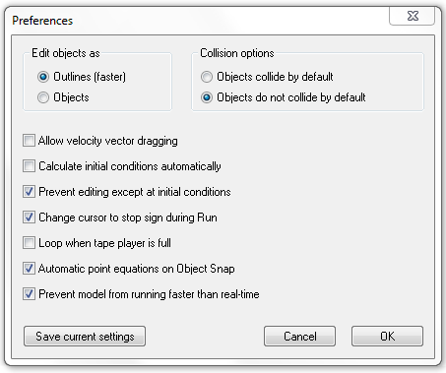
Pairs of objects
Left-click on one object and then hold down the Shift Key and left-click on another object
Then select Object and Collide or select Object and Do Not Collide
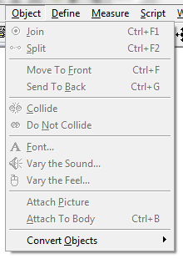

13) Add a motor
Left-click on point A on the Crank to highlight it and press the Delete Key to remove point A
Move the end of the crank away from the origin and add a new round point A to the Crank
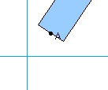

Select the Motor drawing tool
Position the icon and left-click to attach the motor to ground
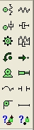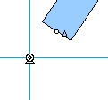

Left-click on the motor to highlight it
Select Split from the tool bar on the left
Select Window then Properties to see the names for the Base Point and the Motor in the Properties window
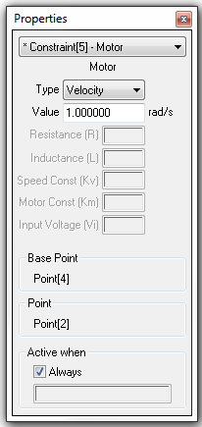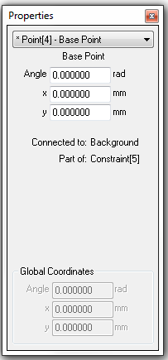

Left-click on the CENTER of the motor and drag the point icon onto point A on the Crank
Select the Join button from the tool bar on the left
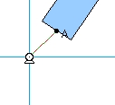

Double left-click on the motor to show the Properties pop-up
Use Type Velocity to create a speed control motor
A constant positive value causes a constant CCW rotation speed

Animate your slider crank by selecting Run and then later Stop from the toolbar at the top
Select World then Erase Track (Ctrl+E) to clean the screen if needed

Use Type Rotation to create a position control motor
You may enter a formula in the value window to vary position as a function of time
The formula “1.57*sin(3.14*t)” will produce ±90 degrees of rotation at 0.5 Hz (2 second period).

Use Type Torque to create a torque control motor
A constant positive value causes a constant CCW torque
Alternately you may enter a formula in the value window to vary torque as a function of time

14) Changing animation speed and integrator error
Select World then Accuracy
Smaller values for the upper box under Animation Step provide fewer animation steps
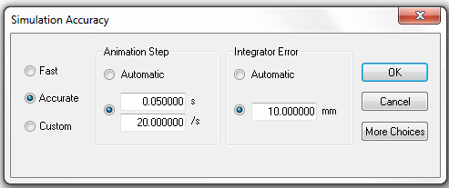

For very fast motion, default settings may cause joints to drift apart
The following settings are a good place to start when making adjustments

Select World then Accuracy
Manually set Animation Step to 0.001 sec
Select the Integrator Error radio button for Automatic

Then select More Choices
Select the Integrator radio button for Kutta-Merson (accurate)
Select the Integration Step radio button for Variable
Select Overlap Error and Assembly Error and Significant digits radio buttons for Automatic
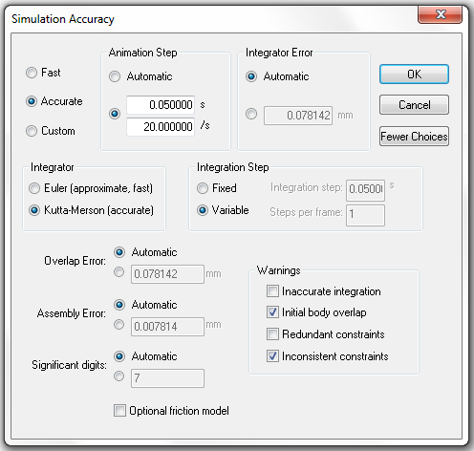
15) Modify link inertial properties
Left-click on the ConRod to highlight it and select Window then Appearance

Check the Show center of mass box
Select Window then Geometry
Select the radio button for COM x-offset to change the centroid location
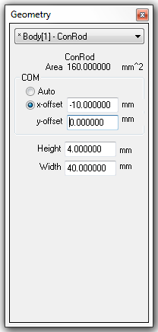

Select Window then Properties
You may change the mass and mass moment of inertia
Note: WM assumes all objects are 1 unit thick

16) Create a polygonal link
Select the Polygon drawing tool from the tool bar on the left
Left-click for the first vertex
Move the cursor and left-click to place more vertices
Double left-click to complete the Polygon

Left-click on the polygonal object to highlight it
Select Window then Geometry
Edit the table at the bottom of the Geometry pop-up to resize your object
You may edit in World coordinates or Shape coordinates
You may Insert new vertices or Delete current vertices

17) Displaying and exporting numerical data
Left-click on the Piston to highlight it and select Measure then P-V-A then X
Select Run and then later Stop from the toolbar at the top
Different output formats for the Measure window may be selected with the hollow arrow
You may have several Measure windows for different variables open at the same time
To remove a Measure window, left-click on it to select and press the Delete Key
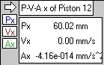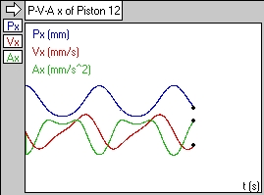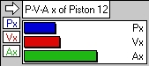

Select File then Export and choose a suitable folder and filename
Select Export type Meter Data (*.dta)
Select Export to save meter data from your most recent run
*.dta files contain tab-delimited text and may be opened with Notepad, Word or Excel
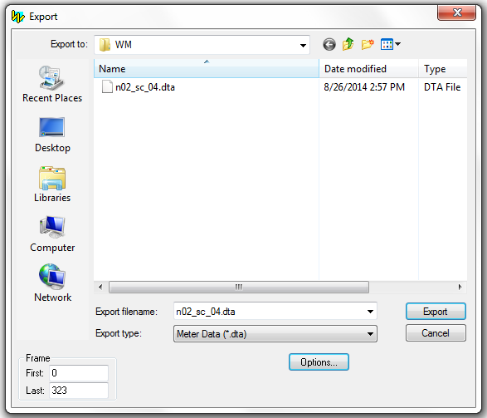
18) Exporting animation
Select File then Export and choose a suitable folder and filename
Select Export type Video for Windows (*.avi)
Select Export to save an AVI animation of your most recent run
You may also control the number of frames that are exported
Note: Exporting *.avi files may cause problems with exporting *.dta files in future runs
