Working Model Tutorial for Four Bar D Mechanism

1) Start Working Model 2D

2) Set display and units
Select View then Workspace
Check the X,Y Axes and Coordinates boxes and then select Close
X and Y indicator boxes showing cursor location will appear in the lower left corner

Select View then Numbers and Units then More Choices
Select Distance in Millimeters
Select Rotation in Radians and then select OK

Select View then View Size
Set Window width to 150 then select OK

3) Save this example
Select File then Save As
Choose a suitable folder and filename
Select Save

REMEMBER TO SAVE YOUR WORK OFTEN!

4) Draw the crank
Select the Rectangle drawing tool from the tool bar on the left
Observing the H and W indicator boxes, draw a rectangle that is 14 mm high by 2 mm wide

5) Resize the crank if necessary
Left-click on the crank to highlight it
Then left-click on the H indicator box and enter 14
Or left-click on the W indicator box and enter 2
Finally, left-click on the crank to redraw the new rectangle

6) Place points on the crank
Select the round Point Element drawing tool from the tool bar on the left
Position the cursor over the center of the lower edge of the crank
WAIT for a small X to appear to snap onto the center of that edge
Left-click to attach the point to the crank

Repeat to place a point at the center of the top edge of the crank

7) Label the crank
Left-click on the crank to highlight it
Select Window then Appearance
Remove the check on the Track outline box

Check the Show name box
Left-click on the box that says Rectangle and enter the name Crank

Left-click on the point at the bottom of the crank
Remove the check on the Track center of mass box
Check the Show name box
Left-click on the box that says Point and type the name A

Repeat to name the point at the top edge as B

8) Draw and label the follower
Repeat steps 4) through 7) to draw a follower that is 20 mm high by 2 mm wide with name Follower and with points C at the bottom and D at the top

9) Draw the coupler

Move the crank and follower away from the origin and y-axis
Select the Polygon drawing tool from the tool bar on the left
Left-click on the origin for the first vertex
Observing the DX and DY indicator boxes, move the cursor to DX= 0, DY= 71
Left-click to place the second vertex
Repeat to place the third vertex at DX= 4, DY= -2
Repeat to place the fourth vertex at DX= -2, DY= 0
Repeat to place the fifth vertex at DX= 0, DY= -69
Double left-click to complete the Polygon

10) Resize the coupler if necessary
Left-click on the coupler to highlight it
Select Window then Geometry
Edit the table at the bottom of the Geometry pop-up to match the following table
 | X | Y
1 | 0 | 0
2 | 0 | 71
3 | 4 | 69
4 | 2 | 69
5 | 2 | 0

11) Place points on the coupler
Select the round Point Element drawing tool from the tool bar on the left
Position the cursor over the center of the lower edge of the coupler
WAIT for a small X to appear to snap onto the center of that edge
Left-click to attach the point to the coupler

Repeat to place a point at the sharp tip at the top of the coupler

Repeat to place a point near the center of the coupler but not on an edge

The small X will not appear
Double left-click on the point to show the Properties pop-up

Change the Global Coordinates for this point to X= 1, Y= 33

12) Label the coupler
Repeat step 7) to label the coupler as Coupler with points B at the bottom, C in the middle and P the sharp tip

For point P, check the Track connect box

13) Place the ground pin
Move the crank, follower and coupler away from the origin
Select the round Pin Joint drawing tool
Position the icon at X= 17, Y= 32 and left-click to place the ground pin

If necessary, double left-click on the icon to show the Properties pop-up
Manually change the location to X= 17, Y= 32

14) Place the motor
Select the round Motor drawing tool
Position the icon at the origin and left-click to place the motor

15) Connect the motor to the crank
Left-click on the motor to highlight it
Select Split from the tool bar on the left
Left-click on the CENTER of the motor and drag the ground point onto point A on the crank
A dotted line should show this connection
Select Join from the tool bar on the left
The crank is now connected to the motor at point A
You should be able to left-click and drag the crank to rotate it about the motor

16) Connect the ground pin to the follower
Left-click on the ground pin to highlight it
Hold down the Shift Key and left-click on point D on the follower to highlight it also
Select the Join button from the tool bar on the left to create a revolute joint
The follower is now connected to the ground by a pin joint D
You should be able to left-click and drag the follower to rotate it about the ground pin

17) Connect the crank to the coupler
Left-click on point B on the crank
Hold down the Shift Key and left-click on point B on the coupler to highlight it also
Select the Join button from the tool bar on the left to create a revolute joint
The crank is now connected to the coupler by pin joint B
You should be able to left-click and drag on either link to rotate them

18) Connect the coupler to the follower
Repeat step 17) to connect point C on the coupler to point C on the follower
The coupler is now connected to the follower by pin joint C
You should be able to left-click and drag on any link to move the linkage

19) Changing initial assembly configuration
Left-click on any pin joint to highlight it
Select Split from the tool bar on the left
Left-click and drag any link to a more desirable position
Select Join from the tool bar on the left to reconnect that pin joint

20) Animate the linkage by selecting Run
Stop the animation by selecting Stop
Select World then Erase Track to clear messy animations

21) Changing animation speed
Select World then Accuracy
Smaller values for the upper box under Animation Step provide slower animation

22) Changing motor speed
Double left-click on the motor to show the Properties pop-up
Use positive velocity values for CCW rotation and negative velocity values for CW rotation

23) Displaying numerical data
Left-click on the follower to highlight it
Select Measure then P-V-A then Rotation
Select Run

24) Exporting data
Select File then Export

Choose a suitable folder and filename
Select Export type Meter Data (*.dta)
Select Export
*.dta files contain tab-delimited text and may be opened with Notepad, Word or Excel

Exporting video animation into *.avi files may cause problems with exporting *.dta files in future runs.

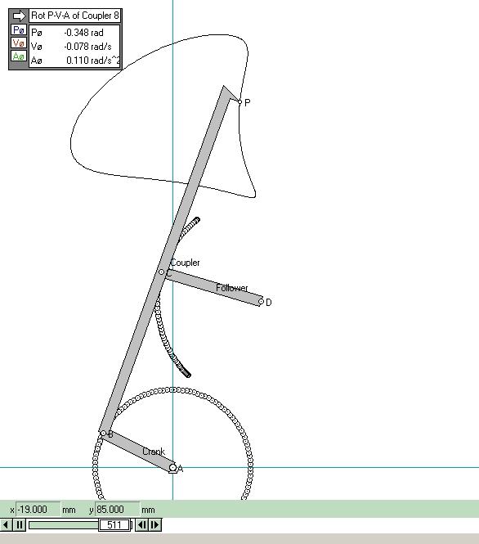
film path

3 mm

AB = 14 mm
BC = 33 mm
CD = 20 mm
AD = 17 mm X
32 mm Y

69 mm

