SolidWorks Motion Tutorial - HJSIII, 190213

1) Your mechanism
Create a SolidWorks (SW) assembly SLDASM for your mechanism. Open your mechanism file and ensure that it has mobility by manually moving links. The following tutorial assumes that your mechanism has mobility M=1, that your driver is a rotary motor and your output link is in rotation. Other drivers and mechanisms with higher mobility may also be simulated.

2) Activate SolidWorks Motion
Left-click and pull-down Options to selects Add-Ins. This may take several seconds.

Select SolidWorks Motion and SolidWorks Simulation and then left-click OK.
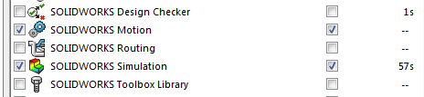

3) Name for Motion Study
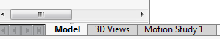
Right-click on the “Motion Study 1” tab in the lower left corner of the screen and select Rename. After you rename your study, left-click on your Motion Study tab. The MotionManager window will appear below your SW model. You may right-click on the Motion Study tab to Create New Motion Studies.

4) Type of Motion Study
At the left upper corner side of the the MotionManager toolbar, pull-down and select Motion Analysis for the Type of Study.
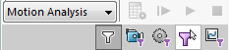

5) Drivers
Left-click on the Motor icon in the MotionManager toolbar. A Motor PropertyManager pane will appear to the left of your SW model.

Choose a Rotary Motor. For the Face entry in the Component/Direction window, left-click on the front face of the crank in your SW model. You may reverse motor direction by clicking on the arrow icon in the Motor definition pane.

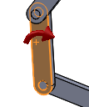
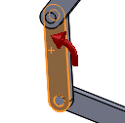
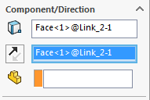

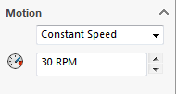
In the Motion area in the Motor PropertyManager pane, pull-down and select Constant Speed and then set the speed to 30 rpm. Be certain to left-click the green arrow in the Motor PropertyManager pane to save it. A RotaryMotor1 element will appear in the MotionManager tree.

You may add other driver elements using the Motor, Spring, Damper, Force, Contact and Gravity icons.

6) Animation and Analysis Speed
Left-click on the Motion Studies Properties icon in the MotionManager toolbar. A Motion Studies Properties PropertyManager pane will appear to the left of the model.

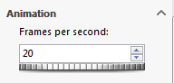
Change the Animation speed to 20 frames per second.

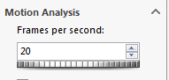
Change the Motion Analysis speed to 20 frames per second.
Be certain to left-click the green arrow in the Motion Studies Properties PropertyManager pane to save it.

You may need to adjust these values for faster mechanisms.

7) REMEMBER TO SAVE YOUR WORK OFTEN! Use File Save As …

8) Simulation time control
Left-click and drag the diamond icon in the MotionManager time line to define the length of the motion study for 10 seconds.
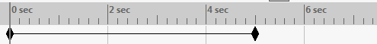

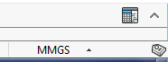
You may need to Expand MotionManager using the up arrow in the lower right corner of the screen.

9) Analyze
Left-click on the Calculate icon in the MotionManager toolbar to begin the motion study. Left-click on the Stop icon (black square) in the MotionManager toolbar to stop the motion study or replay if needed. Use the Play from Start icon (bar-arrow) and Play icon (arrow) to control replay after calculations are complete.

10) View simulation
You may pull-down to select Playback Speed and Playback Mode (Normal, Loop or Recriprocate). You may also left-click on the timeline to see results at any time.

11) Output results
Left-click on the Results and Plots icon in the MotionManager toolbar to open the Results PropertyManager pane to the left of your SW model.

Select Displacement/Velocity/Acceleration category and sub-category of Angular Displacement. Left-click on the front face of the crank to plot of crank angle as a function of time. Be certain to left-click the green arrow in the Results and Plots PropertyManager pane. A new graph window will appear. You can resize it if needed.
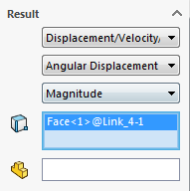

Right-click on the graph to export the data to a CSV file.

When you plot and save Angular Velocity and Angular Acceleration outputs, you must specify result component direction - NOT magnitude. Note that units for angular velocity and angular acceleration are deg/sec and deg/sec² rather than the more customary rad/sec and rad/sec².

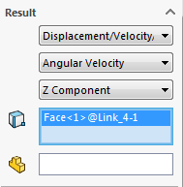
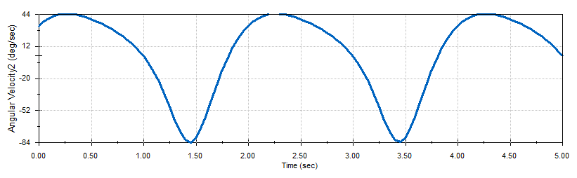
CORRECT

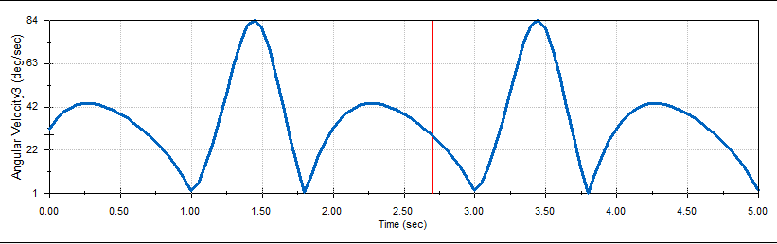
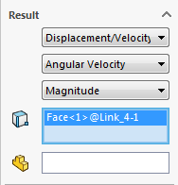
INCORRECT

You may also use Results and Plots to see point paths, motor driver torque, motor power and joint reactions.

Left-click the Save Animation icon to save an AVI movie.

