POLYCENTRIC HINGE - SKELETAL DIAGRAM

**D**

**3**

**4**

**F**

**C**

**5**

**G**

**E**

**8**

**6**

**B**

**H**

**7**

**A**

**2**

**1**

**1**

POLYCENTRIC HINGE - VECTORS

**R10**

**D**

**R4**

**F**

**C**

**R6**

**R9**

**R3**

**R5**

**E**

**R7**

**H**

**R8**

**B**

**R2**

**R1**

**A**

**G**

|  |  |  |  |  |  |
| --- | --- | --- | --- | --- | --- |
| Vector | Position of | Length  (mm) |  | Angle  (deg) |  |
| 1 | H wrt A | 21.67 | constant | 0.00 | constant |
| 2 | B wrt A | 26.69 | constant | 181.61 | var |
| 3 | C wrt B | 26.00 | constant | 36.95 | var |
| 4 | D wrt E | 14.00 | constant | 99.38 | driver |
| 5 | E wrt F | 17.83 | constant | -15.87 | var |
| 6 | F wrt H | 22.47 | constant | 146.31 | 9 - 5.33° |
| 7 | G wrt H | 22.03 | var | 171.56 | var |
| 8 | G wrt A | 3.23 | constant | 92.21 | 2 - 89.40° |
| 9 | C wrt H | 31.33 | constant | 151.64 | var |
| 10 | D wrt C | 24.62 | constant | 15.36 | 3 - 21.59° |







**Sewing Machine**

Determine angles ,  and  as well as distance s for this sewing machine linkage at the position shown below.





D

AD2 = AG2 + DG2

AD = 4.066 cm

tan GDA = AG / DG

GDA = 20.44°

C

D

4

❑

G

E

A



3

20.44°

D

C

5

D

AB = 1.60 cm

BC = 3.57 cm

DC = 2.24 cm

CE = 1.60 cm

DE = 2.74 cm

EF = 3.81 cm

AG = 1.42 cm

DG = 3.81 cm

DCE = 90°

CDE = 35.7°





20.44°

2

B





e

e

45°

2

G

B

A

B

G

s

A

F

24.56°

6

A

D

G

s

❑



E

F

e2 = AB2 + AD2 - 2 (AB) (AD) cos 24.56° e = 2.694 cm

sin  / AB = sin 24.56° / e  = 14.29°

e2 = BC2 + CD2 - 2 (BC) (CD) cos   = 48.94°

sin  / BC = sin  / e  = 87.77° or 92.23° ??? check which one

BC2 = e2 + CD2 + - 2 e (CD) cos   = 92.23°

GDA -  +  = CDG =  + CDE  = 62.65°

❑ + CDE +  +  = 180°  = 32.68°

DE sin  = AG + EF sin   = 15.43°

s + DG = DE cos  + EF cos  s = 1.12 cm

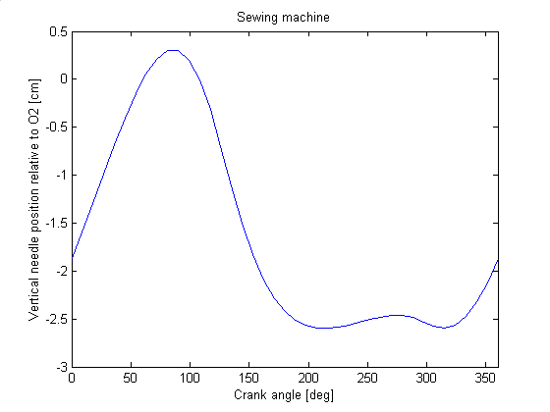

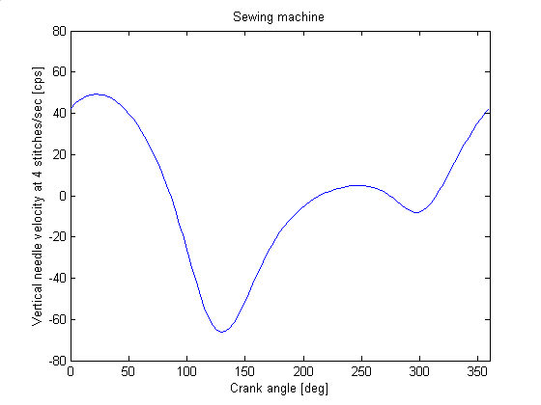 Determine the angular velocity of links 2, 3, 4 and 5 as well as the velocity of needle 6 for the sewing machine linkage as shown below when sewing at 4 stitches per second constant speed.

15.4°

45°

32.7°

62.7°

2

4

3

A

5

6

D

B

C

E

G

F

AB = 1.60 cm

BC = 3.57 cm

DC = 2.24 cm

CE = 1.60 cm

DE = 2.74 cm

EF = 3.81 cm

AG = 1.42 cm

DG = 3.81 cm

DCE = 90°

CDE = 35.7°

constant

2

2 = 4 stitches/sec = +8 rad/sec

VB = AB 2 = 40.21 cps



|  |  |  |
| --- | --- | --- |
| ? | AB 2 | ? |
| ⊥CD | ⊥AB | ⊥BC |

VB / sin 48.9° = VC / sin 77.7° = VC/B / sin 53.4°

VC = 52.31 cps 4 = VC / CD = 23.27 rad/sec CW

VC/B = 42.84 cps 3 = VC/B / BC = 12.00 rad/sec CW

98.4°

45°

53.4°

77.7°

VB

VC

VC/B

48.9°

8.4°

45°

VB

45°

32.7°

VC

VC/B

27.3°

VE = DE 4 = 63.77 cps



|  |  |  |
| --- | --- | --- |
| ? | DE 4 | ? |
| vertical | ⊥DE | ⊥EF |

VE / sin 74.6° = VF / sin 78.1° = VF/E / sin 27.3°

VF = 64.72 cps

VF/E = 30.34 cps 5 = VF/E / EF = 7.96 rad/sec CCW

VE

VF

VF/E

62.7°

15.4°

Determine the angular velocity of links 2, 3, 4 and 5 as well as the velocity of needle 6 for the sewing machine linkage as shown below when sewing at 4 stitches per second constant speed.

74.6°

VF/E

78.1°

VE

VF

R2

B

C

R1

R3

R4

A

D

15.4°

45°

32.7°

62.7°

2

4

3

A

5

6

D

B

C

E

G

F

AB = 1.60 cm

BC = 3.57 cm

DC = 2.24 cm

CE = 1.60 cm

DE = 2.74 cm

EF = 3.81 cm

AG = 1.42 cm

DG = 3.81 cm

DCE = 90°

CDE = 35.7°

constant

2

2 = +8 rad/sec

|  |  |  |
| --- | --- | --- |
|  | r [cm] | ❑ [deg] |
| 1 | 4.07 | 110.4 |
| 2 | 1.60 | 135.0 |
| 3 | 3.57 | 57.3 |
| 4 | 2.24 | 8.4 |

3 = -r2 2 sin(2-4) / r3 sin(3-4) = -12.00 rad/s

4 = -r2 2 sin(2-3) / r4 sin(3-4) = -23.27 rad/s

R2*

E

F

R1*

R3*

R4*

D

G

2* = 4 = -23.27 rad/sec

|  |  |  |
| --- | --- | --- |
|  | r* [cm] | * [deg] |
| 1 | 4.93 | 270 |
| 2 | 2.74 | 332.7 |
| 3 | 3.81 | 254.6 |
| 4 | 1.42 | 0 |

3* = - r2*2*cos(2*-1*) / r3* cos(3*-1*) = + 7.96 rad/s

*= - r2* 2* sin(2*-3*) / cos(3*-1*) = + 64.71cps

5 = 3* = 7.96 rad/sec CCW

 = 64.71 cps down

Determine the angular velocity of links 2, 3, 4 and 5 as well as the velocity of needle 6 for the sewing machine linkage as shown below when sewing at 4 stitches per second constant speed.

R1

R3

R4

R7

R8

R6

R5

A

D

B

C

G

E

F

R2

15.4°

45°

32.7°

62.7°

2

4

3

A

5

6

D

B

C

E

G

F

AB = 1.60 cm

BC = 3.57 cm

DC = 2.24 cm

CE = 1.60 cm

DE = 2.74 cm

EF = 3.81 cm

AG = 1.42 cm

DG = 3.81 cm

DCE = 90°

CDE = 35.7°

constant

2

|  |  |  |
| --- | --- | --- |
|  | r [cm] | ❑ [deg] |
| 1 | 1.42 constant | 180 constant |
| 2 | 1.60 constant | 135 driver |
| 3 | 3.57 constant | 57.3 variable |
| 4 | 2.24 constant | 8.4 variable |
| 5 | 3.81 constant | 254.6 variable |
| 6 | 1.12 variable | 270 constant |
| 7 | 3.81 constant | 90 constant |
| 8 | 1.60 constant | 4 - 90 constraint |







REAL: 

IMAG: 







REAL: 

IMAG: 





using MATLAB



Determine the angular acceleration of links 2, 3, 4 and 5 as well as the acceleration of needle 6 for the sewing machine linkage as shown below when sewing at 4 stitches per second constant speed.

15.4°

45°

32.7°

62.7°

2

4

3

A

5

6

D

B

C

E

G

F

AB = 1.60 cm

BC = 3.57 cm

DC = 2.24 cm

CE = 1.60 cm

DE = 2.74 cm

EF = 3.81 cm

AG = 1.42 cm

DG = 3.81 cm

DCE = 90°

CDE = 35.7°

constant

2

R2

B

C

R1

R3

R4

A

D

2 = +8 rad/sec 2 = 0 angular velocities from velocity solution

|  |  |  |  |  |  |  |
| --- | --- | --- | --- | --- | --- | --- |
|  | r [cm] | ❑ [deg] | [rad/sec] | [cpss] | [rad/s/s] | [cpss] |
| 1 | 4.07 | 110.4 |  |  |  |  |
| 2 | 1.60 | 135.0 | +25.13 | +1010.6 | 0 | 0 |
| 3 | 3.57 | 57.3 | -12.00 | +514.1 | ? |  |
| 4 | 2.24 | 8.4 | -23.27 | +1212.9 | ? |  |



 

closed form

= ( - r2 sin(2-4) - r2 cos(2-4) - r3  cos(3-4) + r4  ) / r3 sin(3-4) = 549.3 rad/s/s

= ( - r2 sin(2-3) - r2 cos(2-3) - r3  + r4  cos(4-3)) / r4 sin(3-4) = 40.4 rad/s/s

R2*

E

F

R1*

R3*

R4*

D

G

2* = 4 = -23.27 rad/sec 2* = 4 = +40.4 rad/s/s 3* = 5 = -23.27 rad/sec

|  |  |  |  |  |  |  |
| --- | --- | --- | --- | --- | --- | --- |
|  | r* [cm] | * [deg] | * [rad/sec] | * [cpss] | * [rad/s/s] | * [cpss] |
| 1 | 4.93 | 270 |  |  |  |  |
| 2 | 2.74 | 332.7 | -23.27 | +1483.7 | +40.4 | +110.7 |
| 3 | 3.81 | 254.6 | +7.96 | +241.4 | ? |  |
| 4 | 1.42 | 0 |  |  |  |  |



 