1) For a right McPherson strut, attach local coordinate frames to each link for a fixed position of the steering rack. Clearly label all auxiliary points and vectors needed to form constraints.

2) Write a corresponding set of generalized coordinates  .

3) Symbolically write a constraint vector  for this mechanism using the vertical absolute translation driver for the strut-spindle assembly  for

.

4) Numerically check the residuals of  using measurements from model hardware.

5) Symbolically write the corresponding Jacobian matrix .

6) Numerically evaluate the elements of the Jacobian and compute the determinant.

7) Program your constraints and Jacobian into a Newton-Raphson iterative algorithm to solve position kinematics at any desired time.

8) Symbolically write the velocity right-hand-side vector and program to solve for generalized coordinate velocities at any desired time.

9) Place your position and velocity algorithms within an outer loop to drive the strut-spindle assembly over 0 ≤ t ≤ 1 sec. Plot toe-in angle versus vertical position of the strut-spindle assembly. Additionally plot all three components of global angular velocity of the strut-spindle assembly versus time.

**EXTRA CREDIT**

Symbolically write the acceleration right-hand-side vector and program to solve for generalized coordinate accelerations. Plot all three components of global angular acceleration of the strut-spindle assembly versus time.

**PISTON**

**ROD**

**RACK**

# TIE

**ROD**

**STRUT**

**WHEEL**

**SPINDLE**

**A-ARM**

**CYLINDER**

**CHASSIS**

**MOUNT**

**CHASSIS**

**MOUNT**

**CHASSIS**

**MOUNT**

# A

# B

# F

# C

# D

# E3

# 1 = ground

**2 = A-arm**

**3 = strut / cylinder**

**4 = piston**

# E4

# 4

# 1

# 3

# 1

# 2

# 1

# 1 = ground

**2 = A-arm**

**3 = strut / cylinder**

**4 = piston**

# F1

# F4

# y4

**PISTON**

**ROD**

**RACK**

# TIE

**ROD**

**STRUT**

**WHEEL**

**SPINDLE**

**A-ARM**

**CHASSIS**

**MOUNT**

**CHASSIS**

## MOUNT

**CHASSIS**

## MOUNT

**CYLINDER**

# A = revolute (5)

**B = sperical (3)**

**CD = double spherical (1)**

**E = prismatic (5)**

**F = spherical (3)**

# z4

# x4

# use double spherical

**between C and D**

# D

# E4

# C

# y3

# C3

# z3

# E3

# fixed

# steering

**angle**

# D1

# x3

# y1

# z1

# B3

# z2

# y2

# B2

# x1

# A1

# A2

# x2

McPherson strut model - rear view McPherson strut model - side view

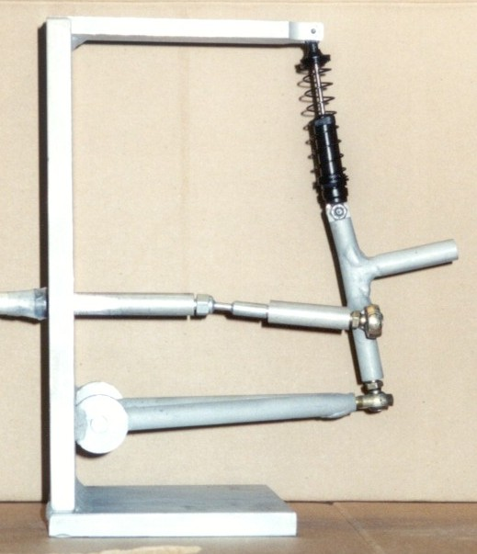 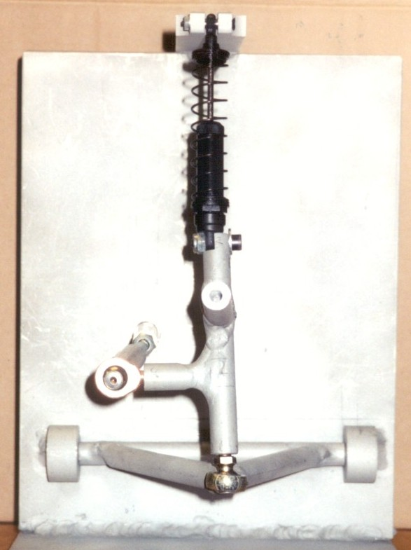

# A

# B

# F

# C

# D

# E3

# z1

# z3

# y3

# y1

# z4

# y4

# 1 = ground

**2 = A-arm**

**3 = strut / cylinder**

**4 = piston**

# E4

# A

# B

# F

# C

# D

# E3

# x1

# y2

# x3

# y3

# x2

# y1

# x4

# y4

# 1 = ground

**2 = A-arm**

**3 = strut / cylinder**

**4 = piston**

# E4

 

# y1

# z1

26.35 cm

507 pixels

0.05187 cm/ pixel

20.64 cm

541 pixels

0.03815 cm/ pixel

# E4

# y1

# x1

# E3

# D

# C

# F

# B

# A

# F

# E4

# E3

# D

# C

# B

# A

cm x1 y1 z1

A 0 0 0

B 15.70 1.40 0

C 15.49 5.87 5.77

D 6.03 6.81 4.60

E3 13.51 12.16 0

E4 13.03 15.56 0

F 12.06 22.35 0

scaled from photographs on class web page

**Constraints**



**Velocity**

